Identification of Simple Sequence Repeats Related to Dormancy
Induction in Vaccinium corymbosum

Daniel Tuerff
Laboratory Methods in Genomics
Spring 2013

Introduction
Vaccinium corymbosum, also known as the Northern highbush blueberry, is a perennial flowering plant commonly grown for its sweet tasting berries. The highbush blueberry is the most commercially produced species of blueberry in North America. More than 50 cultivars have been produced for seasonality and fruit characteristics (USDA Plants, 2012).
In order to grow blueberries more efficiently, it is important to identify the mechanisms behind plant dormancy. It has been found that the peak of dormancy is the best time for pruning plants (Bevacqua et al., 2012). Dormancy is also important for storing and preserving blueberries for extended periods of time during transport. Through selective breeding, it could be possible to select cultivars that enter or exit dormancy at specific times and under specific environmental conditions.
During dormancy, plants enter into a state of suspended growth with an absence of metabolic activity. Environmental factors such as lack of water or extreme temperature change can induce this state until conditions are favorable again. In addition to environmental factors, dormancy is also affected by endogenous factors such as plant hormones (Ruttink et al., 2007).
Abscisic acid is a plant hormone that can induce dormancy in plants. While it has many functions, abscisic acid inhibits fruit ripening, inhibits cell growth/seed germination, and down regulates enzymes needed for photosynthesis. The abscisic acid pathway begins with a pyrabactin resistance receptor (PYR/PYL) that inhibits 2C protein phosphatases (PP2C). PP2C is a negative regulator of plant dormancy. When uninhibited by PYR/PYL, PP2C removes a phosphate group from SNF1-related kinase 2 (SnRK). SnRK2 phosphorylates abscisic acid responsive element binding proteins (ABFs). Abscisic Acid Insensitive 3 (ABI3) is highly conserved amongst plants and is responsible for controlling bud growth as a transcription factor (Graeber et al., 2012)
In addition to genes in the abscisic acid pathway, I looked at genes causing evergrowing mutants (evg) in Prunus persica. Evergrowing mutants have a genomic deletion that affects MADS-box genes. The evergrowing deletion prevents dormancy from occurring and can be detrimental to the plant. Plants that do not enter dormancy under stressful conditions will die. Dormancy Associated MADS-box (DAM) was found to be responsible for controlling bud dormancy through regulation of gene expression (Leida et al., 2012). DAM6 is specifically related to peach-dormancy. Real-time RT-PCR showed reduced DAM6 transcript levels during a rise in growth competence of flower buds (Leida et al., 2012). DAM6 could be used as a marker for chilling requirements and dormancy timing. It would be possible for blueberry growers to know which crops
My project consisted of BLASTing genes related to dormancy against 454 blueberry genome scaffolds. Through the BLAST results, I was able to find simple sequence repeats (SSRs). The BLAST results allowed me to generate primers using the Vaccinium website. These primers could then be used by blueberry cultivators for selective breeding. During the project, I also tested the GenSAS website to see if it would be useful for our blueberry project. I was assigned to look at the tRNA scan function of the website.

Materials and Methods
I began the assignment with the search for articles on dormancy induction in eudicots. I searched for organisms that were similar to Vaccinium corymbosum with National Center for Biotechnology Information (NCBI) and Google. Arabidopsis thaliana and Prunus persica were commonly used because of the extensive amount of research in dormancy. Genes that were related to the abscisic pathway, metabolism, oxidation-reduction, and signaling/transcription in plants were picked from these papers on dormancy. I also found genes involved in signaling pathways through the Kyoto Encyclopedia of Genes and Genomes (KEGG). After finding specific genes and proteins, I found the amino acid sequences corresponding with the proteins using the protein search in NCBI. I omitted proteins that did not have a full sequence.
BLAST
The next step required using Apple’s Terminal app to BLAST the amino acid sequence against the blueberry scaffolds. To do this, I used the command “cd” (file location here)” without the parenthesis to allow the program to locate the folder containing the 454 scaffolds. Next, I used the command “./bin/makeblastdb -in (scaffold txt file name here) -input_type fasta -dbtype nucl -title blueberry_Genome” to create a database from the 454 scaffolds. This loaded the previously gathered 454 blueberry scaffolds for BLASTing against my dormancy genes.
Figure 1. Terminal window showing commands used to create a database for BLAST.

I BLASTed the amino acid sequences against the new database using the command “bin/tblastn -query (Amino acid sequence in FASTA format) -db Sorted_454Scaffolds.txt.” The command uses tBLASTn to compare the protein query amino acid sequence against the nucleotide sequence from the scaffolds. The output from this command usually gave several scaffolds to choose from, with a bit score, E value, and percentage of identities. I picked the scaffold with the lowest E value because it had the most similarity to my query. It was important to note which nucleotide the query sequence started on the scaffold (Figure 3).
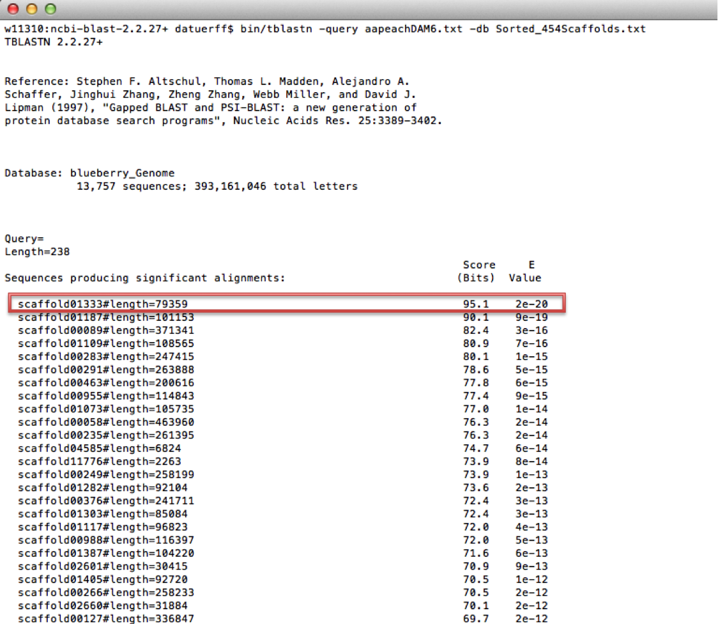
Figure 2. tBLASTn results. Scaffold with lowest E Value is highlighted in red.

The screenshot below shows the starting location of my query sequence on the scaffold. In this case, my query sequence starts at the 18535th nucleotide on scaffold 1333.
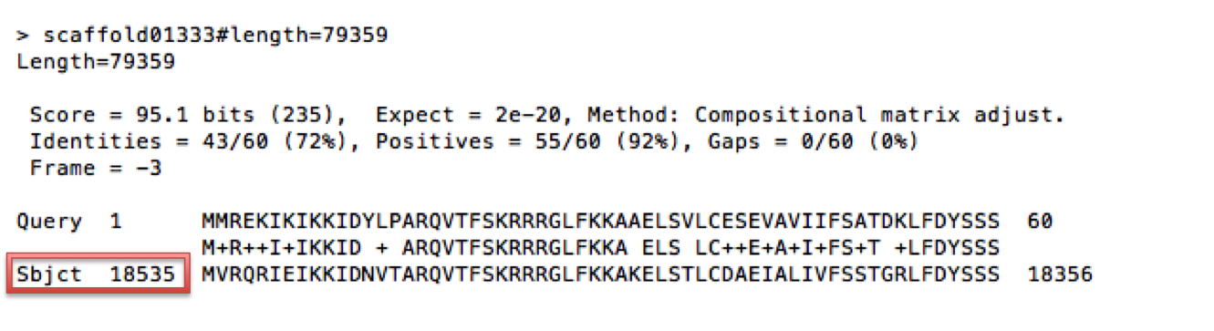
Figure 3. tBLASTn results continued. The query start location is highlighted in red.

Vaccinium Database Search
Using the scaffold with the lowest E-value, I searched the provided 454 blueberry scaffolds for the scaffold containing the gene of interest. I used the “ctrl + F” function to bring up a search window in the .txt file containing the scaffolds. I typed in “scaffold(number here)” in the search box to search for the scaffold identified by the tBLASTn. The entire scaffold was copied into a .txt file to be uploaded on the Vaccinium website. To upload my scaffold, I went to the Vaccinium website, over the tools tab and clicked SSR. Figure 4 shows the SSR Server that The sequence file was uploaded with values of 0 for tetranucelotides, pentanucleotides, and hexanucelotides.

Figure 4. Vaccinium Genome Database SSR search (Genome Database for Vaccinium. Tetra through Hexanucleotides (highlighted in red) should have values of zero.

Primers
After submitting a job, a link was sent back to me through an email. The link took me to a webpage with multiple other links. I downloaded the link with the excel file. The excel file was sorted by number of repeats so that the greatest number of repeats was toward the top. Primer pairs were picked by both number of repeats and proximity to the query sequence. My first priority was to pick the primers that had more than 15 repeats. If there were none, I tried to find primers that were at least within 10,000 bases of my gene. Using these guidelines, I was able to generate three sets of primers.
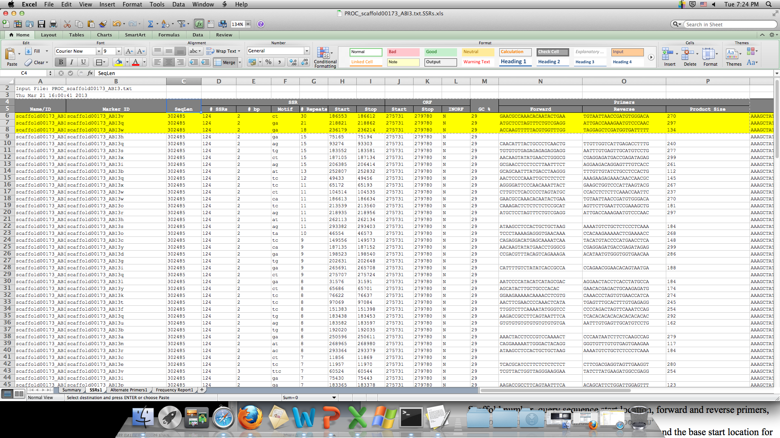
Repeats

Primers

Figure 5. Excel spreadsheet showing SSR search results. Repeats and primers are located with red arrows.

Scaffold number, query sequence start location, forward and reverse primers, nucleotide repeats, number of repeats, PCR product size, and the base start location for each SSR were recorded into an organized word file.
Example of a finished report:
Found in Scaffold 00173 (query sequence starts at base 74854 on scaffold)
1)
For Primer GAACGCCAAACACAATACTGAA
Rev Primer TGTAATTAACCGATGTGGGACA
repeats (ga) x30 PCR product =270 bp & start at base 186553

GenSAS
To test the GenSAS website, I first logged on and clicked “Use GenSAS” (GenSAS, 2013). I copied the scaffold sequence identified for a dormancy related gene into the sequence box. I then added tRNAscan as a task, hit “create task,” and hit the feather icon in the task queue to start the task. The feather turned blue to let me know that the task had started. I was sent an email telling me my scan was complete, and logged in to look at the results.Figure 6. GenSAS tRNAscan. The tRNAscan tool is framed in red.

Results
23 total SSRs were obtained. For each SSR, three sets of forward and reverse primers were generated. The genes were picked from the abscisic pathway, metabolism, oxidation-reduction, and dormancy-related signaling/transcription in plants. The majority of organisms were either Arabidopsis thaliana or Prunus persica.
Gene | Organism
ABI3 | Arabidopsis thaliana
FUS3 | Arabidopsis thaliana
LEC1 | Arabidopsis thaliana
LEC2 | Arabidopsis thaliana
PP2C | Arabidopsis thaliana
PYL/PYR | Arabidopsis thaliana
SNRK2 | Arabidopsis thaliana
Cytochrome p450 | Populus trichocarpa
DAM5 | Prunus persica
DAM6 | Prunus persica
NAC domain protein IPR003441 | Populus trichocarpa
Zinc finger protein | Camellia sinensis
GRAS family transcription factor | Populus trichocarpa
NAC domain protein NAC1 | Gossypium hirsutum
Mitogen activated protein kinase kinase kinase | Ricinus communis
Transcription factor AP2-EREBP | Lotus japonicus
DAM4 | Prunus persica
FLC | Arabidopsis thaliana
UDP-galactose 4 epimerase | Cyamopsis tetragonoloba
S-like ribonuclease | Prunus dulcis
Acyl:coa ligase | Populus trichocarpa
Strictosidine synthase family protein | Brassica napus
chs-like protein | Populus trichocarpa
Carboxyl-terminal protease | Zea mays
Chalcone synthase family protein | Arabidopsis halleri subsp. Gemmifera
Xyloglucan endotransglucosylase/ hydrolase 5 | Malus x domestica
Table 1. SSRs identified for each gene except for FLC (shown in red). Genes were obtained from several different organisms.

An SSR for the transcription factor Flowering Locus C (FLC) was not obtained because the scaffold was too small. I found multiple SSRs for genes involved in hormone regulation, maturation regulation, signaling, transcription, and metabolism related to dormancy.
Unfortunately, GenSAS was unable to find any tRNAs in my scan. It is possible that this tool works under certain conditions. However, my tests did not yield any results. The website is currently unable to run any tasks I give it (5/7/2013).
Discussion
I was able to obtain SSRs for 23 different dormancy-related genes. The majority of the genes were related to either the abscisic acid pathway or evergrowing mutants. I was able to obtain a scaffold for FLC, however no SSR primers were generated from the Vaccinium website. Future research may be able to obtain primers for FLC if a larger scaffold is generated through blueberry genome sequencing. FLC is an important gene because responsible for regulating the developmental life cycle in Arabidopsis thaliana.
SSRs that I successfully generated from this research could be used to identify plants for crossbreeding by tracking different alleles. Primers generated from my research could be used to create PCR product from a young blueberry plant. If PCR product size is different for a certain allele, it could be used to screen plants for specific genotypes before they are fully grown. This would speed up the screening process to get desired phenotypes such as increased or decreased time of dormancy. My research will help blueberry growers create cultivars with desired traits. With increased control of blueberry dormancy timing, growers can accurately know when their blueberries will grow. Future research should continue the search for dormancy related genes in Vaccinium corymbosum.

References
Bevacqua D, Génard M, Lescourret F. A simple model to predict the probability of a peach (Prunus persicae) tree bud to develop as a long or short shoot as a consequence of winter pruning intensity and previous year growth. PLoS ONE. 2012;7(12):e52185.
Genome Database for Vaccinium. Plants for Human Health Institute. 07 May 2013. <http://www.vaccinium.org/>.
GenSAS. 07 May 2013. <http://gensas.bioinfo.wsu.edu/>.
Graeber K, Nakabayashi K, Miatton E, Leubner-metzger G, Soppe WJ. Molecular mechanisms of seed dormancy. Plant Cell Environ. 2012;35(10):1769-86.
KEGG: Kyoto Encyclopedia of Genes and Genomes. 07 May 2013. <http://www.genome.jp/kegg/>.
"Highbush Blueberry." USDA PLANTS. N.p., n.d. Web. 07 May 2013. <http://plants.usda.gov/java/>.
Leida C, Conesa A, Llácer G, Badenes ML, Ríos G. Histone modifications and expression of DAM6 gene in peach are modulated during bud dormancy release in a cultivar-dependent manner. New Phytol. 2012;193(1):67-80.
Leida C, Terol J, Martí G, et al. Identification of genes associated with bud dormancy release in Prunus persica by suppression subtractive hybridization. Tree Physiol. 2010;30(5):655-66.
National Center for Biotechnology Information. U.S. National Library of Medicine. 07 May 2013 <http://www.ncbi.nlm.nih.gov/>.
Ruttink T, Arend M, Morreel K, et al. A molecular timetable for apical bud formation and dormancy induction in poplar. Plant Cell. 2007;19(8):2370-90.

Acknowledgments
Thank you Dr. Allan Brown at NCSU, Dr. Jeannie Rowland with the USDA, Dr. Doreen Main at WSU, Dr. Malcolm Campbell at Davidson College, and the BIO343 class.

Appendix
ABI3 Found in Scaffold 173 (query sequence starts at base 74854 on scaffold)
1)
For Primer GAACGCCAAACACAATACTGAA
Rev Primer TGTAATTAACCGATGTGGGACA
repeats (ga) x30 PCR product =270 bp & start at base 186553

2)
For Primer ATGCTCCTAGTTTCTGTCGAGG
Rev Primer ATTGACCAAAGAATGTCCCAAC
repeats (ga) x21 PCR product =297 bp & start at base 218821
3)
For Primer ACCAAGTTTTTACGTGGTTTGG
Rev Primer TAGGAGCTCGATGGTGATTTTT
Repeats (ga) x18 PCR product =134 bp & start at base 236179

Acylcoa Found in Scaffold 1173 (query sequence starts at base 36878 on scaffold)
1)
For Primer ATTCAACGGCTCAGATTCACTT
Rev Primer TACAAATCCAAACACACGGAAC
repeats (ta) x29 PCR product =251 bp & start at base 87799

2)
For Primer TGTGAAATGGAGGTACCCTTCT
Rev Primer CAGATGAATTGCTGAAACCTGA
repeats (ct) x15 PCR product =187 bp & start at base 76484
3)
For Primer CATTGGGCTGACATTAAGGTTT
Rev Primer TCTGCATGTTTGTTGGGTTTAG
Repeats (tg) x10 PCR product =210 bp & start at base 6200

Carboxyl terminal processing protease Found in Scaffold 2378 (query sequence starts at base 10045 on scaffold)

1)
For Primer AAGGCTCAAGACAACAATCCAT
Rev Primer GCTCCATATACGAAAAGCTTGG
repeats (ag) x10 PCR product =102 bp & start at base 18932
2)
For Primer TTTTTATGTATCCCCGGAACC
Rev Primer CGAAATGCTGAAACTTGTCTTG
Repeats (ac) x7 PCR product =186 bp & start at base 60

3)
For Primer TGCTGGAGAAAAAGAAACACTG
Rev Primer ATGATTGGAGCTCTGATACCGT
repeats (ct) x6 PCR product =213 bp & start at base 2896

Chalcone synthase family protein Found in Scaffold 491 (query sequence starts at base 132065 on scaffold)
1)
For Primer GCCAACTATAAGCCTGAACCAC
Rev Primer ATAGCCTGGGTTTCACAGATTG
repeats (ag) x16 PCR product =281 bp & start at base 92449

2)
For Primer GAATAGCAGGGTCTTTCCAATG
Rev Primer ATTTCCGGACACTATTACCCCT
repeats (ag) x14 PCR product =239 bp & start at base 152527
3)
For Primer GCCAACTATAAGCCTGAACCAC
Rev Primer ATAGCCTGGGTTTCACAGATTG
Repeats (tg) x12 PCR product =281 bp & start at base 92425

Chs-like protein Scaffold 814 (query sequence starts at base 40156 on scaffold)
1)
For Primer AGGTCTTTGTTTCCAACCTTGA
Rev Primer CGGTTTGGTTTGGTTCATAAGT
repeats (ga) x17 PCR product =232 bp & start at base 13893

2)
For Primer GAATTTGCAGGAATTATGGCTC
Rev Primer GTTCCCCATTCTTCTCCTCTCT
repeats (ct) x11 PCR product =170 bp & start at base 28175
3)
For Primer AGACAACCTTCCCAAACTCAAA
Rev Primer TGCAGTATGCTTTCTGACCACT
Repeats (ca) x10 PCR product =279 bp & start at base 10144
Cytochrome p450 Found in Scaffold 586 (query sequence starts at base 92166 on scaffold)
1)
For Primer ATAGCGGCTCTCCAAAAACAT
Rev Primer ATCTAGGGTTTCGAGTCCACCT
repeats (ag) x21 PCR product =234 bp & start at base 136135

2)
For Primer AGCGTATTCCATTCTGGACTGT
Rev Primer ATATTTGGCACCTCAATTGCTC
repeats (ta) x15 PCR product =293 bp & start at base 56735
3)
For Primer GTACGAGAAAAACTTGGATGCC
Rev Primer TATCCAGAGATTCCAGACCCAT
Repeats (ga) x9 PCR product =267 bp & start at base 50281

Cytochrome p450 Found in Scaffold 586 (query sequence starts at base 92166 on scaffold)
1)
For Primer ATAGCGGCTCTCCAAAAACAT
Rev Primer ATCTAGGGTTTCGAGTCCACCT
repeats (ag) x21 PCR product =234 bp & start at base 136135

2)
For Primer AGCGTATTCCATTCTGGACTGT
Rev Primer ATATTTGGCACCTCAATTGCTC
repeats (ta) x15 PCR product =293 bp & start at base 56735
3)
For Primer GTACGAGAAAAACTTGGATGCC
Rev Primer TATCCAGAGATTCCAGACCCAT
Repeats (ga) x9 PCR product =267 bp & start at base 50281

DAM4
Found in Scaffold 01333 (query sequence starts at base 18544 on scaffold)
1)
For Primer AGCCGTAGGAGAACAAGATCAA
Rev Primer GCACTCCTAGGTCCGAAGTATC
repeats (ac) x10 PCR product =242 bp & start at base 73805

2)
For Primer ATCATGCACCGCCCTATTATAC
Rev Primer GAGGCACTTTTATATGGGTTGG
repeats (tc) x7 PCR product =244 bp & start at base 27010
3)
For Primer TATGGTCAACAACCGCTACATC
Rev Primer TTTATTAGGGCTTGGTCTCGAA
Repeats (gca) x9 PCR product =210 bp & start at base 30618

DAM5 Found in Scaffold 1187 (query sequence starts at base 47701 on scaffold)
1)
For Primer GCTACTGTTCTCGTCTCCTCGT
Rev Primer TCAATAGAACCTTCCACCGACT
repeats (ct) x13 PCR product =116 bp & start at base 78977

2)
For Primer AATGTTTTGTGTCTCCCAATCC
Rev Primer GGCACAACGCTAGTTGATAAAG
repeats (ga) x12 PCR product =275 bp & start at base 95120
3)
For Primer CAAATGGTGATAGCAAACATGG
Rev Primer CTCAAAGAAAATTCCCAAGACG
Repeats (tta) x7 PCR product =274 bp & start at base 57880

DAM6 Found in Scaffold 01333 (query sequence starts at base 18535 on scaffold)
1)
For Primer TGGGTAGAATCAGAGAAAACGG
Rev Primer AAAATGACGGGTGGTCCTATTT
repeats (ag) x18 PCR product =284 bp & start at base 58236

2)
For Primer AGCCGTAGGAGAACAAGATCAA
Rev Primer GCACTCCTAGGTCCGAAGTATC
repeats (ac) x10 PCR product = 242 bp & start at base 73824
3)
For Primer TATGGTCAACAACCGCTACATC
Rev Primer TTTATTAGGGCTTGGTCTCGAA
Repeats (gca) x9 PCR product =210 bp & start at base 30592

FUS3LEC2 Found in Scaffold 00219 (query sequence starts at base 74050 on scaffold)
1)
For Primer ACTGATGGAGGAGCACGATTAT
Rev Primer TTTTTGAGGTGCAATGTGACTC
repeats (tc) x10 PCR product =262 bp & start at base 163071

2)
For Primer TGGGTTCCATTACTACCTAGCG
Rev Primer CAAATTGAAACGGAAGGAGTGT
repeats (ct) x PCR product = 257 bp & start at base 27318
3)
For Primer GGGGTACTGGGTTCCATTACTA
Rev Primer TAGGTTTGAAAATCGAGAGCGT
Repeats (tc) x PCR product =285 bp & start at base 22139

GRAS family protein Found in Scaffold 567 (query sequence starts at base 24082 on scaffold)
1)
For Primer AAACAAGCATCAACGCAGAGTA
Rev Primer AAGCTTGTGGGGTCATAGGATA
repeats (ag) x13 PCR product =219 bp & start at base 29639

2)
For Primer ACGTACCCTCTCAACGAGTCAT
Rev Primer ATCAAAAATCCCTTACTGGGGT
repeats (tc) x12 PCR product =216 bp & start at base 23439
3)
For Primer GATTCCCTATCCAGCTTACGTG
Rev Primer TTCCACTAGTTTAATGTCCGGC
Repeats (ag) x6 PCR product =118 bp & start at base 20805

LEC1 found in scaffold 00036 (query sequence starts at base 301135 on scaffold)
1)
For Primer GCACACAAAGGAGTTTCACTCA
Rev Primer GTTTCGTTTCCTTTCGTTTCCT
repeats (ag) x30 PCR product =187 bp & start at base 95860

2)
For Primer ACTCGTTGCGAATAAATCCACT
Rev Primer CACCCCAATTCTCCAAAGGTA
repeats (ag) x14 PCR product =172 bp & start at base 473440
3)
For Primer TACTCAGTGGACATTGCTTGCT
Rev Primer CCTCTTCCTTCTCCTCCTCTTC
Repeats (ag) x22 PCR product =245 bp & start at base 164682

MAPKKK3 Found in Scaffold 394 (query sequence starts at base 135452 on scaffold)
1)
For Primer TTGAGTGCATTTCTCTCTGGAA
Rev Primer TAATGATGACATGGATTCACCG
repeats (ga) x13 PCR product =125 bp & start at base 170993

2)
For Primer CATTAACCCTACCCCATCTTCA
Rev Primer GAAATAAAACCCGTTACGGACA
repeats (ct) x12 PCR product =235 bp & start at base 28356
3)
For Primer ACTGCTACGATCAAAACTGGGT
Rev Primer ATAATGAAGTCGGGGTTTGATG
Repeats (tc) x11 PCR product =277 bp & start at base 52896

NAC domain protein NAC1 Found in Scaffold 72 (query sequence starts at base 258035 on scaffold)

1)
For Primer TGGGTACAAAACCTTAGCTTGG
Rev Primer TCTCGTACCCAAAGAAATGACC
repeats (ct) x25 PCR product =164 bp & start at base 347939

2)
For Primer AACAATCGGCCCTTGTTAGATA
Rev Primer TATTCTAAATCCAGGGCCTTCA
repeats (tg) x19 PCR product =129 bp & start at base 194575
3)
For Primer TTCATAATTTGGGGAGGGAGTA
Rev Primer AGGCCGACTTTCTCTTCTTCTT
Repeats (gt) x12 PCR product =256 bp & start at base 142010

NAC domain protein IPR003441 Found in Scaffold 01415 (query sequence starts at base 34984 on scaffold)
1)
For Primer AGATTATTAGCGTGAAGCTCCG
Rev Primer GATGCCATCATACGAAAGGACT
repeats (ga) x19 PCR product =214 bp & start at base 18700

2)
For Primer AGGGGTCCATAGCACATAAAAA
Rev Primer ATGTCGGAGGAAGTCGAAACTA
repeats (ag) x14 PCR product =244 bp & start at base 54313
3)
For Primer TACCAAATACCAATTTGAGGCG
Rev Primer ATCTAAATACTCCCTCCGTCCC
Repeats (ta) x7 PCR product =127 bp & start at base 44338
PP2C Found in Scaffold 644 (query sequence starts at base 26276 on scaffold)
1)
For Primer CTCCCAAAAACTCTGCACCTAC
Rev Primer CCCCATTAATTTACATAGGCGA
repeats (ct) x16 PCR product =259 bp & start at base 1879

2)
For Primer GCATGCCTGATCACAATTAGAA
Rev Primer ATTTCCAGATGGTCTCTTACCG
repeats (ga) x9 PCR product =175 bp & start at base 70686
3)
For Primer ATTTCTGGTCTTTCCTTCACCA
Rev Primer AGTTCTCGAATGGAAGCAATGT
Repeats (tc) x13 PCR product =133 bp & start at base 122220

PYL7 Found in Scaffold 00766 (query sequence starts at base 30762 on scaffold)
1)
For Primer CCCCAATTCAGGTCTATCAAAA
Rev Primer CTAAGAGCATCTCCAACTGCCT
repeats (ga) x7 PCR product =297 bp & start at base 3418

2)
For Primer CTTTCTCCTTTCACCCAAACAC
Rev Primer TTGCATATCCGTCTCAAGAAGA
repeats (ct) x8 PCR product =191 bp & start at base 87340
3)
For Primer TCTGTCATCCTGCACAATATCC
Rev Primer GAAAGTTGAGTTTTCGAATGGG
Repeats (ct) x6 PCR product =257 bp & start at base 66733

S like Ribonuclease Found in Scaffold 484 (query sequence starts at base 175226 on scaffold)
1)
For Primer CAGGACCACAAATGAATTAGCA
Rev Primer AACTTACCGTAAACGACCTCCA
repeats (ag) x16 PCR product =139 bp & start at base 78786

2)
For Primer GGACTAACAATGAAGGGTGGAG
Rev Primer GGCTCAGAAAATAGCAGCACTT
repeats (ga) x11 PCR product =265 bp & start at base 85952
3)
For Primer TTACACCTCAGGATGTGCAGAC
Rev Primer CCCCCAAATTAAAGGGTAAAAC
Repeats (ga) x10 PCR product =277 bp & start at base 87363

SNRK2 found in Scaffold 00548 (query sequence starts at base 150361 on scaffold)

1)
For Primer TATGTGTGCTAACCTGCCATTC
Rev Primer CCAAAACCTCGAAATCAAGAAC
repeats (ct) x12 PCR product = 247 bp & start at base 77319

2)
For Primer GCTCCTAGAAAGAAACCTACCTCA
Rev Primer TTAAGGCACCAAGAACTCCACT
repeats (ag) x21 PCR product = 291 bp & start at base 87552
3)
For Primer TGGAATTAAGTTCGCTAACCGT
Rev Primer TTGCAGAAACCACTTAACCCTT
Repeats (ag) x PCR product = 286 bp & start at base 175818

Strictosidine synthase family protein Found in Scaffold 182 (query sequence starts at base 68497 on scaffold)
1)
For Primer CTGAAATGTACCAAAACGACCA
Rev Primer AAACAACCTGGGTAAACAATGC
repeats (ga) x16 PCR product =167 bp & start at base 297782

2)
For Primer CTAGGTCGCTCACATTCTTCAA
Rev Primer GAAATAGGAGGATGGTGCGTAG
repeats (ca) x12 PCR product =262 bp & start at base 144969
3)
For Primer AAGTACCCCAAGATTGGAAGTG
Rev Primer GCTCGCCCTTGATATATTTTTG
Repeats (ga) x12 PCR product =262 bp & start at base 235417

UDP galactose-4 epimerase Found in Scaffold 658 (query sequence starts at base 70755 on scaffold)
1)
For Primer CAGGGACTACAAATACGCTTCC
Rev Primer TCACGAAACATATACGGCAAAG
repeats (ct) x9 PCR product =272 bp & start at base 44180

2)
For Primer CAACACATGAACATTACCCACC
Rev Primer GACTTGTTGGGGGAGAGTGTAG
repeats (ag) x8 PCR product =285 bp & start at base 51379
3)
For Primer TGAGTTGCCAAGAATTGTGTTC
Rev Primer GCATTAGATGGGTTTTCTGGAG
Repeats (ga) x9 PCR product =263 bp & start at base 143206

Xyloglucan endotransglucosylase/ hydrolase 5 Found in Scaffold 1511 (query sequence starts at base 36878 on scaffold)
1)
For Primer GATGGACTTGTGTGTGTGTGTG
Rev Primer TGAGCCTTTGAAAACCTCTCTC
repeats (ag) x25 PCR product =126 bp & start at base 27538

2)
For Primer TTCTGGTCTTGGTACGAATGTG
Rev Primer CGTAATCAACAGTTCACTCCCA
repeats (ga) x12 PCR product =120 bp & start at base 33443
3)
For Primer GAGGGTGAACAAATTAAATGGC
Rev Primer TGCTTCTCTCCCAAATTTGACT
Repeats (tc) x10 PCR product =283 bp & start at base 16624

Zinc finger protein Found in Scaffold 2129 (query sequence starts at base 12347 on scaffold)
1)
For Primer ACCCTAACAAAATCAAAACCCG
Rev Primer TCCAAACACGATTTCTAACCCT
repeats (ga) x21 PCR product =152 bp & start at base 40907

2)
For Primer ACTACCTACCCCTAACCCCGTA
Rev Primer AATTAGGTGTGTTGCTGGGAAT
repeats (ct) x16 PCR product =242 bp & start at base 39654
3)
For Primer GGGAAGAGAGAGAGGAAAGGAG
Rev Primer AACCGTAGACTTTTGGTTTGGA
Repeats (ga) x8 PCR product =280 bp & start at base14865

