Mathematical Modeling of Transcription and Translation

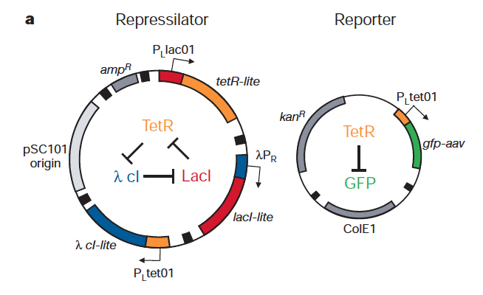
- The following is a “cartoon” depiction of a genetic system called the repressilator (1). Study the design and predict possible behaviors of the system.

- Once you understand the design, open the NetLogo model of the repressilator.

  - Press the “Setup” button to initialize the model. You can restart the model at any time by pressing this button.
  - Press the “Go” button to start running the model. You will need to slow the model down to see what is going on. Describe the behavior you observe.
  - Experiment with different values of the “Threshold” parameter to produce different behaviors.
  - In the NetLogo model, the three promoters are all colored grey, but a better representation might be to color each promoter the same color as the gene that represses it. By watching the behavior of the model, hypothesize which gene represses each promoter.
  - Pick a value of the threshold that causes all 3 protein levels to oscillate regularly. Restart the model several times. Are the results exactly the same each time?
  - Click on the “Code” button and study the logic of the model. Once you understand the logic, explain why the model behaved the way it did with the different values of the threshold, and when you restarted several times. Also, use the logic to confirm your answer to part (d).
  - Discuss the strengths and weaknesses in the NetLogo approach to modeling the repressilator. Can you suggest ways to improve or refine the model?

- Open the Excel model of the repressilator.
  - Write the quantity used to represent the rate of change in the mRNA level of a gene as a function of two variables.
  - Explain why this function is a reasonable representation of transcription rate in the repressilator.
  - Repeat parts (a) and (b) for the rate of change in protein level of a gene.
  - Find parameter values that achieve the model behaviors depicted in the Powerpoint presentation.
  - Discuss the strengths and weaknesses in the Excel approach to modeling the repressilator. Can you suggest ways to improve or refine the model?
  - Compare and contrast the NetLogo and Excel modeling approaches.

