Brittany Elek

**EC: 2.6.1.85**

**para-aminobenzoate synthetase**

**BLASTed using *Vitis vinifera* (wine grape) as the query**

Blast results:

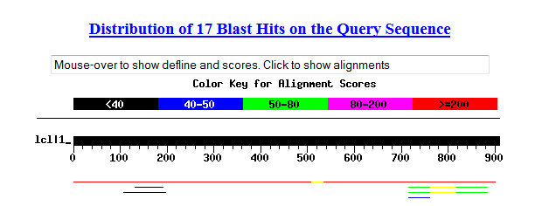

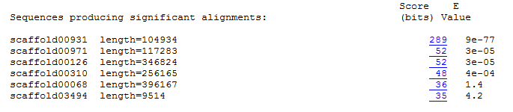

**2.6.1.85 found in Scaffold 00931 (query sequence starts at base 79725 on scaffold)**

1)

For Primer TAGCCCTAGTTGTGGTGTTGTG

Rev Primer ATTGCACACCACATTCAGTCTC

Repeats (ag) x 18 PCR product = 260 bp & start at base 56084

2)

For Primer TCCCTTAGCCTATAAAAGGGGA

Rev Primer CGGATAGGAAGGATGATGAAAG

Repeats (ctt) x 15 PCR product = 299 bp & start at base 100054

3)

For Primer TGATGTATGACGGTTAGATGCC

Rev Primer CGTCTCTCTCTCTCTCTCTCTCTCT

Repeats (gt) x 11 PCR product = 177 bp & start at base 79816

**2.6.1.85 found in Scaffold 00971 (query sequence starts at base 84910 on scaffold)**

1)

For Primer TAACTAGTGCAGTCTTGCTGCC

Rev Primer TCAATACTCATTCGGTGAAACG

Repeats (ga) x 20 PCR product = 209 bp & start at base 45900

2)

For Primer TGGAAACAACGCAAACTATCAC

Rev Primer TGCCATCAGACTGTCTACCATC

Repeats (ct) x 14 PCR product = 179 bp & start at base 98363

3)

For Primer CATGCATTCTTGAGAAAGGTGA

Rev Primer GGTCCACCACACCAAAATTACT

Repeats (ag) x 13 PCR product = 289 bp & start at base 105790

**2.6.1.85 found in Scaffold 00126 (query sequence starts at base 304201 on scaffold)**

1)

For Primer CCAAACTCCAAGTTGTCCTTTC

Rev Primer GGCCTGAATTATTTTCTGATGG

Repeats (ag) x 19 PCR product = 154 bp & start at base 227731

2)

For Primer GGACGTTATGGAGCGAAGTTT

Rev Primer TCAGCCTTTTCCTTTCCTGATA

Repeats (tc) x 16 PCR product = 231 bp & start at base 255378

3)

For Primer CCAAACTCCAAGTTGTCCTTTC

Rev Primer GGCCTGAATTATTTTCTGATGG

Repeats (ga) x 15 PCR product = 154 bp & start at base 227681

**2.6.1.85 found in Scaffold 00310 (query sequence starts at base 199378 on scaffold)**

1)

For Primer GAGACGAAAGACATTAGACATGC

Rev Primer CCTGACGAAAAACGTTACAACTC

Repeats (ga) x 17 PCR product = 298 bp & start at base 254186

2)

For Primer GGCAAATTCTCCAAACAACTTC

Rev Primer CAAACCAAACAAGGAAGTCACA

Repeats (ct) x 16 PCR product = 280 bp & start at base 242713

3)

For Primer TATTGCTCATCCAACATTCGAC

Rev Primer TTACTCCTGACATTAAAGCGCA

Repeats (tc) x 12 PCR product = 161 bp & start at base 243187

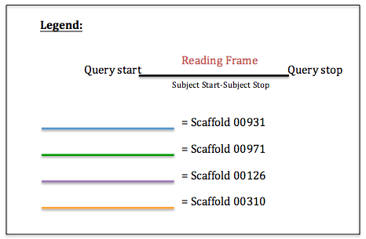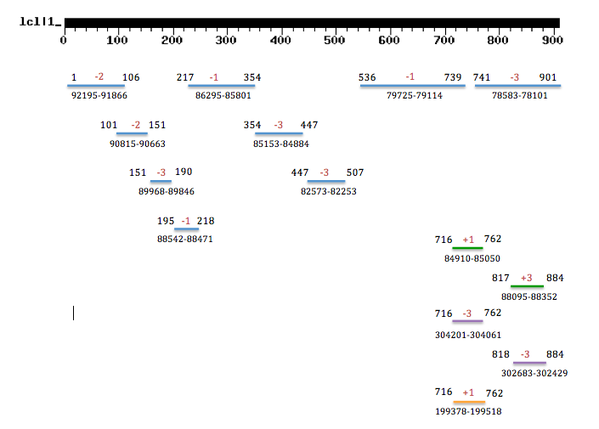

Figure: Results of tBLASTn of para-aminobenzoate synthetase [EC:2.6.1.85] using *Vitis vinifera* as the query against *Vaccinium corymbosum* 454-scaffolds. There were four significant scaffolds (shown in diagram above). The fragments within scaffolds are due to frame shifts.