Erich Baker
Independent Study in Synthetic Biology
Drs. Campbell & Heyer
9 May 2012
Research Proposal
Introduction
Phytochromes – A family of proteins that respond to a particular wavelength of light by changing shape. In nature, they are commonly found in plants, where they are sensitive to subtle changes in light, helping trigger processes like flowering. Almost all phytochromes are responsive to red or far-red light. Phytochromes, in their light-activated shape, generally interact with a phytochromes-interacting factor (PIF), which then acts as a transcription factor for a particular gene. Through this process, a gene is indirectly activated when exposed to a wavelength of light that a particular phytochrome is exposed to. Recently, researchers have also described phytochromes that react to blue or green light and which can be used in tandem with a red-sensitive phytochrome. However, because the red-sensitive phytochromes are more well-studied, I will focus on them. In Tabor, et al., researchers described a robust, reversible light-sensitive system involving a protein called Ch8 which is responsive to 705nm light (for activation) and 645nm light (deactivation). The design of the system is illustrated below, including a NOT gate which is necessary to convert the system from a NOT red sensor to a red sensor. Details on the construction of the plasmid containing this system can be found in the Materials and Methods section of Tabor, et al. (At times I had time accessing the supplemental materials of this paper due to a pay wall). In essence, this system causes production of a product, in this diagram lacZ, when the cell is exposed to 705nm light, and turns that production off when exposed to 650nm light.
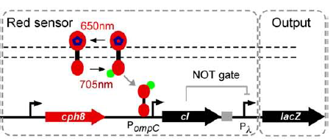
Light Sensitive Channel Proteins – A family of proteins which span the cell membrane and are responsive to light. When exposed to the correct wavelength of light, these channels open, allowing movement of some substance in or out of the cell. What wavelength they are responsive to, and what substance is moved, depends on the protein. In Knopfel et al., researchers described NpHR, a halorhodopsin pump from Natronomonas pharaonis. NpHR is sensitive to yellow light (525 nm), and when activated, allows hydrogen ions to move into the cell and chloride ions to move out. While NpHR is studied primarily for its ability to stop motor neurons from working by hyperpolarizing them, an increase in hydrogen ion concentration inside the cell also means that intracellular pH would drop. The action of NpHR is illustrated below. The intracellular pH of a cell with this channel protein would drop when exposed to light of 525nm.
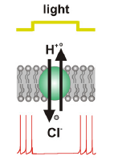
Synthetic Ribosomal Binding Sites – In Salis, et al., researchers showed that the sequence of the ribosomal biding site (RBS), can greatly affect translation efficiency. The exact sequence of the RBS changes how the mRNA folds, affecting how accessible it is to the ribosome. The time it takes for the ribosome to bind to the mRNA is the rate-limiting step in translation, and so efficiency can be greatly increased (up to 100,000 times), by optimizing the RBS for the quickest possible binding time. The researchers produced a model which can predict how a given mRNA will fold, and gives the optimal ribosomal binding site for maximal production of a particular gene. This model can be accessed at https://salis.psu.edu/software/forward.
Concept
My concept for a potential project integrates the above three techniques into a system in E. coli that produces a variable level of fluorescence in response to two separate light inputs. One input would be red light of 705 nm, activating the Cph8-based red light sensor. This sensor would be tied to production of green fluorescent protein. In addition, a synthetic ribosomal binding site would be placed in front of the GFP gene, designed to maximize output of GFP for robust fluorescence. The other input would be yellow light of 525nm, to activate the NpHR ion channel, which would allow hydrogen ions into the cell. The red light would stimulate production of GFP, while the yellow light would allow hydrogen ions into the cell, lowering intracellular pH. As described in Kneen, et al. pH changes in the 5-8 range can alter absorbance of GFP by up to 10-fold. GFP will respond to the pH changes in under 1 millisecond, and the changes are reversible, meaning that the GFP will continue to change appearance as pH goes down. Thus, the appearance of the GFP would depend on the presence and intensity of both the red and yellow light. The concept is diagrammed below.
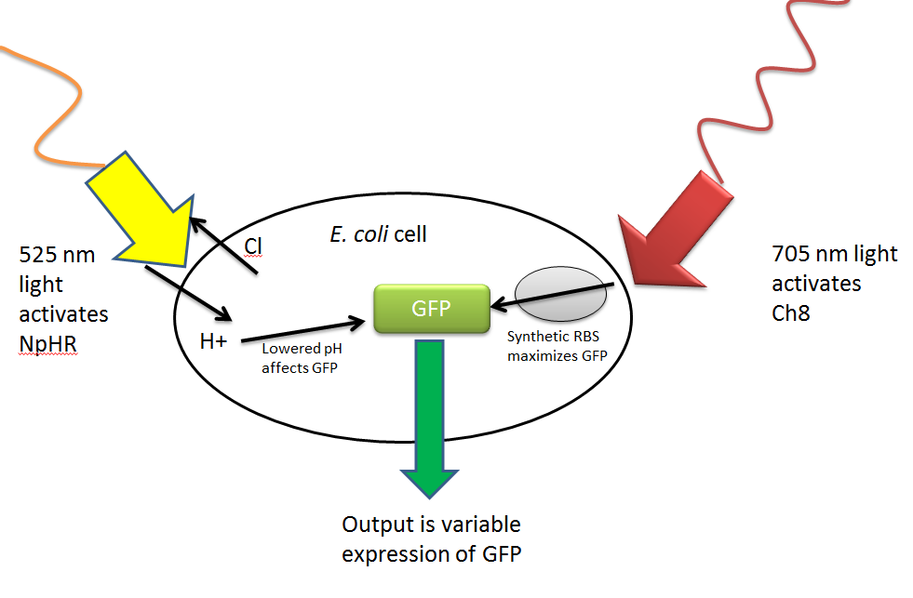
GFP used is the common laboratory strain first isolated from Aequorea victoria. The exact sequence is at the bottom of the document. Because the optimal synthetic RBS changes depending on what the target protein is, I ran the GFP sequence through the model at https://salis.psu.edu/software/forward. The output from the model indicates that GGACAGGTCCACAATAAATAAGGAGGAAAGAC would be the best RBS to integrate in order to maximize production of GFP.
Variations in the intensity of the light used to activate Cph8 lead to different amounts of product produced. Controlling the intensity of the 705 nm light would allow you to select for the amount of GFP expressed. Though I can’t find any literature on the effects of light-intensity on the activation of NpHR, the same is likely true for that system and easily testable. I hypothesize that more intense light at 525nm would lead to increased ion flow across the membrane. In addition, 705 and 525 nms are the wavelengths at which these systems are reported to respond to best, but they likely respond to other, similar wavelengths. Altering the exact wavelength of light applied would modulate the amount of GFP produced or the magnitude of intracellular pH change. It’s also worth noting that because 705 and 525 nm are not terribly far apart on the spectrum, there could be some noise in this design where one system picks up light intended to activate the other. For example, Cph8 is deactivated by 650 nm light, and might respond at a reduced level to 525nm light intended to stimulate NpHR.
Both the red-sensing Cph8 system and the yellow-sensing NpHR could be integrated into E. coli on plasmids. Construction of a plasmid containing the red-sensor is outlined in Tabor, et al. and details on construction of a plasmid containing NpHR can be found at http://www.stanford.edu/group/dlab/optogenetics/sequence_info.html#nphr, referenced in Knopfel, et al. I’m not sure how high the copy number of these plasmids should be to produce a strong effect- that may have to be discovered through experimentation. In particular, NpHR is studied primarily for its ability to disable motor neurons by hyperpolarizing them, and its effect on intracellular pH is noted but not extremely well characterized. I don’t know how dramatic of an effect the NpHR channels will have on intracellular pH, and the copy number of the plasmid might have to be high in order to produce an appreciable decrease in pH.
This concept would create a system where the output, fluorescence, can be finely tuned with two different light-based inputs. Multiple light inputs could be used to exert a finer level of control over engineered cells, allowing them to respond to a greater number of inputs or situations in a greater number of ways. The type of output in this system also combines the binary presence/absence aspect of fluorescent reporters with a gradient of absorbance due to the pH. This type of reporting means that the cell’s appearance can tell you more about its local environment than a fluorescent reporter alone.

Bibliography
Kneen, Malea, Javier Farinas, Yuxin Li, and A. S. Verkman. "Green Fluorescent Protein as a Noninvasive Intracellular PH Indicator." Biophysical Journal 74 (1998): 1591-599. Web. <http://www.ncbi.nlm.nih.gov/pmc/articles/PMC1299504/pdf/9512054.pdf>.
Knopfel, Thomas, Michael Z. Lin, Anselm Levskaya, Lin Tian, John Y. Lin, and Edward S. Boyden. "Toward the Second Generation of Optogenetic Tools." The Journal of Neuroscience 30.45 (2010): 14998-5004. Web. <http://www.neuro.cjb.net/content/30/45/14998.full.pdf>.
Salis, Howard M., Ethan A. Mirsky, and Christopher A. Voigt. "Automated Design of Synthetic Ribosome Binding Sites to Control Protein Expression." Nature Biotechnology 27.10 (2009): 946-50. Web. <http://www.ncbi.nlm.nih.gov/pmc/articles/PMC2782888/pdf/nihms145791.pdf>.
Tabor, Jeffrey J., Anselm Levskaya, and Christopher A. Voigt. "Multichromatic Control of Gene Expression in Escherichia Coli." Journal of Molecular Biology (2010). Web. <http://www.taborlab.rice.edu/pdf/tabor_jmb_2010.pdf>.

GFP sequence that was used as the input into the synthetic RBS model

atgagtaaag gagaagaact tttcactgga gtggtcccag ttcttgttga attagatggcgatgttaatg ggcaaaaatt ctctgtcagt ggagagggtg aaggtgatgc aacatacggaaaacttaccc ttaattttat ttgcactact gggaagctac ctgttccatg gccaacacttgtcactactt tctcttatgg tgttcaatgc ttctcaagat acccagatca tatgaaacag
catgactttt tcaagagtgc catgcccgaa ggttatgtac aggaaagaac tatattttac aaagatgacg ggaactacaa gacacgtgct gaagtcaagt ttgaaggtga tacccttgtt
aatagaatcg agttaaaagg tattgatttt aaagaagatg gaaacattct tggacacaaa atggaataca actataactc acataatgta tacatcatgg gagacaaacc aaagaatggc atcaaagtta acttcaaaat tagacacaac attaaagatg gaagcgttca attagcagac
cattatcaac aaaatactcc aattggcgat ggccctgtcc ttttaccaga caaccattac
ctgtccacac aatctgccct ttccaaagat cccaacgaaa agagagatca catgatcctt
cttgagtttg taacagctgc taggattaca catggcatgg atgaactata caaa

