Gracie Gordon

Entry: 100252672
CDS T01084
Definition: folic acid synthesis protein fol1-like
Folate biosynthesis
Class: Metabolism; Metabolism of cofactors and vitamins; Folate biosynthesis

2.5.1.15 found in scaffold 00003 (query sequence starts at base 803754 on scaffold)

1)
For Primer AGTTCAGACAATTCAACGTCCA
Rev Primer AGTTCAGACAATTCAACGTCCA
Repeats (ag) x16 PCR product = 207 bp start at base 743328
2)
For Primer TGAAAACTCAGCCTAAACCCAG
Rev Primer ATGCTCCCTCTCTTTCCTCTCT
Repeats (ag) x10 PCR product = 206 bp start at base 811354

3)
For Primer CCTACAGACTGCCGTTTCTTCT
Rev Primer TCGTGACAAAATACACAGAGGG
Repeats (ga) x11 PCR product = 257 bp start at base 780006

2.5.1.15 found in scaffold 01432 (query sequence starts at base 60917 on scaffold)

1)
For Primer TCAGGCCAATTTTAGGAGGATA
Rev Primer GAAAACCGTGTAATTGAATGCC
Repeats (tta) x6 PCR product = 213 bp start at base 63373

2)
For Primer CAGTATCCTGGGATTTAGGTGG
Rev Primer GGTGAGTGTAACACCCCAAACT
Repeats (ga) x10 PCR product = 234 bp start at base 77019

3)
For Primer TACACACCTTTGGAGCTTGGTA
Rev Primer GGAATCACATATCAACCAAGGG
Repeats (tg) x9 PCR product = 290 bp start at base 77578

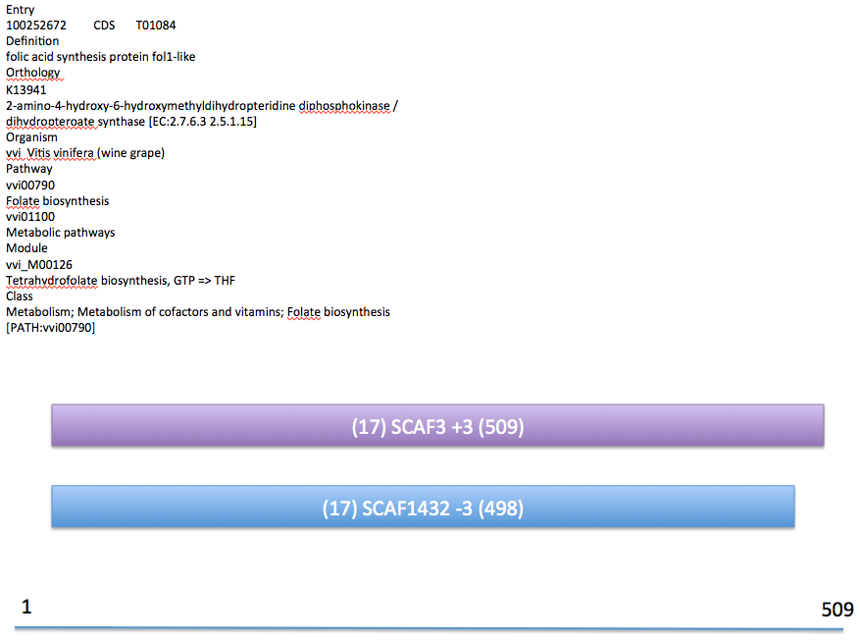
Fig 1. This is a map of the scaffold hits in Grape that match the folic acid synthesis protein sequence. The protein is 509 amino acids long, which is shown at the scale on the bottom.

