Michael Lorentsen

EC 3.1.3.1 not found in Vaccinium corymbosum (blueberry) when compared to either vitis vinifera or Arabidopsis thaliana

-Took AA sequence of 3.1.3.1 vitis vinifera (wine grape) and did tblastn versus blueberry 454 scaffolds, obtained 0 hits

- Took AA sequence of 3.1.3.1 Arabidopsis thaliana and did tblastn versus blueberry 454 scaffolds, obtained 3 hits with e values of 2.3, 3.0, and 6.7 respectively

EC 6.3.4.3 found in Scaffold 00232 (query sequence starts at base 226382 on scaffold)

1)
For Primer GTCCCTAAAGCTTCTGAAAGCA
Rev Primer AAACGGGTAGTTATTCAAGCCA
repeats (tc) x17 PCR product = 257 bp & start at base 189800

2)
For Primer TTCTCCTACAACTCCTCTTCGC
Rev Primer TGAGTAGCCGGTGGTATTAGGT
repeats (cca) x8 PCR product = 162 bp & start at base 214077

3)
For Primer CTTCAAGGTGCCTCATCTCTCT
Rev Primer GTCATAAATTGAACCTCCGCTC
repeats (tc) x8 PCR product = 226 bp & start at base 217434

EC 6.3.4.3 found in Scaffold 00890 (query sequence starts at base 5799 on scaffold)

1)
For Primer GATTGACAAGCAACAGGTTCAT
Rev Primer TTTCTTCGGACTTCGGTAATGT
repeats (ga) x10 PCR product = 275 bp & start at base 4297

2)
For Primer GCTTTGTCCATCTTTTGAGAGG
Rev Primer ATGGAAAGTGAGAAGAAACCCA
repeats (ag) x11 PCR product = 117 bp & start at base 50142

3)
For Primer ATAAATGGGTGGAGTATGGCAG
Rev Primer CCCAAGCAAATTCTCAACTAGC
repeats (tct) x18 PCR product = 215 bp & start at base 53835

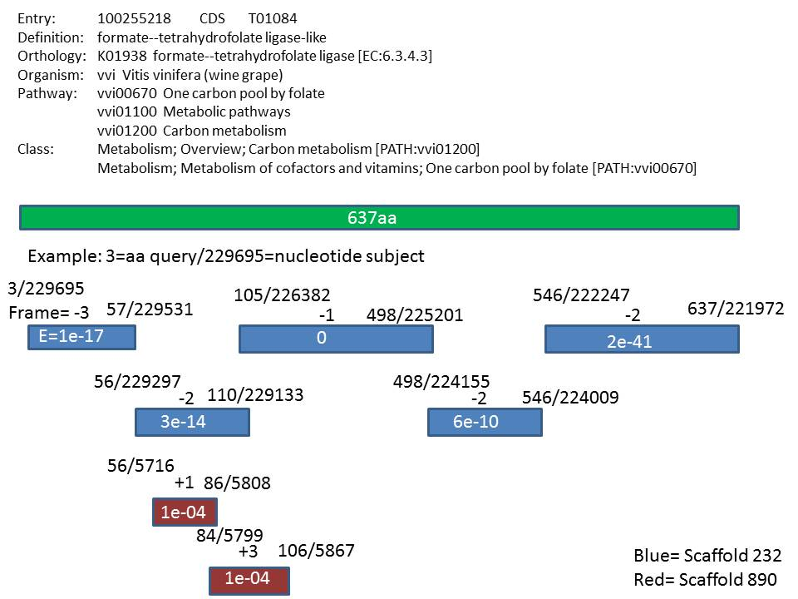
Figure 1: EC: 6.3.4.3 is a 637 amino acid sequence from Vitis vinifera and was blasted against V. corymbosum 454-scaffolds. The results are depicted above. Scaffold 232 is mapped in blue and scaffold 890 is mapped in red. The e values are shown in each box and the amino acid query values as well as the nucleotide subjects are shown above each box (i.e. 3/229695). The reading frame is also shown above each box.

