ENZYME Tutorial
The standard format in RAST is to list components of each pathway by EC number. If the enzyme with that EC number has been found in the organism, then one can click on the box and go to the page for that gene. If not, one of the easiest ways to find information about an enzyme is through ENZYME. Let’s use the H. utahensis pathway for phospholipid metabolism as our example. We are interested in the function of enzyme 1.1.1.2 . Since RAST predicts that this enzyme is not present in our organism, it doesn’t give us any further information. Thus, we will use ENZYME.
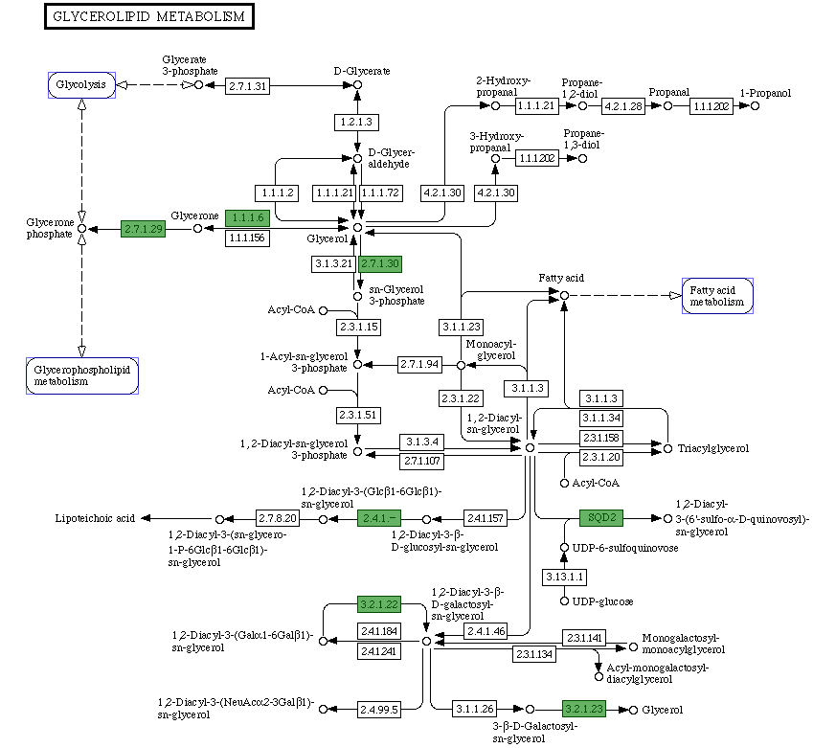
This is the front page of ENZYME website:
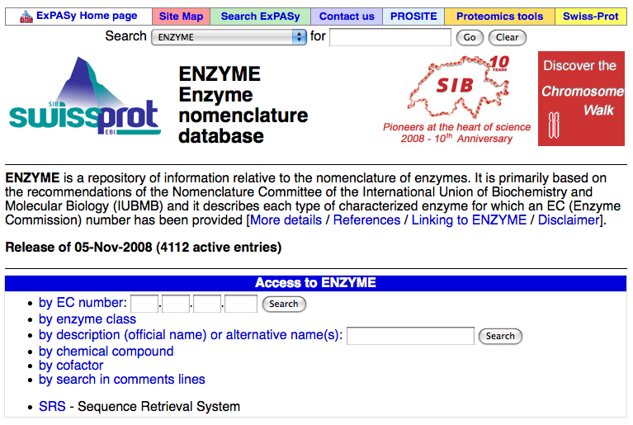
In the case described above, it is easiest to search by EC number. Simple type the EC number into the black spaces next to “by EC number.” Here, we know the complete EC number, but you can still search for enzymes even if you don’t know all of the numbers. 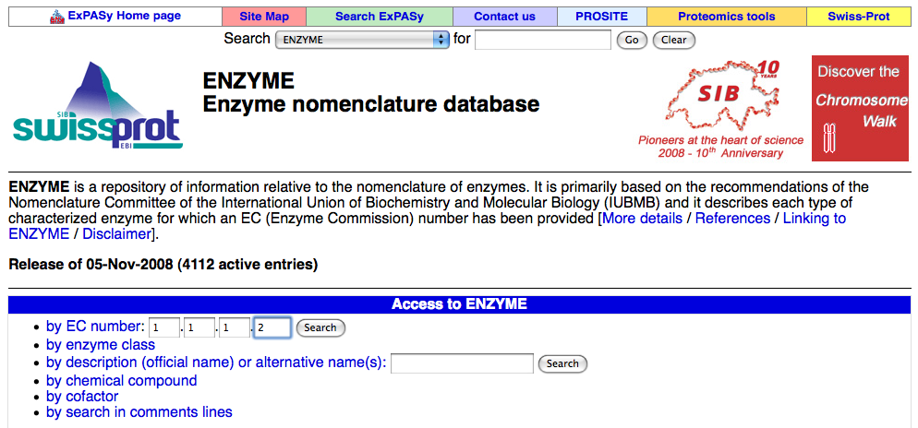

Here are the results of our search for EC number 1.1.1.2:
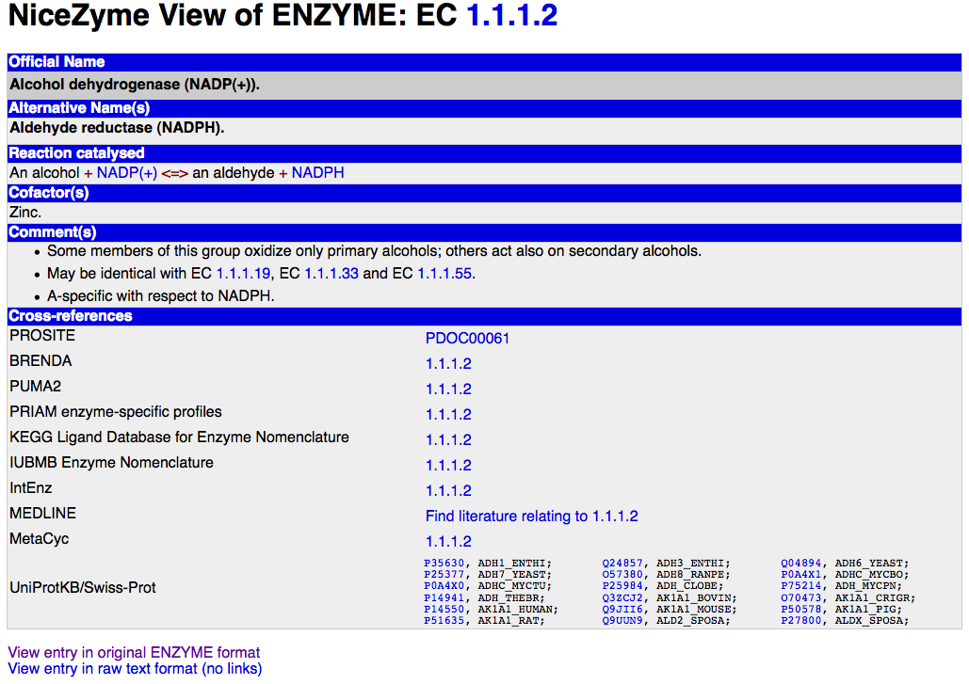
The NiceZyme format is pretty easy to use. The first row will always be the official name of the enzyme, which will be immediately followed by any alternative names. In this case, the official name for EC number 1.1.1.2 is alcohol dehydrogenase {NADP(+)}, but the enzyme is also called aldehyde reducatase (NADPH). These names can be very useful, since two databases may give the same gene two different names, but they may be equivalent.
Next, the overall reaction that the enzyme catalyzes will be given. A cofactor will be listed for enzymes that have a cofactor. Enzymes that were once called by another EC number will have the old EC number listed.
The comments section can be one of the most useful parts of the enzyme page. It provides useful information about the enzyme that may not fit into one of the traditional categories. In this example, the enzyme may be identical to three other enzymes. You would want to consider these other enzymes when speculating if the catalytic activity of this enzyme is found in your organism.
Another great feature of ENZYME is the links to other databases. The first one, PROSITE, gives a brief description of the enzyme family and lists the other enzymes found in that family.
BRENDA, the next link, is very helpful. BRENDA lists the pathways that this enzyme is involved and provides links to the KEGG pages for each. It also includes the alternative names found in the annotation of genomes of different species. In addition, it lists the known substrates the enzyme acts upon in various organisms. This information could be useful in the development of lab experiments to test the pathway annotations.
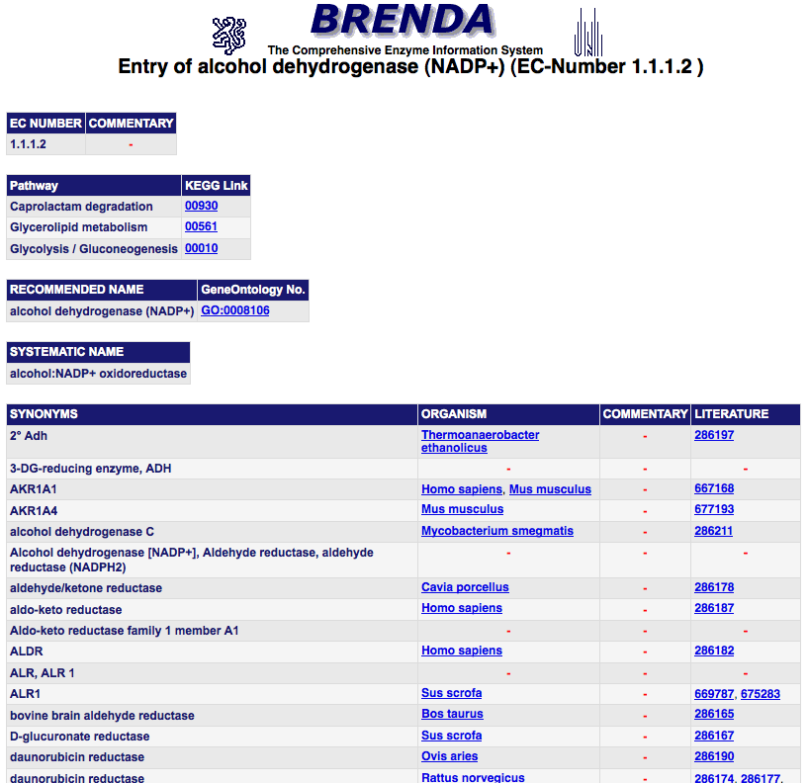
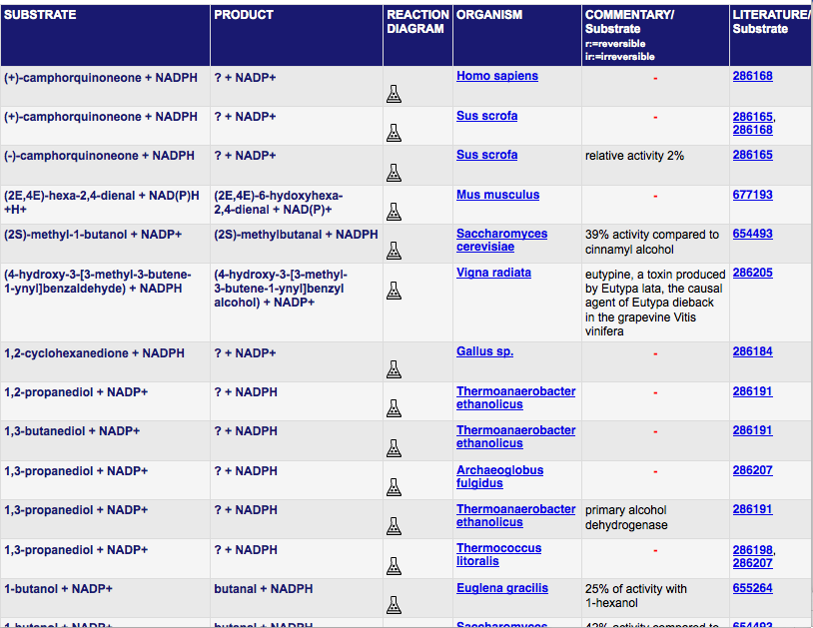
ENZYME also links to the KEGG page for the enzyme. It also links to the IUBMB enzyme nomenclature page, which provides the names of journal articles that discuss the enzyme. The link to PubMed also provides the user with relevant journal articles.
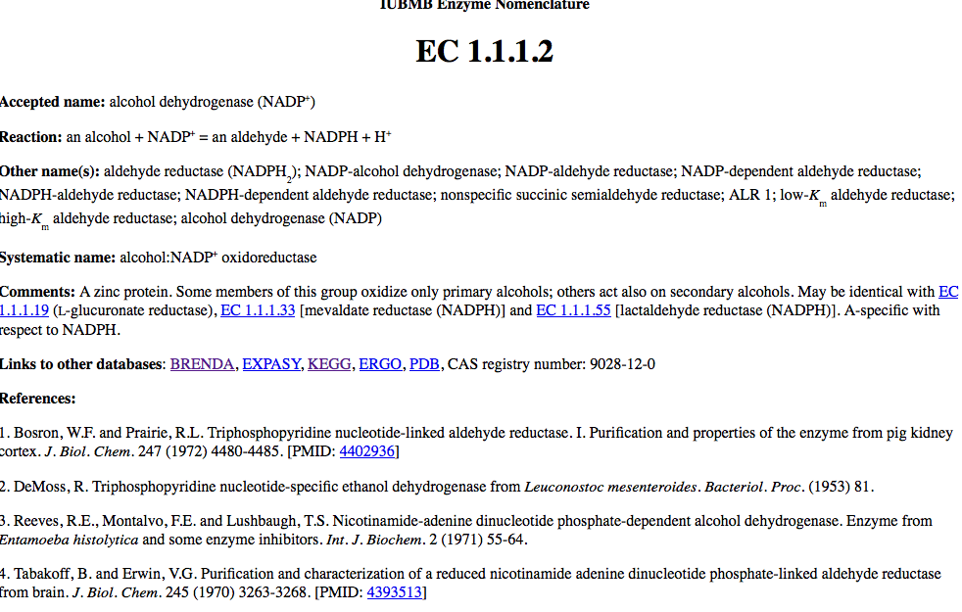
ENZYME also links to MetaCyc, which gives a simple schematic of the overall reaction the enzyme catalyzes, seen below in red. It also gives an overview of the gene-reaction schematics. The boxes on the left are genes, the circles are polypeptides and protein complexes and the boxes on the right are reactions. The line from our enzyme to the circle indicates that that enzyme codes for that protein. This polypeptide is a subunit of a two-polypeptide complex. The lines from the other genes on the right indicate that those genes also code for that polypeptide.
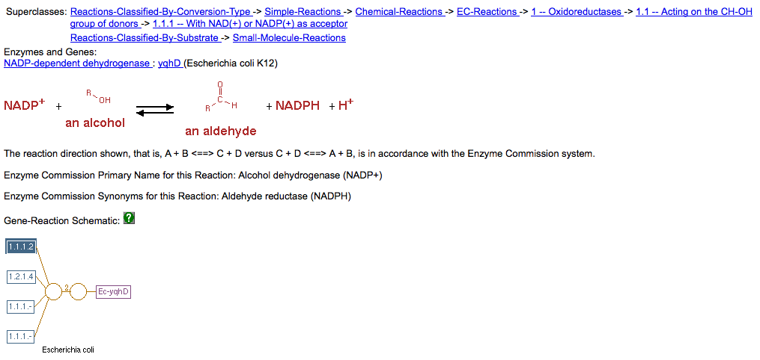
Another very useful sets of links is UniProtKB/Swiss-Prot. These links show which species have this enzyme and provide links to the amino acid sequences. One can select a sequence and then BLAST against the genome of their organisms to see if there any significant hits.

Now that we’ve looked at the links from the individual enzyme page, let’s go back to the front page. One of ENZYME’s most useful features is the ability to search by name, not just EC number.
We’ll stick to the same example. Say that RAST named one of the genes in your genome an “aldehyde reductase.” If we type “aldehyde reductase” into the box next to description, we are brought to a page that lists all enzymes whose names include the phrase aldehyde reductase. 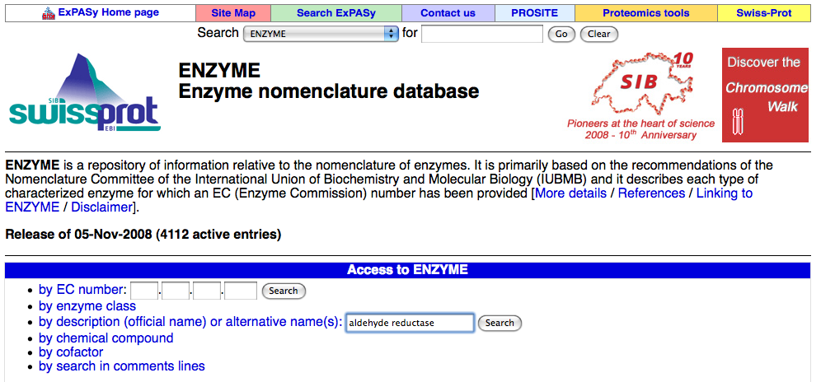
Then, we can select the one that applies based on the other information we may have, such as specific reaction catalyzed or cofactor.
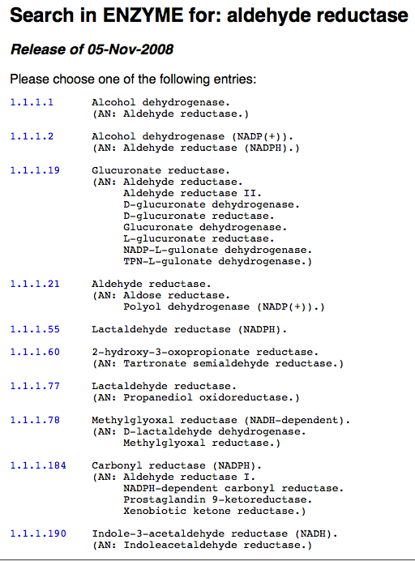

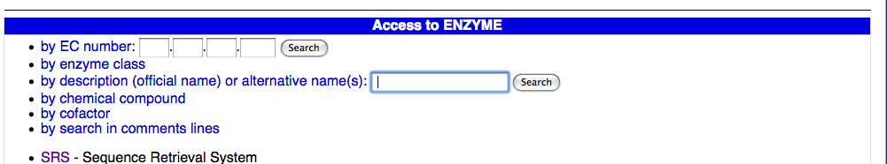
SRS, or sequence retrieval system, is another useful feature of ENZYME. When you click on the SRS link, you’re brought to the page seen below.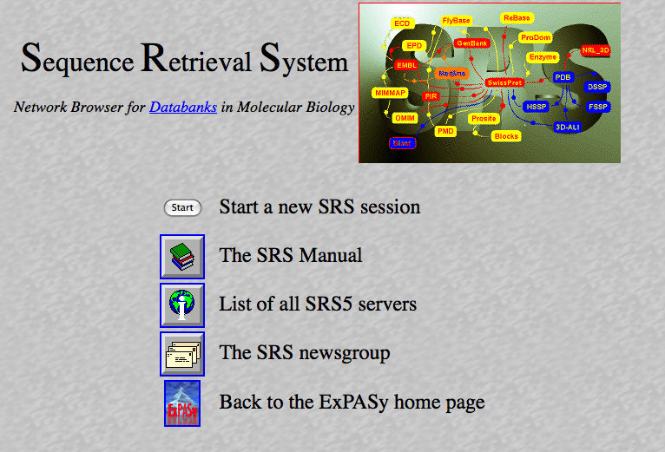
Click “start new session” and then “continue” and you reach a page with search fields. This enables you to search for a certain enzyme sequence and narrow by species name, sequence length and molecular weight, to name a few criteria. In the below example, I’ve selected alcohol dehydrogenase and Mus musculus, the common house mouse. 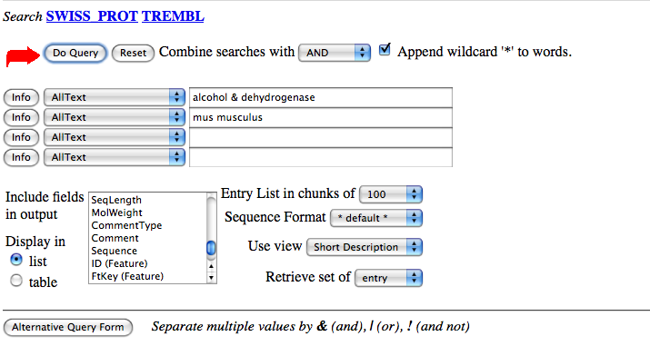
This search found 36 links to alcohol dehydrogenases in M. musculus. You can click on the links to find the amino acid sequences of the gene products and use them to BLAST against your organism’s genome.

