Genes Associated with Fruit Ripening for Blueberry (Vaccinium corymbosum)
and SSR Markers for these Genes

Genomics Laboratory Methods

Bio 343

Catherine Doyle

May 9, 2013

Abstract
Blueberry (Vaccinium corymbosum), a slightly climacteric fruit, is a principle economic crop due to high consumer demand. Recent realization of blueberries positive effects on human health, and loss of crop production has trigged a need for higher crop yield. Therefore, I sought to annotate the fruit-ripening pathway in the blueberry to produce simple sequence repeat (SSR) markers that can be tools for selective breeding to increase crop production and antioxidant benefits. To annotate the blueberry genome, I located genes in the fruit-ripening pathway and generated SSR primer pairs for laboratory verification. I successfully located and generated 3 SSR primer pairs for 42 genes in the fruit-ripening pathway for blueberry. These SSR markers will provide useful tools for selective breeding to enhance fruit production.

Introduction
Blueberry (Vaccinium corymbosum) has seen an increased consumer demand since the 1970s, increasing by more than 60% between 1990 and 2005 (Rowland et al., 2012; Vicente et al., 2007). The increase in consumer awareness of the positive effects of blueberries on human health has increased the demand and economic success of the fruit (Zifikin et al., 2012). Blueberries are high in antioxidants, anthocyanins and resveratrol, both of which are linked to anti-cancer activity, reduced ricks of cardiovascular, and neurodegenerative diseases, lower cholesterol, improved night vision, and decreased macular degeneration (Rowland et al., 2012; Vicente et al., 2007; Zifikin et al., 2012). The high consumer demand for blueberries, combined with loss of production, has resulted in a need for more rapid production of high quality fruit (Rowland et al., 2012).
Recently, blueberry cultivators have experienced challenges that have decreased crop yield such as, early warm spells, spring freezes, lack of pollinators, and early arrival of insects and diseases (García-Salazar, 2012; Rowland et al., 2012). Therefore, to increase crop yield blueberry, cultivators have turned to artificial selection, the intentional reproduction of individuals with desirable traits (Annenberg Learning, 2013). By identifying genes in regulatory pathways that control ripening, cultivators can enhance selective breeding to increase crop yield. Thus, I sought to identify and locate genes in blueberry that initiate ripening for breeding purposes.
Anthocyanins and resveratrol are tightly regulated by gene expression during the development of blueberries (Zifikin et al., 2012). Anthocyanins, vacuolar pigments, are members of the flavonoid family, a class of secondary metabolites (Wrolstad, 2001). Resveratrol is a natural phenol and phytoalexin, an antimicrobial and antioxidative chemical (Higdon, 2005). The pathway regulating blueberry ripening is connected to the pathway regulating the production of anthocyanins and resveratrol (Zifikin et al., 2012). Therefore, understanding the pathway for ripening in blueberry will provide greater insight into the production of anthocyanins and resveratrol that aid in human health. In addition, understanding blueberry ripening can provide the potential to selectively breed blueberry fruit with higher antioxidant properties.

Climacteric vs. Non-Climacteric Fruit Ripening
Ripening is associated with color change, altered sugar metabolism, softening, aroma, and an increased susceptibility to pathogen infection (Barry and Giovannoni, 2007). Blueberries develop over eight stages with the onset of fruit ripening occurring between stage 5 and stage 6 (Figure 1). The onset of fruit ripening is initiated by the absence or presence of elevated ethylene synthesis depending on the species (Barry and Giovannoni, 2007). In climacteric fruit, such as tomato and apple, the climacteric stage is a stage at the onset of ripening, which is linked to high levels of ethylene production and cellular respiration (Barry and Giovannoni, 2007). In non-climacteric fruit, such as grape and strawberry, the climacteric stage is linked to the absence of ethylene and bursts of cellular respiration (Zifikin et al., 2012). Blueberries are slightly climacteric fruit, in which the climacteric stage does not respond to a rise in ethylene production. Unlike the closely related grape and strawberry, blueberry’s climacteric stage requires moderate ethylene expression (Zifikin et al., 2012). Non-climacteric species may represent mutations in ethylene synthesis limiting their ability to respond to elevations in ethylene expression (Barry and Giovannoni, 2007). However, both climacteric and non-climacteric fruit have common regulatory mechanisms and similar active ethylene receptors. Blueberry, slightly climacteric fruit should contain orthologs from both climacteric and non-climacteric species associated with ripening. Thus, I investigated the presence of genes involved in ripening for both climacteric and non-climacteric fruit in the blueberry genome in hopes to identify genes responsible for fruit ripening (Giovannoni 2004).
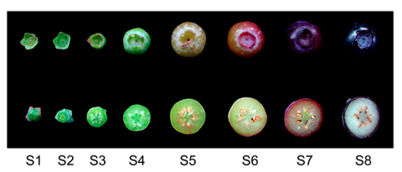

Figure 1. Developmental stages of blueberries.
Whole fruit (top row) and bisected fruit (bottom row) separated into eight stages from flowering (S1) to full maturation (S8). Onset of fruit ripening occurs between (S5) and stage (S6) when fully formed fruit’s pigmentation starts to change from green to blue (Zifikin et al., 2012).

Gene Regulation of Ethylene Biosynthesis in Climacteric Fruit
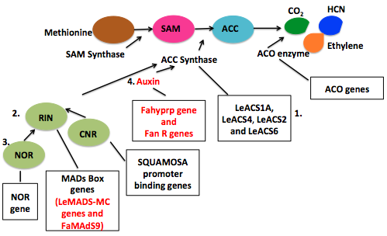
The blueberry research community considers blueberry to be climacteric fruit, which requires ethylene synthesis at the onset of ripening for normal ripening (Giovannoni, 2004). Therefore, I investigated the presence of genes in the blueberry genome that lead to ethylene synthesis. Ethylene synthesis starts with the conversion of methionine to S-adenosyl-L-methionine (SAM) catalyzed by the enzyme SAM synthase (Figure 2). The metabolite 1- aminocyclopropane-1-carboxylic acid (ACC) is formed from SAM via ACC synthase. ACC is converted into ethylene, which is catalyzed by ACC oxidase (ACO). The formation of ACC also leads to the production of the nucleoside 5-methylthioadenosine (MTA), which is recycled via the methionine cycle to yield a new molecule of methionine (Plant & Soil Sciences eLibrary, 2013).

Figure 2. Ethylene biosynthesis.
The pathway represents the conversion of the amino acid methionine to ethylene, which initiates fruit ripening in both climacteric and non-climacteric fruit. Boxes show genes of interest, which regulate ACC synthase and ACO activity for climacteric species (black) and non-climacteric species (red). Numbers indicate gene families regulating ACC synthase activity (adapted from: Plant & Soil Sciences eLibrary, 2013).
The conversion of SAM to ACC via ACC synthase is the rate-limiting step in ethylene biosynthesis. Levels of ACC synthase determine the rate of conversion and are regulated by different gene families. The four families of genes that regulate ACC synthase levels are: 1) LeACS genes; 2) RIN MAD-Box genes; 3) NOR genes; and 4) Auxin related genes. LeACS genes control the levels of ACC synthase by increasing ACC synthase expression. Acting upstream of ethylene synthesis, the ripening-inhibitor (RIN) locus and the non-ripening (NOR) locus, regulated by the colorless non-ripening (CRN) locus, play a role in determining the competency of fruit to ripen. Genes located at the RIN and NOR loci block ethylene synthesis by causing abnormal regulation of LeACS genes. Exogenous ethylene can partially restore ethylene synthesis, indicating how slightly climacteric such as, blueberry can respond to ethylene despite containing the RIN and NOR mutant (Barry and Giovanni, 2007). Furthermore, the conversion of ACC to ethylene via the ACO enzyme is regulated by the ACO gene family, which increases ACO activity (Barry and Giovanni, 2007; Figure 2).

Gene Regulation of Ethylene Biosynthesis in Non-Climacteric Fruit
In strawberries, a non-climacteric fruit, the hormone auxin increases the expression of ACC synthase and is coordinated with different genes and gene families. Fahyprp, a gene involved in anchoring polymeric polyphenols regulated by auxin, indirectly regulates ethylene synthesis (Cumpildo-Laso et al., 2012). In addition, the FAN R gene family, a family of flavonoid metabolites coordinates with auxin supporting ripening (Blanco-Portales et al., 2004; Figure 2).

Ripening Synthesis Pathway
Once ethylene is produced, it binds to the ethylene receptor (ETR) enabling constitutive triple response (CTR1) integral membrane protein located in the plasma membrane to translocate to the endoplasmic recticulum (Figure 3). In the endoplasmic reticulum, CTR1 interacts preferentially with ETR leading to the phosphorylation of MPK6 and the activation of unknown transcription factors regulated by the ethylene insensitive 2 (EIN2), ethylene insensitive 3 (EIN3) and ethylene response factor (ERF) gene families (Barry and Giovanni, 2007). In the absence of ethylene, EIN3-binding F-box 1 and 2 (EBF1 and EBF2) proteins, degrade EIN3 through ubiquitination. Through a negative feedback loop, EIN3 self-regulates by increasing the accumulation of EBF1/2. With sufficient levels of EIN3, EBF1/2 ubiquitination of EIN3 is stopped from the nucleus. EIN3 binds to a motif within the ERF1 activating the expression of ERF1/2 genes, which allows for transcription of DNA downstream for phenotypic changes associated with fruit ripening (Barry and Giovanni, 2007).
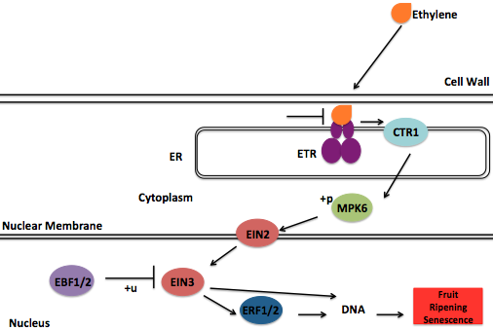

Figure 3. Ripening synthesis pathway.
Ethylene binds to the ETR receptor trigging the expression of the CTR1 gene, which leads to the phosphorylation (+p) of MPK6 and the initiation of scaffold gene interactions in the nucleus. Expression of EIN3 leads to the activation of ERF1/2, which activates transcription of DNA downstream for phenotypic changes associated with ripening. +u= ubiniquination (adapted from: Kanehisa Laboratories, 2012).

Project Design and Goals
I identified blueberry orthologs of genes from both climacteric and non-climacteric species’ fruit-ripening pathways to annotate the fruit-ripening pathway in blueberry (Figure 2, Figure 3). I investigated genes involved in ethylene biosynthesis (Figure 2) from climacteric fruit (e.g. tomato) and ethylene synthesis from both climacteric and non-climacteric (e.g. strawberry and grape; Figure 3). Coupled with the genes involved in ethylene biosynthesis and fruit ripening synthesis, I investigated various genes in non-cliamteric fruit associated with ripening. I investigated the presence of FaAAT2, involved in biosynthesis of esters that contribute to fruit flavor, FaGAST1/2 gene, which affects fruit size and ripening (Cumpildo-Laso et al., 2012), and the recently documented VvK1.2 gene in grape that mediates rapid K⁺ transport in berry cells inducing ripening (Cuellar et al., 2013). In addition to pathway research, I explored one component of the bioinformatics tool GenSAS. You also identified SSR primer pairs for as many of these as you could fine, right?

Methods

Gene and Scaffold Identification
I performed a literature search to identify genes of interest in the time of fruit of ripening pathway (Barry and Giovannoni, 2007; Giovannoni, 2004; Cumpildo-Laso et al., 2012; Manning, 1998; Kanehisa Laboratories, 2012; Blanco-Portales et al., 2004; Seymour et al., 2010; Moyano-Canete et al., 2012; Barry et al., 2000; Cuellar et al., 2013; Alexander and Grierson, 2002; Lelievre et al., 1997). I searched NCBI Entrez for the amino acid sequence for proteins of interests (National Center for Biotechnology Information, 2013). I retrieved amino acid sequences of proteins for climacteric fruit from tomato, Solanum lycopersicum, and non-climacteric fruit from grape, Vitis vinifera, and strawberry, Fragaria × ananassa. To determine if an ortholog found in tomato, grape, or strawberry was present in the blueberry genome, I ran a local NCBI tBLASTn with the amino acid sequence. To perform a local NCBI tBLASTn, I created a new database on the local drive of a Mac computer and inserted the 454 blueberry genome from Allen Brown of North Carolina State University in FASTA format (Figure 4). Through Terminal version 2.2.3 (303.2), I performed at tBLASTn using the amino acid sequence in FASTA format against the blueberry genome and saved the scaffold match with the smallest E-value. The output of bit scores from the tBLASTn, appears in descending order and for simplistic reasons I used the scaffold from the blueberry genome with the smallest E-value or most significant alignment. If the smallest E-value was greater than 1e-6, I took the scaffold match from the next smallest E-value. I repeated this step for each gene of interest by replacing the “genesequence” proportion of geneseqeunce.txt with the file name of the gene sequence being queried (Figure 4). I formatted the tBLASTn code to report BLAST results for each consecutive gene in an output text file for easier access. Using the find tool, I searched the blueberry genome database for the scaffold identified as the most significant alignment from the tBLASTn, and copied its DNA sequence into a new FASTA format text file for SSR identification (Figure 4)
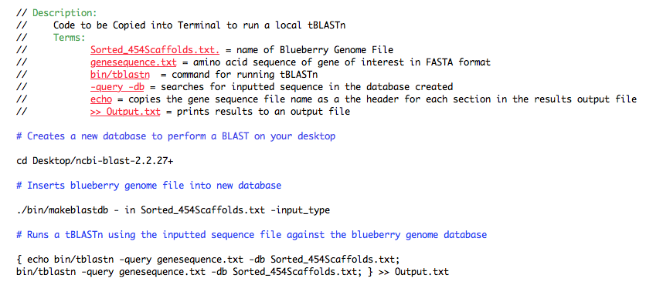

Figure 4. Code to run NCBI local tBLASTn in Terminal.
Code creates new a database on a computer to perform a tBLASTn, inserts a genome file into the database, and runs a tBLASTn against the database. Terms (red) and headers (blue) describe the code and their functions.

SSR Primer Selection
I uploaded the DNA sequence in FASTA format of identified scaffolds for genes of interests to the Genome Database for Vaccinium (Genome Database for Vaccinium, 2011) to generate SSR results. At the Genome Database for Vaccinium, under tools on the homepage, I selected SSR and created a new SSR job. I entered a FASTA file with all scaffold sequences (from 1 big scaffold to n smaller scaffolds) for genes of interest and set all motifs to 0 except Dinucleotides = 5 and Trinucelotides = 4. I specified the motif frequency of dinucleotides and trinucelotides because I want the SSR primer pairs generated to contain dinucleotides that repeat at least 5 times in the genome and trinucletoides that repeat at least 4 times. I specified the motif frequency before submitting the SSR job to increase the speed of the job and simplify primer pair selection.
From the Genome Database for Vaccinium, I received an email notification that the SSR job was complete and a link to view the results. I clicked on “view your results” and was taken to a web page where I could view the input file, an excel file containing SSR results, an output file of three primer pairs, and an output file of SSR sequences. I clicked on the Excel file containing SSRs, the repeat numbers, genomic location, and motif frequency, coupled with primer pairs. From the SSR results, I selected primer pairs that blueberry experts will use as tools to experimentally validate the location of genes of interest. I selected proposed primers from SSR results based off the following guidelines: 1) SSRs of di or tri nucleotide repeats; 2) SSRs with repeats greater than five; 3) total fragment length between 100bp-700bp; and 4) proximity to gene of interest’s location on the scaffold (Appendix A).

GenSaS Transcript BLAST
On the GENome Sequence Annotation Server (GenSAS, 2013), I copied the DNA sequence of scaffold00111 in FASTA format into the sequence information box (Figure 5).

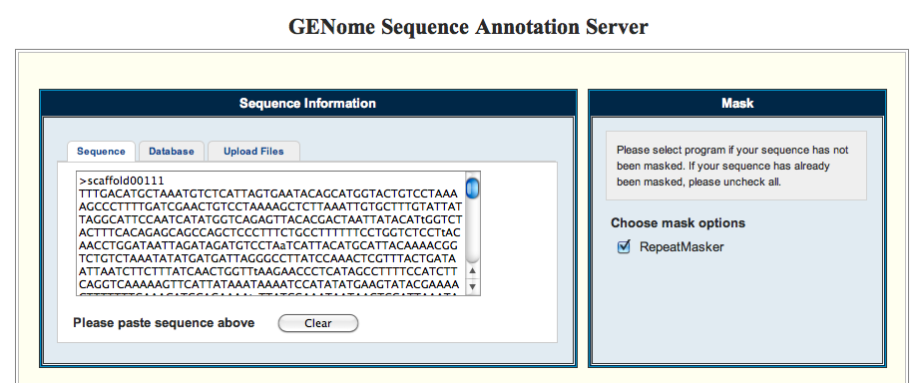

Figure 5. Visual representation of scaffold0011 copied into sequence information box.
I selected the plus sign for the “Transcript BLAST” option and created a task (Figure 6A). Under create task I named the task for later identification (Figure 6B).

B)
A)
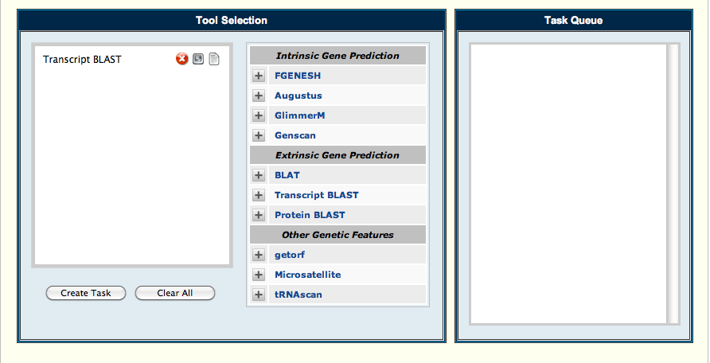
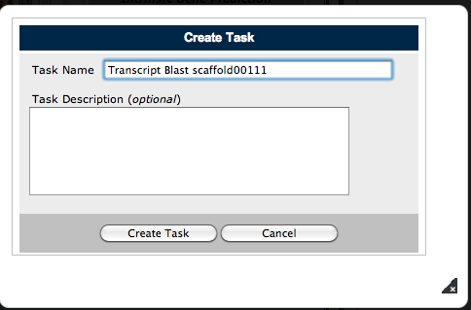

Figure 6. Tool selection and task creation for Scaffold00111.
- Visual representation of how to select a tool for a query. B) Visual representation of how to create a task.

To submit the transcript BLAST task, I selected the feather changing the color from red to blue (Figure 7).
B)

A)

Figure 7. Submission of transcript BLAST task.
A) Representation of Task Queue before submission with red feather. B) Representation of Task Queue after submission with blue feather. Arrow points to i button selected to view results.

Results

Identification of SSR primer pairs near genes of interest
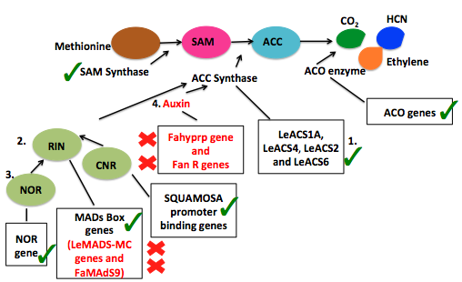
I successfully found and generated three SSR primer pairs (Appendix A) for 42 genes out of the 70 genes (Appendix A; Figure 8; Figure 9) I identified in literature (Appendix B; Appendix C). I was unable to find the amino acid sequence for proteins regulating the expression of the hormone auxin and FaGAST1, a gene involved in non-climacteric ripening. The tBLASTn for FaMADS9 and LEACS4 produced zero hits. SSR results failed for genes AT5G1883 and TCTR1 located at the CRN locus, and for SAM synthase due to the length of scaffold (Appendix C).

Figure 8. Genes successfully identified in ethylene biosynthesis.
The figure shows genes from climacteric (black) and non-climacteric (red) species involved in regulating ethylene biosynthesis leading to fruit ripening. Green check marks identify genes or gene families successfully located in ethylene biosynthesis. Red X’s identify genes and gene families unsuccessfully located in the ethylene biosynthesis pathway. Numbers indicate gene families regulating ACC Synthase activity (adapted from: Plant & Soil Sciences eLibrary, 2013).
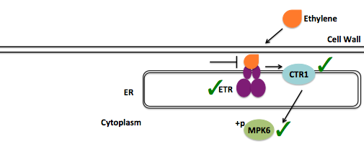

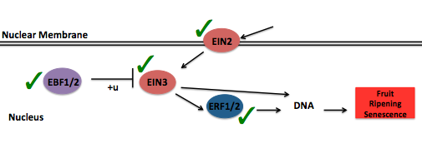

Figure 9. Genes successfully identified in ripening synthesis pathway.
The figure shows genes from climacteric and non-climacteric species in ethylene synthesis leading to fruit ripening. Green check marks identify genes or gene families successfully located in ethylene biosynthesis (adapted from Plant & Soil Sciences eLibrary, 2013).

GenSAS Transcript BLAST
The GenSAS transcript BLAST for scaffold0011 failed (Figure 10A-B). To view the print out failed results, I went back to the task queue on the GenSAS server and selected the i button to view the failed results (Figure 10B). Neither the output box nor the email notification provided identification of the error or why the task failed (Figure 10A-B). GenSAS’s site manager suggested that the file for scaffold00111 was not selected, and to try selecting the FASTA file from my sequence database of uploaded sequences when creating a task inside the transcript BLAST tool (Ficklin, 2013). I re-ran the transcript BLAST for scaffold0011 following the site manager’s directions. I found that the select FASTA file button was absent on the GenSAS server, prohibiting successfully completion of the task (GenSAS, 2013).

A)

B)

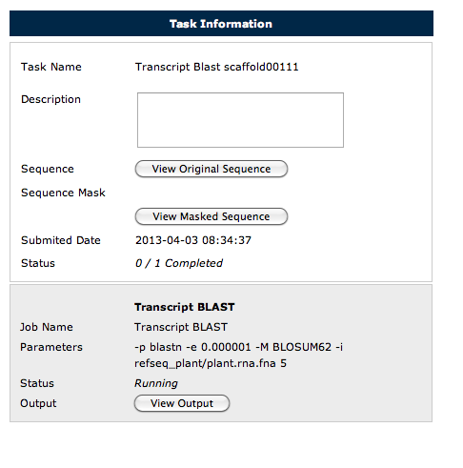

Figure 10. Transcript BLAST failed results.
A) Email report indicating failed task. B) Representation of failed task results from task output box. Black arrows indicate button selected to view output.

Discussion
With an increase in consumer demand due to the positive effects of blueberries on human health, combined with loss of production, has resulted in a need for quicker production of high quality fruit. I sought to find genes in the fruit-ripening pathway in the blueberry to produce SSR markers that will be beneficial tools for selective breeding to increase crop production and antioxidant benefits. I located genes in the fruit ripening pathway and generated SSR primer pairs for laboratory verification. I successfully located and generated 3 SSR primer pairs for 42 genes in the fruit-ripening pathway for blueberry. These SSR markers will provide useful tools for selective breeding to enhance fruit production.
I found a high prevalence of genes associated with cliamteric ripening in ethylene biosynthesis suggesting that the mechanisms initiating fruit ripening in blueberry are more closely related to climacteric ripening, as blueberry experts speculated. I failed to locate the orthologs from non-climacteric species in ethylene biosynthesis that regulate the levels of ethylene synthesis. [This is a big deal. Perhaps you could comment on the implications of your search. Which do you think best describes blueberry??] I was able to locate all the orthologs present in non-climacteric and climacteric species for the ripening synthesis pathway (Figure 9). Therefore, it is likely that the difference between climacteric and non-climacteric ripening occurs in ethylene biosynthesis, at the RIN, CRN and NOR locus (Barry and Giovanni, 2007).
Further research should investigate and identify genes at the NOR locus, which influence the ripening of non-climacteric and slightly climacteric fruit. Through literature searches, I was unable to identify any known genes at the NOR locus. However, through the NCBI Entrez database (National Center for Biotechnology Information, 2013), I was able to find one gene at the NOR locus from Arabidopsis thaliana. The NOR locus is of great interest because its interaction with the RIN and CRN locus might explain why some fruit like strawberry appear insensitive to ethylene, or why blueberry is slightly climacteric. Understanding the protein-protein interactions at the NOR locus is crucial for providing the missing link between climacteric and non-climacteric species, and will be important for future work in selective breading. Therefore, further research should investigate what genes are located at the NOR locus for a more annotated genome such as, Arabidopsis thaliana in hopes to map out protein-protein interactions, and find orthologs in blueberry and other species.
Blueberry breeders can use SSR primer pairs to identify alleles for numerous genes that can increase crop production, and antioxidant properties for cross breeding. There are over 200 varieties of blueberry species with a variety of characterized traits. It is assumed that alleles that convey phenotypes of interest are linked to SSR variations. Therefore, experts can test the SSR markers I generated with known phenotypic varieties of blueberries. Using the PCR primers, experts can test the DNA of the different varieties to ensure the SSRs amplified by the PCR primers are polymorphic DNA markers. As a result, breeders can screen new seedlings with SSR primers to track alleles linked to SSR polymorphism or traits of interest. Thus, SSR primers can be used to select for alleles associated with ripening. This method accelerates traditional breeding methods, increased efficiency, and allows breeders put resources into desired phenotypes. In summary, under further investigation the fruit-ripening pathway can be fully annotated in blueberry, providing the ability to selectively breed for a faster yielding crop with more abundant antioxidant benefits.

References
Alexander Lucille and Grierson Don. 2002. Ethylene biosynthesis and action in tomato: a model for climacteric fruit ripening. Journal of Experimental Botany. Vol. 53: 2039-2055.
Annenberg Learning. Life Science Session 5; Artificial Selection at Work. [Internet} Available from: http://www.learner.org/courses/essential/life/session5/closer1.html. Accessed 29 April 2013.
Blanco-Portales Rosario et al. 2004. Plant Molecular Biology. Vol. 55: 763-780.
Barry Cornelius S. and Giovannoni James J. 2007. Ethylene and Fruit Ripening. J Plant Growth Regul. Vol. 26: 143-159.
Cuellar Teresa et al. 2013. Potassium transport in developing fleshy fruits: the inward K⁺ channel VvK1.2 is activated by CIPK-CBL complexes and induced in ripening berry flesh cells. The Plant Journal. 73: 1006-1018.
Cumpildo-Laso Guadalupe et al. 2012. The fruit ripening-related gene FaAAT2 encodes an acyl transferase involved in strawberry aroma biogenesis. Journal of Experimental Botany. Vol. 63:4275-4290.
Carcia-Salazar Carlos. 2012. [Internet]. Climate change impacts Michigan blueberry industry. Michigan State University Extension. Available from; http://msue.anr.msu.edu/news/climate_change_impacts_michigan_blueberry_industry. Accessed 2 May 2013.
Genome Database for Vaccinium. 2011. [Internet]. Plants for Human Health Institute, North Carolina State University and Washington State University. Available from: http://www.vaccinium.org/About. Accessed 13 March 2013.
GenSAS. 2013. [Internet]. Washington State University. Available from: http://gensas.bioinfo.wsu.edu/home. Accessed 13 March 2013.
Giovannoni James J. 2004. Genetic Regulation of Fruit Development and Ripening. The Plant Cell. Vol. 16: S170-S180.
Higdon Jane. 2005. Resveratrol. [Internet]. Available from: http://lpi.oregonstate.edu/infocenter/phytochemicals/resveratrol/. Accessed 29 April 2013.
Kanehisa Laboratories. 2012. KEGG Plant hormone signal transduction - Vitis vinifera (wine grape). [Internet]. Available from: http://www.genome.jp/kegg-bin/show_pathway?org_name=vvi&mapno=04075&mapscale=&show_description=hide. Accessed 29 April 2013.
Lelievre Jean-Marc et al. 1997. Ethylene and Fruit Ripening. Physiologia Plantarum. Vol. 101: 727-739.
Manning Kenneth. 1998. Isolation of a set of ripening-related genes from strawberry: their identification and possible relationship to fruit quality traits. Planta Vol. 205: 622-631.
Moyano-Canete Enriqueta et al. 2012. FaGAST2, A Strawberry Ripening-Related Gene, Acts Together With FaGAST1 To Determine Cell Size Of Fruit Receptacle. http://pcp.oxfordjournals.org/.
National Center for Biotechnology Information [database online]. National Library of Medicine. Available from: http://www.ncbi.nlm.nih.gov/. Accessed 2 May 2013.
Plant & Soil Sciences eLibrary. Ethylene Induction. [Internet]. Available from: http://passel.unl.edu/pages/informationmodule.php?idinformationmodule=998688536&topicorder=7&maxto=11. Accessed 29 April 2013.
Rowland Lisa J. et al. 2012. Generating Genomic Tools for Blueberry Improvement. Standard Research and Extension Project, Renewal Application. http://www.bio.davidson.edu/courses/bio343/2012/Renewal8.pdf.
Seymour Graham B. et al. 2011. A SEPALLATA gene is involved in the development and ripening of strawberry (FragariaXananassa Duch.)fruit, a non-climacteric tissue. Journal of Experimental Botany. Vol. 62: 1179-1188.
Stephen Ficklin. 2013. Personal Communication.
Vicente Ariel R. et al. 2007. Temporal Sequence of Cell Wall Disassembly Events in Developing Fruits. 2. Analysis of Blueberry (Vaccinium Species). J. Agric. Food Chem. Vol. 55: 4125-4130.
Wrolstad Ronald. 2001. The Possible Health Benefits of Anthocyanin Pigments and Polyphenolics. [Internet]. Available from: http://lpi.oregonstate.edu/ss01/anthocyanin.html. Accessed 29 April 2013.
Zifkin Michael et al. 2011. Gene Expression and Metabolite Profiling of Developing Highbush Blueberry Fruit Indicates Transcriptional Regulation of Flavonoid Metabolism and Activation of Abscisic Acid Metabolism. Plant Physiology. Vol. 158: 200-224.

Acknowledgements
I like to thank Dr. Allan Brown (North Carolina State University), Jeannie Rowland (United States Department of Agriculture) and Doreen Main (Washington State University) for their support and advice. I would like to all the individuals in Laboratory Methods in Genomics, especially Austin Mudd, Erich Baker, Daniel Tuerff, Spencer Chadinha, Mark Angel, Tim Keating, Stewart Dalton, and our professor, Dr. A. Malcolm Campbell (Davidson College).

Appendix A
SSR Primers:
AGL3 Found in Scaffold 009988 (query sequence starts a base 71232 on scaffold)
1)
For Primer TCGTACCAGCACTCTCTCTCTC
Rev Primer ACTATTTCCATCTGAATCGCAC
Repeats (ag) X 29 PCR product = 179bp & start at base 76819
2)
For Primer CTCCCTAATCATGACAAGGACC
Rev Primer GGCTGATTGATGAGGAAGAAAT
Repeats (ag) X 10 PCR product = 277 bp & start at base 38614
3)
For Primer TATTGATAAAGGTGGGGCTCTC
Rev Primer GCTTCCATCTCCTTCTGCTAAA
Repeats (ag) X 9 PCR product = 285 bp & start at base 61113

AP1 Found in Scaffold 01303 (query sequence starts a base 77931 on scaffold)
1)
For Primer CTTGTTAGCGACAGTCAGGTTG
Rev Primer ACCTCCGGATCTCTCTCTCTCT
Repeats (ga) X 34 PCR product = 264bp & start at base 27759
2)
For Primer AGTTCATACCACACAAGCATGG
Rev Primer CCGGACCGTGAGATTTTTATTA
Repeats (tg) X 11 PCR product = 216 bp & start at base 82028
3)
For Primer CCCCATTCTCTCTCCTTTCTTT
Rev Primer TGAGCCAACAATACCAATTCAG
Repeats (ct) X 11 PCR product = 252 bp & start at base 78108

AT5G5057 Found in Scaffold 01509 (query sequence starts a base 40221 on scaffold)
1)
For Primer GTACGTACTCCGTTTCCGTTTC
Rev Primer CACAGTCACCTTTGAATAGGCA
Repeats (ct) X 24 PCR product = 220 bp & start at base 59025
2)
For Primer GGTAGTTGTGGGAGATCAAAGC
Rev Primer CTTCCACATTTAGCCCTACCAC
Repeats (gga) X 10 PCR product = 178 bp & start at base 63911
3)
For Primer CCCATTTCCTAACATAACCCAA
Rev Primer TAACTGTTGATTAATGGTGCGG
Repeats (tc) X 9 PCR product = 148 bp & start at base 49436

AT1G69170 Found in Scaffold 02020 (query sequence starts a base 41726 on scaffold)
1)
For Primer AACTATGAAACGAACAAGGCCA
Rev Primer CCCATAGGAAGGAGAGGAATTT
Repeats (att) X 19 PCR product = 236 bp & start at base 20904
2)
For Primer GGCGGATACATTCAGTACATCA
Rev Primer AATTTGACCGGGAAAGGTAAGT
Repeats (ag) X 13 PCR product = 149 bp & start at base 36988
3)
For Primer CCTGTTCAAGTACCCTAGTCGG
Rev Primer ATCCCCAAATCGTATGTTTCAC
Repeats (ag) X10 PCR product = 254 bp & start at base 6421

AT2G33810 Found in Scaffold 00062 (query sequence starts a base 412489 on scaffold)
1)
For Primer TGACGAAGTACCTGGTTTGATG
Rev Primer GTTCTCCTTTTCTCTCCCGATT
Repeats (ga) X 38 PCR product = 233 bp & start at base447690
2)
For Primer AGCGGAAATTATAGGAGGGAAG
Rev Primer GGAGAGAGGAGAGAGAGACGAG
Repeats (tc) X 28 PCR product = 205 bp & start at base 423921
3)
For Primer AATACTCACACACACACACCGC
Rev Primer CAAAATTGTGGATCACTCAGGA
Repeats (ga) X 26 PCR product = 264 bp & start at base 178250

EBF1/2 Found in Scaffold 00028 (query sequence starts a base 374000 on scaffold)
1)
For Primer TGACGAAGTACCTGGTTTGATG
Rev Primer GTTCTCCTTTTCTCTCCCGATT
Repeats (ct) X 38 PCR product = 233 bp & start at base447690
2)
For Primer AGCGGAAATTATAGGAGGGAAG
Rev Primer GGAGAGAGGAGAGAGAGACGAG
Repeats (ct) X 28 PCR product = 205 bp & start at base 423921
3)
For Primer AATACTCACACACACACACCGC
Rev Primer CAAAATTGTGGATCACTCAGGA
Repeats (ct) X 26 PCR product = 264 bp & start at base 178250

EIN2 Found in scaffold02351 (query sequence starts a base 12453 on scaffold)
1)
For Primer GAGGCTCTGGATTGAGATTTTG
Rev Primer TTTCAAGAAACCACACGTTGAG
Repeats (ag) X 12 PCR product = 233 bp & start at base 4339
2)
For Primer TAAAAGAGATGGCCTTGTTCGT
Rev Primer TGATTGGAGGGAGAAATAAGGA
Repeats (tc) X 10 PCR product = 168 bp & start at base 13034
3)
For Primer CTGGGTCACGGAAAGTTTCTAC
Rev Primer GATCTAATACACGTGTGGCCTG
Repeats (tc) X 7 PCR product = 104 bp & start at base 14017

EIN3 found in Scaffold 00028 (query sequence starts at base 374164 on scaffold)

1)
For Primer GATATACGGGCATCACTTCACA
Rev Primer GATATACGGGCATCACTTCACA
Repeats (ct) 26 x PCR product = 263bp & start at base 157501

2)
For Primer GACTTCCGACAGGTGATTCTCT
Rev Primer TGAAGAACACAGCCAGATCAGT
Repeats (ct) 22 x PCR product = 156bp & start at base 160138

3)
For Primer TACCCTCTCATTTTGGAGGAAA
Rev Primer CCCAAACACTTTCCATCTCTTC
Repeats (ct) 18 x PCR product = 226bp & start at base 252005

FAAAT2 found in Scaffold 00201 (query sequence starts at base 19527 on scaffold)

1)
For Primer GAGGAGGGTCGTAACAAACAAC
Rev Primer CGCAGATTTTAGGGAGAGAGAA
Repeats (tc) 17 x PCR product = 179bp & start at base 192280

2)
For Primer AAGAAAGCACGCAAAAAGACTC
Rev Primer ATCGGAGCTCGAGTTGGTATTA
Repeats (tc) 16 x PCR product = 249bp & start at base 116458

3)
For Primer TTTGTCCTCCTTTGACAAACCT
Rev Primer GTAGCCAGTCAGTAGCCCTCAT
Repeats (ag) 16 x PCR product = 226bp & start at base 164533
FUL found in scaffold01303 (query sequence starts at base 77751 on scaffold)

1)
For Primer CTTGTTAGCGACAGTCAGGTTG
Rev Primer ACCTCCGGATCTCTCTCTCTCT
Repeats (ga) 32 x PCR product = 264bp & start at base 27759

2)
For Primer AGTTCATACCACACAAGCATGG
Rev Primer CCGGACCGTGAGATTTTTATTA
Repeats (tg) 13 x PCR product = 216bp & start at base 82028

3)
For Primer CCCCATTCTCTCTCCTTTCTTT
Rev Primer TGAGCCAACAATACCAATTCAG
Repeats (ct) 11 x PCR product = 252bp & start at base 78108

LEACO1 found in scaffold scaffold00111 (query sequence starts at base 144056 on scaffold)

1)
For Primer TCTCTCTGTGGTATCTCCACCA
Rev Primer TGTCGGATGAAGATGAAGTGAC
Repeats (ct) 16 x PCR product = 268bp & start at base 213389

2)
For Primer CCCATCCCATCACTTTCTTATT
Rev Primer ACCAGATAACTCCAGTGGCTGT
Repeats (tc) 15 x PCR product = 245bp & start at base 317973

3)
For Primer TCCATCGGAAGTTCCATAGTTC
Rev Primer TTCCCCATAATCATCTTCCTTG
Repeats (ct) 11x PCR product = 170bp & start at base 22924

LEACS1A found in scaffold scaffold01076 (query sequence starts at base 109450 on scaffold)

1)
For Primer TGATACCAGAACGTAACATCCG
Rev Primer ATCCTACCAACGCCAGAATCTA
Repeats (ct) 15 x PCR product = 227bp & start at base 40751

2)
For Primer TGGAAGACTCACTCTCTTTCCC
Rev Primer AGTAATGAATACACGCACACGC
Repeats (tg) 12 x PCR product = 171bp & start at base 63464

3)
For Primer GGAAACTCCTTGTCCTTTTGTG
Rev Primer GGAAAATCCCTTGGAAAATCTC
Repeats (ct) 11 x PCR product = 265bp & start at base 43958

LEACS2 found in scaffold scaffold01076 (query sequence starts at base 109450 on scaffold)

1)
For Primer TGATACCAGAACGTAACATCCG
Rev Primer ATCCTACCAACGCCAGAATCTA
Repeats (ct) 15 x PCR product = 227bp & start at base 40751

2)
For Primer TGGAAGACTCACTCTCTTTCCC
Rev Primer AGTAATGAATACACGCACACGC
Repeats (tg) 12 x PCR product = 171bp & start at base 63464

3)
For Primer GGAAACTCCTTGTCCTTTTGTG
Rev Primer GGAAAATCCCTTGGAAAATCTC
Repeats (ct) 11 x PCR product = 265bp & start at base 43958

LEACS6 found in scaffold scaffold00103 (query sequence starts at base 42628 on scaffold)

1)
For Primer TCGTTCCGTTACGTTACGTTTA
Rev Primer ACAATCTTTCCAGCCGACTTTA
Repeats (tc) 26 x PCR product = 299bp & start at base 229331

2)
For Primer GGGGAGGAAAGGAAGTTAAAAA
Rev Primer TCAACGTCAACAATCTTTCTGG
Repeats (ag) 13 x PCR product = 181bp & start at base 241638

3)
For Primer TGAGACTGGTGGGTGTTCATAG
Rev Primer AGAGAAGCCTCGAATAAGGACC
Repeats (ta) 13 x PCR product = 234bp & start at base 372306

LeMADs –MC found in scaffold01303 (query sequence starts at base 77751 on scaffold)

1)
For Primer CTTGTTAGCGACAGTCAGGTTG
Rev Primer ACCTCCGGATCTCTCTCTCTCT
Repeats (ga) 32 x PCR product = 264bp & start at base 27759

2)
For Primer AGTTCATACCACACAAGCATGG
Rev Primer CCGGACCGTGAGATTTTTATTA
Repeats (tg) 13 x PCR product = 216bp & start at base 82028

3)
For Primer CCCCATTCTCTCTCCTTTCTTT
Rev Primer TGAGCCAACAATACCAATTCAG
Repeats (ct) 11 x PCR product = 252bp & start at base 78108

SEP1 Found in Scaffold 00988 (query sequence starts a base 71052 on scaffold)
1)
For Primer TCGTACCAGCACTCTCTCTCTC
Rev Primer ACTATTTCCATCTGAATCGCAC
Repeats (ct) X 29 PCR product = 179bp & start at base 76819
2)
For Primer CTCCCTAATCATGACAAGGACC
Rev Primer GGCTGATTGATGAGGAAGAAAT
Repeats (ac) X 10 PCR product = 277 bp & start at base 38614
3)
For Primer TATTGATAAAGGTGGGGCTCTC
Rev Primer GCTTCCATCTCCTTCTGCTAAA
Repeats (tc) X 9 PCR product = 285 bp & start at base 61113

SEP2 Found in Scaffold 00988 (query sequence starts a base 71052 on scaffold)
1)
For Primer TCGTACCAGCACTCTCTCTCTC
Rev Primer ACTATTTCCATCTGAATCGCAC
Repeats (ag) X 29 PCR product = 179bp & start at base 76819
2)
For Primer CTCCCTAATCATGACAAGGACC
Rev Primer GGCTGATTGATGAGGAAGAAAT
Repeats (ag) X 10 PCR product = 277 bp & start at base 38614
3)
For Primer TATTGATAAAGGTGGGGCTCTC
Rev Primer GCTTCCATCTCCTTCTGCTAAA
Repeats (ag) X 9 PCR product = 285 bp & start at base 61113

SEP3 Found in Scaffold 00988 (query sequence starts a base 71052 on scaffold)
1)
For Primer TCGTACCAGCACTCTCTCTCTC
Rev Primer ACTATTTCCATCTGAATCGCAC
Repeats (ag) X 29 PCR product = 179bp & start at base 76819
2)
For Primer CTCCCTAATCATGACAAGGACC
Rev Primer GGCTGATTGATGAGGAAGAAAT
Repeats (ag) X 10 PCR product = 277 bp & start at base 38614
3)
For Primer TATTGATAAAGGTGGGGCTCTC
Rev Primer GCTTCCATCTCCTTCTGCTAAA
Repeats (ag) X 9 PCR product = 285 bp & start at base 61113

SPL1 Found in Scaffold 00161 (query sequence starts a base 208103 on scaffold)
1)
For Primer GGTGTTGTGTTTCCACCTTTCT
Rev Primer CTGACTTAATTAACCAGGAGAACGA

Repeats (tta) X 27 PCR product = 282bp & start at base 202032
2)
For Primer GGATGGTTGTCATCGGAGTATT
Rev Primer CCTAACGGACCGAACGAATTA
Repeats (ga) X 19 PCR product =294 bp & start at base 188636
3)
For Primer GTGTGTGTGTGTGTGTGTGTGT
Rev Primer CATGTTGGTTTGCGTATAGCTG
Repeats (ag) X 16 PCR product = 183bp & start at base 162129

SPL4 Found in Scaffold 00062 (query sequence starts a base 412632 on scaffold)
1)
For Primer TGACGAAGTACCTGGTTTGATG
Rev Primer GTTCTCCTTTTCTCTCCCGATT
Repeats (ag) X 38 PCR product = 233 bp & start at base447690
2)
For Primer AGCGGAAATTATAGGAGGGAAG
Rev Primer GGAGAGAGGAGAGAGAGACGAG
Repeats (ag) X 28 PCR product = 205 bp & start at base 423921
3)
For Primer AATACTCACACACACACACCGC
Rev Primer CAAAATTGTGGATCACTCAGGA
Repeats (ag) X 26 PCR product = 264 bp & start at base 178250

SPL12 Found in Scaffold 00161 (query sequence starts a base 208097 on scaffold)
1)
For Primer GGTGTTGTGTTTCCACCTTTCT
Rev Primer CTGACTTAATTAACCAGGAGAACGA

Repeats (tta) X 27 PCR product = 282bp & start at base 202032
2)
For Primer GGATGGTTGTCATCGGAGTATT
Rev Primer CCTAACGGACCGAACGAATTA
Repeats (ga) X 19 PCR product =294 bp & start at base 188636
3)
For Primer GTGTGTGTGTGTGTGTGTGTGT
Rev Primer CATGTTGGTTTGCGTATAGCTG
Repeats (ag) X 16 PCR product = 183bp & start at base 162129

TC1239TM Found in Scaffold 00988 (query sequence starts a base 71053 on scaffold)
1)
For Primer TCGTACCAGCACTCTCTCTCTC
Rev Primer ACTATTTCCATCTGAATCGCAC
Repeats (ag) X 29 PCR product = 179bp & start at base 76819
2)
For Primer CTCCCTAATCATGACAAGGACC
Rev Primer GGCTGATTGATGAGGAAGAAAT
Repeats (ag) X 10 PCR product = 277 bp & start at base 38614
3)
For Primer TATTGATAAAGGTGGGGCTCTC
Rev Primer GCTTCCATCTCCTTCTGCTAAA
Repeats (ag) X 9 PCR product = 285 bp & start at base 61113

TDR4 found in scaffold01303 (query sequence starts at base 77752 on scaffold)

1)
For Primer CTTGTTAGCGACAGTCAGGTTG
Rev Primer ACCTCCGGATCTCTCTCTCTCT
Repeats (ga) 32 x PCR product = 264bp & start at base 27759

2)
For Primer AGTTCATACCACACAAGCATGG
Rev Primer CCGGACCGTGAGATTTTTATTA
Repeats (tg) 13 x PCR product = 216bp & start at base 82028

3)
For Primer CCCCATTCTCTCTCCTTTCTTT
Rev Primer TGAGCCAACAATACCAATTCAG
Repeats (ct) 11 x PCR product = 252bp & start at base 78108

TM29TM Found in Scaffold 00988 (query sequence starts a base 71023 on scaffold)
1)
For Primer TCGTACCAGCACTCTCTCTCTC
Rev Primer ACTATTTCCATCTGAATCGCAC
Repeats (ag) X 29 PCR product = 179bp & start at base 76819
2)
For Primer CTCCCTAATCATGACAAGGACC
Rev Primer GGCTGATTGATGAGGAAGAAAT
Repeats (ag) X 10 PCR product = 277 bp & start at base 38614
3)
For Primer TATTGATAAAGGTGGGGCTCTC
Rev Primer GCTTCCATCTCCTTCTGCTAAA
Repeats (ag) X 9 PCR product = 285 bp & start at base 61113

SPl5 Found in Scaffold 00105 (query sequence starts a base 147433 on scaffold)
1)
For Primer ATCAGGATTGGAGATTTGAAGG
Rev Primer AGAAGAAGAAGAAGAATGGGGG
Repeats (ct) X 16 PCR product = 275bp & start at base 59100
2)
For Primer AAACCTTTTACTGGATTGGGTG
Rev Primer TGGGCTTGCTCTTACCTAGAAG
Repeats (ag) X 15 PCR product = 250 bp & start at base 96543
3)
For Primer GTTTTCCCCCTAATTTTTCCCT
Rev Primer AATAATTGTGCTAGTGGGTGGG
Repeats (ctt) X 13 PCR product = 167 bp & start at base 31187

SPl9 Found in Scaffold 00691 (query sequence starts a base 62061 on scaffold)
1)
For Primer CACCTTGAGATCTCTCTCTCTCTC
Rev Primer CCCAATCCACATTGAACAGAAT
Repeats (tc) X 16 PCR product = 300bp & start at base 36515
2)

For Primer GCACCATTCTTAATAACATTGCACC
Rev Primer CACGAGAGAGAGAGAGAGAGAGAGA

Repeats (tc) X 11 PCR product = 298bp & start at base 36283
3)
For Primer TGAGTTTGGGAGTGAGTTTGTG
Rev Primer CGTATCTCAATCAACGATCTGC
Repeats (ag) X 10 PCR product = 270 bp & start at base 102666

SPl0 Found in Scaffold 00127 (query sequence starts a base 165806 on scaffold)
1)
For Primer TCGAGTCAAAACTCAAAACTGG
Rev Primer CATCATCTGTGCATGTGTGTGT
Repeats (ct) X 33 PCR product = 210bp & start at base 130673
2)
For Primer CATCACAAACTCGAAAAAGCAG
Rev Primer AGAAACATCAGAACTCTTCGGC
Repeats (gt) X 19 PCR product = 282bp & start at base 291053
3)
For Primer ATCTGGAGGTCCGGATTAGAAG
Rev Primer CCTTCCTAGCAGACTCTTCGTT
Repeats (ag) X 16 PCR product = 197bp & start at base 3642

SPl1 Found in Scaffold 00127 (query sequence starts a base 165806 on scaffold)
1)
For Primer TCGAGTCAAAACTCAAAACTGG
Rev Primer CATCATCTGTGCATGTGTGTGT
Repeats (ct) X 33 PCR product = 210bp & start at base 130673
2)
For Primer CATCACAAACTCGAAAAAGCAG
Rev Primer AGAAACATCAGAACTCTTCGGC
Repeats (gt) X 19 PCR product = 282bp & start at base 291053
3)
For Primer ATCTGGAGGTCCGGATTAGAAG
Rev Primer CCTTCCTAGCAGACTCTTCGTT
Repeats (ag) X 16 PCR product = 197bp & start at base 3642

SPl4 Found in Scaffold 00426 (query sequence starts a base 73928 on scaffold)
1)
For Primer AACTTACTAGGAAAGCCCAACTTC
Rev Primer GGTTACGTTGGAAACAGAGGAG
Repeats (tta) X 16 PCR product = 299bp & start at base 171597
2)
For Primer TTACTAATCCAAGGCCTTTCCA
Rev Primer GAGCCGTTAAATAGTGCTGCTT
Repeats (ac) X 15 PCR product = 249bp & start at base 78723
3)
For Primer GGGCAATTAAACTCTCCTCCTT
Rev Primer TTTCCCATTCTCCCACAATAAC
Repeats (att) X 15 PCR product = 273bp & start at base 126454

SPl5 Found in Scaffold 00069 (query sequence starts a base 62076 on scaffold)
1)
For Primer GTGTAGATGTTGTGCGAGGGTA
Rev Primer CAACAACTCGTTATATTCCGCA
Repeats (ga) X 10 PCR product = 256bp & start at base 7631
2)
For Primer CCACCTAATCCATTCAAAAAGG
Rev Primer TACCAAATCCCTCAATCCAAAG
Repeats (ag) X 9 PCR product = 293bp & start at base 127286
3)
For Primer GCTACAAACCAAAAAGAATCGG
Rev Primer AAAAATCCTCCTTGACTGGGTT
Repeats (ac) X 8 PCR product = 259bp & start at base 45233

TAG1 Found in Scaffold 01387 (query sequence starts a base 90185 on scaffold)
1)
For Primer TAATCCCTCCCACACACCTAAC
Rev Primer AGGCTAAAGAGGGAAATCATCC
Repeats (ga) X 9 PCR product = 239bp & start at base 88925
2)
For Primer TTTAGATGGGAGCAAACCCTAA
Rev Primer GAAATCGTAGGTGGAAGCAAAC
Repeats (ga) X 8 PCR product = 261bp & start at base 65152
3)
For Primer GACAGCCTAGTGGGTTGATTTT
Rev Primer ATTGGTTTGCAGTTGTCATACG
Repeats (ct) X 8 PCR product = 152bp & start at base 95753

TDR6 Found in Scaffold 00052 (query sequence starts a base 343270 on scaffold)
1)
For Primer ATTAACCTCTTCAATCCACCGA
Rev Primer CTTGATGCTCTTCTATTGCGTG
Repeats (ag) X 28 PCR product = 272bp & start at base 309882
2)
For Primer AACATGGACAACAGTACCTCCC
Rev Primer ACGTATGCAGCATCCATAACAG
Repeats (ga) X 22 PCR product = 292bp & start at base 301776
3)
For Primer TGATCACCAACTCCAACCATTA
Rev Primer ATATTGACATGTCTGCACCAGC
Repeats (tc) X 20 PCR product = 282bp & start at base 205843

ERF1/2 Found in Scaffold 00150 (query sequence starts a base 39508 on scaffold)
1)
For Primer AGGGGGAGAAAAGAGAGAGAGA
Rev Primer GAAAGGTAACTTCCGTACACGC
Repeats (ag) X 19 PCR product = 134bp & start at base 179949
2)
For Primer CCAATTGATGCTGTTGTGAAGT
Rev Primer TTCCGTACACGCCTTATTCTCT
Repeats (ag) X 15 PCR product = 235bp & start at base 179892
3)
For Primer ATAAGTGCATGATGCTGTCCAC
Rev Primer GAGGAGGAGGAGGAGGTATTGT
Repeats (ct) X 15 PCR product = 282bp & start at base 197690

ERF Found in Scaffold 00111 (query sequence starts a base 144127 on scaffold)
1)
For Primer ATTAACCTCTTCAATCCACCGA
Rev Primer CTTGATGCTCTTCTATTGCGTG
Repeats (ct) X 28 PCR product = 272bp & start at base 309882
2)
For Primer AACATGGACAACAGTACCTCCC
Rev Primer ACGTATGCAGCATCCATAACAG
Repeats (tc) X 22 PCR product = 292bp & start at base 301776
3)
For Primer TGATCACCAACTCCAACCATTA
Rev Primer TTCCCCATAATCATCTTCCTTG
Repeats (ct) 11x PCR product = 170bp & start at base 22924

TC117868 Found in Scaffold 04072 (query sequence starts a base 5255 on scaffold)
1)
For Primer ATTAACCTCTTCAATCCACCGA

Rev Primer CTTGATGCTCTTCTATTGCGTG
Repeats (ag) X 28 PCR product = 272bp & start at base 309882
2)
For Primer AACATGGACAACAGTACCTCCC
Rev Primer ACGTATGCAGCATCCATAACAG
Repeats (ag) X 22 PCR product = 292bp & start at base 301776
3)
For Primer TGATCACCAACTCCAACCATTA

CRN Found in Scaffold 00062 (query sequence starts a base 414214 on scaffold)
1)
For Primer TGACGAAGTACCTGGTTTGATG
Rev Primer GTTCTCCTTTTCTCTCCCGATT
Repeats (ga) X 38 PCR product = 233 bp & start at base447690
2)
For Primer AGCGGAAATTATAGGAGGGAAG
Rev Primer GGAGAGAGGAGAGAGAGACGAG
Repeats (tc) X 28 PCR product = 205 bp & start at base 423921
3)
For Primer AATACTCACACACACACACCGC
Rev Primer CAAAATTGTGGATCACTCAGGA
Repeats (ga) X 26 PCR product = 264 bp & start at base 178250

E4 Found in Scaffold 00780 (query sequence starts a base 83439 on scaffold)
1)
For Primer GTGTTCTAGACACATCGAACGC
Rev Primer CGAAGGTATAATTCTCGCATCC
Repeats (ag) X 12 PCR product = 155bp & start at base 62665
2)
For Primer TAGGGTTCCATGTTCGAAAGTT
Rev Primer CATCATCACGGGTAGAGAAATG
Repeats (taa) X 10 PCR product = 189bp & start at base 85987
3)

For Primer GGAAGGGAGGATAGCTATATTAGTC
Rev Primer CTGTTTATCCGACCACTGTTCA
Repeats (ag) X 9 PCR product = 229bp & start at base 96779

ETR1grape Found in Scaffold 00112 (query sequence starts a base 123470 on scaffold)
1)
For Primer ACATGCACATAGTTGGAAATCG
Rev Primer GCAGCAGCTCTCTCTCTCTCTC
Repeats (ga) X 35 PCR product = 287bp & start at base 111935
2)
For Primer GTGTGTGTGTGTGTGTGTGTGA
Rev Primer GAAACTTCAGGGGTTTATGTGC
Repeats (ga) X 21 PCR product = 292bp & start at base 112056
3)
For Primer ATGGCTTTGAACATCTCCACTT
Rev Primer AGGGGTTGTTCCAGTGCTATTA
Repeats (aat) X 16 PCR product = 284bp & start at base 16231

MPK6 Found in Scaffold 01009 (query sequence starts a base 73020 on scaffold)
1)
For Primer TGACGCACATGTTTCTATGACA
Rev Primer TCATCCATGACGATGCTAAAAC
Repeats (tg) X 14 PCR product = 160bp & start at base 92213
2)
For Primer CCGATCATGACTGTGTAAGCAT
Rev Primer GTAACGGACTCCCCCTATTTCT
Repeats (ga) X 12 PCR product = 268bp & start at base 92213
3)
For Primer TCACCTTTGTCCTTTCCTTTGT
Rev Primer TAACATACATGGAAACCCCCTC
Repeats (tc) X 12 PCR product = 203bp & start at base 107471

VcK1.2 Found in Scaffold 01458 (query sequence starts a base 64941 on scaffold)
1)
For Primer ATACACTGTCACACACGCACAC
Rev Primer AGCACGAACACTCCTAGAGGTC
Repeats (ag) X 14 PCR product = 295bp & start at base 31982
2)
For Primer TACCAAAGTAGAAGATGGCGGT
Rev Primer CCCCAACTCTTAACAATTTCCA
Repeats (ga) X 11 PCR product = 214bp & start at base 10222
3)
For Primer AATCCCTACGCATACGTGAACT
Rev Primer GCTGCAATCTCTTTCATCTCCT
Repeats (tc) X 11 PCR product = 218bp & start at base 34434

Appendix B
Table 1. Gene ID and Gen Bank Accession Numbers for genes identified in time of fruit ripening pathway.
Gene Name | Gene ID | Gen Bank
AGL3 | 32402422 | AAN52793.1
AP1 | 16162 | CAA78909.1
AT1G69170 | 110735912 | BAE99931.1
AT2G33810 | 2462081 | CAA70578.1
AT5G18830 | 13605912 | AAK32941.1
AT5G50570 | 26450038 | BAC42139.1
CRN | 111183167 | ABH07904.1
E4 | 2342860 | AAB67671.1
EBF1/2 | 20259113 | AAM14272.1
ETR1 | 7547007 | AAF63755.1
EFR | 23297272 | AAN12929.1
EIN2 | 5231113 | AAD41076.1
EIN3 | 225463677 | XP_002276047.1
ERF1/2 | 225458331 | XP_002283027.1
FaAAT2 | 343478089 | JN089766.1
FUL | 30526323 | AAP32475.1
LEACO1 | 350539815 | NP_001234024.1
LEACS1A | 1621641 | AAB17278.1
LEACS6 | 17980218 | AAL50559.1
LeMADS-MC | 20219014 | AAM15774.1
MPK6 | 31711876 | AAP68294.1
NOR | 8809647 | BAA97198.1
SAM Synthase | 23308349 | AAN18144.1
SEP1 | 26452239 | BAC43207.1
SEP2 | 57222144 | AAW38979.1
SEP3 | 194579025 | ACF75546.1
SPL1 | 5931655 | CAB56581.1
SPL2 | 5931649 | CAB56578.1
SPL4 | 5931659 | CAB56583.1
SPL5 | 5931631 | CAB56572.1
SPL8 | 839275 | CAB56594.1
SPL9 | 5931673 | CAB56590.1
SPL10 | 839626 | CAB56589.1
SPL11 | 5931667 | CAB56587.1
SPL12 | 6006395 | CAB56768.1
SPL14 | 67461574 | Q8RY95.3
SPL15 | 21592501 | AAM64451.1
TAG1 | 31442863 | AAP35239.1
TM29 | 350534930 | NP_001233911.1
TC117868 | 22329903 | NP_174527.2
TCTR1 | 544127 | AAD10056.1
TDR4 | 19382 | CAA43169.1
TDR6 | 19386 | CAA43171.1
TM29 | 17432174 | CAC83066.1
VcK1.2 | 31091374 | CBW30482.1

Appendix C

Table 2. Scaffold location of genes identified in time of fruit ripening pathway.
Gene Name | Scaffold | Primer Pair Number
AGL3 | 988 | 3
AP1 | 1303 | 3
AT1G50570 | 1509 | 3
AT1G69170 | 2020 | 3
AT5G18830 | 883 | 0
ATG2G33810 | 62 | 3
CRN | 62 | 3
E4 | 788 | 3
EBF1/2 | 218 | 3
EIN2 | 2031 | 3
EIN3 | 28 | 3
ERF1/2 | 1616 | 3
ERF | 111 | 3
ETR1 | 112 | 3
FAAAT2 | 201 | 3
FaMADS9 | 988 | 3
FUL | 1303 | 3
LEACO1 | 11 | 3
LEACS1A | 1076 | 3
LEACS2 | 1076 | 3
LEACS6 | 103 | 3
LeMADS-MC | 1303 | 3
MPK6 | 1009 | 3
NOR | 23 | 3
SAM Synthase | 6424 | 0
SEP1 | 988 | 3
SEP2 | 988 | 3
SEP3 | 988 | 3
SPL1 | 161 | 3
SPL2 | 127 | 3
SPl4 | 62 | 3
SPL5 | 105 | 3
SPL8 | 490 | 3
SPL9 | 691 | 3
SPL10 | 127 | 3
SPL11 | 127 | 3
SPL12 | 161 | 3
SPL14 | 426 | 3
SPL15 | 696 | 3
TAG1 | 1387 | 3
TCTR1 | 9016 | 0
TM29 | 988 | 3
TC117868 | 49 | 3
TDR4 | 1303 | 3
TDR6 | 52 | 3
TM29 | 988 | 3
VcK1.2 | 1458 | 3

