Brittany Elek and Thomas Pederson
Laboratory Methods in Genomics
Dr. Campbell
May 8, 2014

Investigation of Broccoli Quantitative
Trait Loci Genes Associated with Boron

Abstract

Broccoli, or Brassica oleracea, has many health benefits for humans, as it contains dozens of vitamins and minerals that are important for our bodies (“Broccoli,” 2014). It is important to maintain healthy broccoli so that people can benefit from its nutrients. However, there are boron deficiencies in many countries around the world, including the main producer of broccoli, China (Kato, 2009; “International,” 2012). Boron is an essential nutrient for plants and without it, fruit quality and sets are impaired (Miwa et al., 2010). In this study, we found possible genes associated with boron uptake and storage that could be associated with five given quantitative trait loci (QTLs) in broccoli located on chromosomes 3, 4, 6, 8, and 9. I then identified simple sequence repeats (SSRs) in the Brassica oleracea genome near the candidate genes. Overall, I was able to find 7 candidate genes (NIP3;1 on chromosomes 6 and 8, and PIP2;3 on chromosomes 3, 4, 6, 8, and 9) for the 5 given QTLs and 21 SSRs primer pairs.

Introduction

Brassica oleracea, or broccoli, is a commonly consumed vegetable worldwide. Broccoli, which is rich in many vitamins and minerals, such as vitamin C and vitamin K, is an important source of food for many animals. Furthermore, broccoli has many health benefits for humans, including anti-cancer properties, such as reducing chronic inflammation, oxidative stress, and inadequate detoxification (“Broccoli,” 2014). Although broccoli contains many fundamental vitamins and minerals, these nutrients are unable to benefit humans if there are problems with broccoli production. One major threat to broccoli production around the world is boron deficiency (Kato, 2009). Many regions of the world, such as China and the United States, have limited availability of boron in the soil (Tanaka and Fujiwara, 2008). Furthermore, China and the United States produce almost 63% of the 28,000,000 tons of harvested broccoli each year (“International,” 2012). Therefore it is pertinent for us to maintain healthy broccoli in these areas and understand the ways in which boron affects plants such as broccoli.
Boron deficiency is a problem in many areas across the world, having been reported in at least 80 countries (Kasajima, 2010). Much of the reason for boron deficiency is that 98% of boron is present in the soil as a highly soluble, uncharged molecule boric acid (H₃BO₃; Tanaka et al., 2008). In areas of high rainfall, such as Japan, China, United States, and Brazil, boric acid is easily leached out of the soil, leading to its deficiency (Tanaka and Fujiwara, 2008). The only known function of boron in plants is the cross-linking of pectic polysaccharide rhamnogalacturonan-II, which maintains the cell wall architecture and is necessary for normal growth and development in plants (Kasai et al., 2011). In cases where boron is limited, symptoms mainly occur in growing or expanding organs in the plant rather than mature tissues. These symptoms include inhibition of leaf expansion, root elongation, apical dominance, flower development, and loss of fertility, ultimately leading to decreased fruit and seed sets (Miwa et al., 2010).
Although boron deficiency is a major problem worldwide for plant production, boron can also be toxic at high levels, although the molecular mechanism for boron toxicity is still unclear (Kasai et al., 2011). At toxic levels, boron causes necrosis of marginal regions of leaves, decreased chlorophyll concentrations, and reduced growth (Miwa et al., 2010). Areas where boron toxicity is a problem include, but are not limited to, South Australia, Egypt, and California (Tanaka and Fujiwara, 2008).
One way that we have been dealing with this issue is through the use of fertilizer. However, fertilizer can cause environmental pollution and it is also very costly (Miwa et al., 2006). However, using too much fertilizer could also cause excess boron, which would be toxic to both plants and animals. By examining the broccoli genome and generating boron deficiency-tolerant plants, we may be able to solve these worldwide problems dealing with both boron deficiency and toxicity as well as being able to eliminate the need for as much fertilizer (Kato et al., 2009).
It was about 80 years ago when Warington found that boron is an essential nutrient for plants (Miwa et al., 2010). However, it was not until recently that scientists have discovered some of the genes associated with boron uptake and storage. There are three mechanisms that are currently known for boron to enter the plant: the first is by passive diffusion, the second by active transport by BOR transporter, and the third is transport by nodulin-like intrinsic protein (NIP) channel (Tanka and Fujiwara, 2008). Since boric acid is an uncharged molecule, it is able to passively diffuse through the lipid bilayer when there is a high supply in the soil (Takano et al., 2002). However, when boron is not available in high concentrations, active transport is necessary to import boric acid into the plant. BOR1 was the first gene identified as a boron efflux transporter involved in xylem loading in the plant. It was also found to be necessary for normal shoot growth in low boron concentrations in Arabidopsis thaliana, as severe plant growth reduction occurred under boron deficiency when a mutant BOR1 gene was present (Tanka and Fujiwara, 2008). Lastly, facilitated transport by NIP channel was found to also be necessary for normal growth of Arabidopsis thaliana.
In one study, two rice genes, OsPIP2;4 and OsPIP2;7 were found to be involved in boron permeability and tolerance. When these genes were overexpressed in Arabidopsis thaliana, the plants showed higher biomass production and greater root length (Kumar et al., 2013). Both NIPs and PIPs (the rice genes above) are a subset of major intrinsic proteins (MIPs), which function as water-selective or relatively nonselective channels for water and other small, uncharged molecules and are thought to also mediate the transport of boron across the plasma membrane (Takano et al., 2006). In Arabidopsis thaliana, a total of 35 MIP-encoding genes have been identified. These MIPs are divided into four subfamilies: plasma membrane intrinsic proteins (PIPs), tonoplast intrinsic proteins (TIPs), NOD26-like intrinsic proteins (NIPs), and small basic intrinsic proteins (SIPs; Johanson, 2001; Fig. 1).
The goal of my research was to find potential candidate genes that are associated with given QTLs in broccoli. For each candidate gene, I will identify three simple sequence repeats (SSRs) so our collaborators can investigate whether or not these genes are actually associated with the given broccoli QTLs.
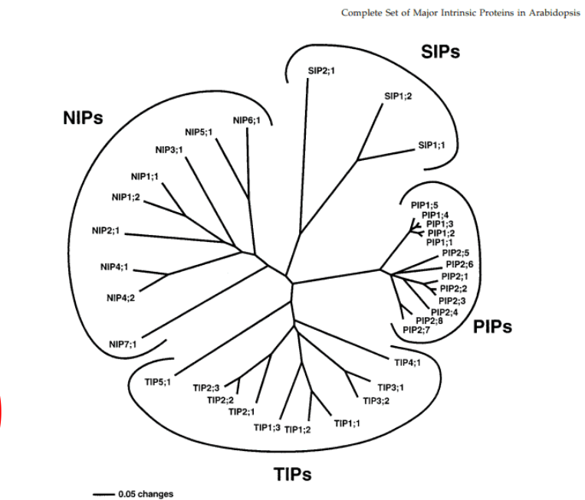
Figure 1. Diagram of the complete set of Major Intrinsic Proteins in Arabidopsis thaliana. (source??)

Methods

I thoroughly read literature about boron and its role in Arabidopsis thaliana. After reading journal articles, I identified possible uptake genes: BOR1, NIP5;1, and NIP6;1 as well as efflux genes: BOR4 and BOR1. I continued doing research and kept in mind genes that were found in other plants, such as rice, just in case they were also present in Brassica oleracea. Some of these were NIP2;1, NIP3;1, PIP2;3, PIP2;7, BOR2, and BOT1. After finding candidate genes, I went to the Nation Center for Biotechnology Information (NCBI, year) website and found the protein sequences for all of the above genes. Then, I used a tBLASTn and BLASTed the sequences against B. oleracea. After BLASTing, I recorded all the hits that had an E-value(expect value) no greater than 1e-06 and were within 10 million base pairs of the QTLs (given in an excel spreadsheet). After using BLAST, I turned to the Integrated Genome Browser (IGB, year) in order to search for other potential genes +/- 2 million base pairs away from the QTL of interest. For every gene of interest that I found in IGB (mostly labeled “aquaporin”), I copied the amino acid sequence and BLASTed against the other amino acid sequences of the genes found from BLAST to see if any of the genes showed up in both BLAST and IGB. After finding all of the boron genes that seemed like good candidates for the QTLs, I found three SSR primer pairs that were within +/- 100,000 base pairs of the gene of interest.

Results

After investigating 17 possible genes that could be linked to the broccoli QTLs of interest for boron (Fig. 2), I found 7 good candidate genes on 5 chromosomes. However, those 7 candidate genes were comprised of only two unique genes: NIP3;1 and PIP2;3 (Figs. 3-7). PIP2;3 was found to be a candidate gene on chromosomes 3, 4, 6, 8, and 9, while NIP3;1 was found to be a candidate gene on chromosomes 6 and 8. From these genes, I was able to find a total of 21 primer pairs (3 for each gene; Fig. 8). Because of how close PIP2;3 and NIP3;1 are located on chromosomes 6 and 8, I was not able to determine which of the genes is a better candidate and they also have the same set of three primer pairs. For a full list of the primer pairs, please see appendix A.

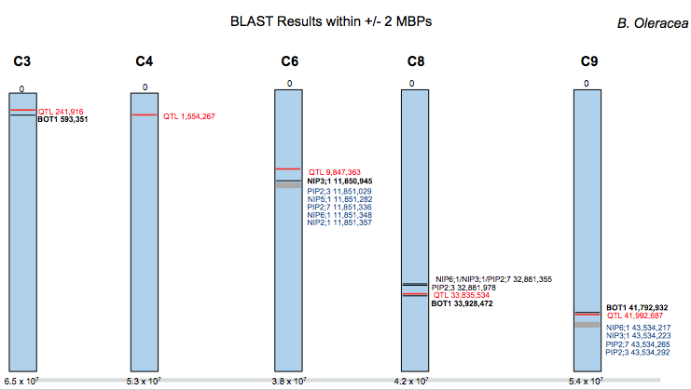

Figure 2. Diagram of BLAST results for B. oleracea of possible candidate genes within +/- 2 million base pairs of QTLs. Blue boxes represent the chromosomes (with the chromosome number above). Red text represents the QTL, black represents single genes, and blue represents clusters of genes. Numbers below chromosomes indicate the chromosome base-pair length.
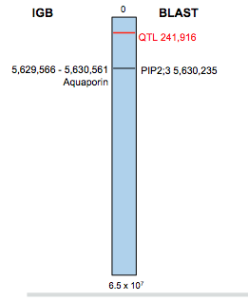
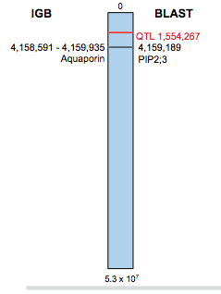

Figure 3. See figures 2-6 legend below Figure 4. See figures 2-6 legend below.

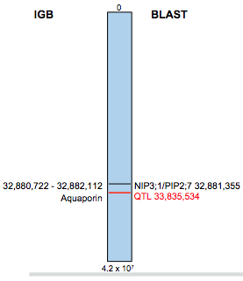
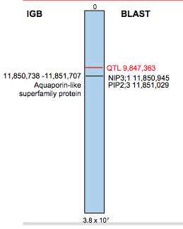

Figure 5. See figures 2-6 legend below. Figure 6. See figures 2-6 legend below.

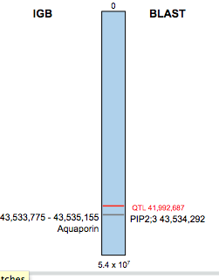

Figures 2-6: IGB vs. BLAST results for chromosomes 3, 4, 6, 8, and 9, in respective order. The QTL is shown in red for each. The IGB results are shown on the left (along with the gene name in the IGB database) and the BLAST results shown on the right (along with the gene name in the BLAST database). The numbers shown are the locations of the gene.

Figure 7. See figures 2-6 legend to right.

Gene | Chromosome | Location Start | QTL location | No. of Primer Pairs
PIP 2;3* | 3 | 5,630,235 | 241,916 | 3
PIP 2;3* | 4 | 4,159,189 | 1,554,267 | 3
NIP 3;1 | 6 | 11,850,945 | 9,847,363 | 3
PIP 2;3 | 6 | 11,851,029 | 9,847,363 | 3
NIP 3;1 | 8 | 32,881,355 | 33,835,534 | 3
PIP 2;3 | 8 | 32,881,978 | 33,835,534 | 3
PIP 2;3 | 9 | 43,534,292 | 41,992,687 | 3⁺

Figure 8. Table of potential B. oleracea genes associated with Given QTLs on chromosomes 3, 4, 6, 8, and 9. * denotes that the gene is not located within the 2 million base pair range of the QTL. ⁺ indicates that one or more of the primer pairs found surrounded repeats of only two base pairs.

Discussion

My study has shown that there are five likely candidate genes to be associated with my given QTLs on chromosomes 3, 4, 6, 8, and 9. Although there are five total genes, there are only two unique genes: PIP2;3 and NIP3;1. It may be likely that the only gene associated with the QTLs are PIP2;3, as this gene is a candidate for the QTL on every chromosome. I am unable to tell whether PIP2;3 or NIP3;1 is a better candidate for the QTLs on chromosomes 6 and 8 because they are so close to each other (BLAST location), and the IGB gene is labeled “aquaporin” and spans the base pairs of both genes according to their BLAST location.
Although not many candidate genes were found, as there is not much information on the uptake and storage of boron in plants thus far, these genes seem to be great possibilities. IGB labeled the genes that caught my attention as “aquaporin” or “aquaporin-like superfamily protein,” which are also known as MIPs, meaning that it not only allows water, but also small, uncharged molecules such as boric acid (Kumar et al., 2013).
The SSR primer pairs that I found will help to continue the studies about boron and the QTLs of interest in Brassica oleracea, thus allowing scientists to alter broccoli in ways that it can be more efficiently grown (such as with less boron), and permitting broccoli farmers to selectively breed for the vegetable that requires the least amount of nutrients (if the desired nutrient is scarce). It is crucial that we are able to further understand the genomics of B. oleracea so that we can efficiently grow it as well as keep toxins out of the environment from fertilizers that are necessary for normal growth and development at this point in time.

Acknowledgements

This study was conducted as a part of a biology course, Laboratory Methods in Genomics, at Davidson College. I would first like to thank Dr. Campbell, the Laboratory Methods in Genomics professor, for all of his help and guidance throughout this study. I would also like to thank Dr. Allen Brown and Dr. Charles David of North Carolina State University for their continued support, advice, and assistance. Lastly, I would like to thank my fellow classmates for all of their helpful feedback and collaboration throughout this project.

References
"Broccoli." The World's Healthiest Foods. The George Mateljan Foundation, 2014. Web. 06 May 2014.
"International Production of Cauliflowers." International Production of Cauliflowers. Food and Agricultural Organization, 2012. Web. 06 May 2014.
Johanson, U. "The Complete Set of Genes Encoding Major Intrinsic Proteins in Arabidopsis Provides a Framework for a New Nomenclature for Major Intrinsic Proteins in Plants." Plant Physiology 126.4 (2001): 1358-369. Print.
Kasai, K., J. Takano, K. Miwa, A. Toyoda, and T. Fujiwara. "High Boron-induced Ubiquitination Regulates Vacuolar Sorting of the BOR1 Borate Transporter in Arabidopsis Thaliana." Journal of Biological Chemistry 286.8 (2011): 6175-183. Print.
Kasajima, Ichiro, Yoko Ide, Masami Yokota Hirai, and Toru Fujiwara. "WRKY6 Is Involved in the Response to Boron Deficiency in." Physiologia Plantarum 139.1 (2010): 80-92. Print.
Kato, Y., K. Miwa, J. Takano, M. Wada, and T. Fujiwara. "Highly Boron Deficiency-Tolerant Plants Generated by Enhanced Expression of NIP5;1, a Boric Acid Channel." Plant and Cell Physiology 50.1 (2009): 58-66. Print.
Kumar, Kundan, Kareem A. Mosa, Sudesh Chhikara, Craig Musante, Jason C. White, and Om Parkash Dhankher. "Two Rice Plasma Membrane Intrinsic Proteins, OsPIP2;4 and OsPIP2;7, Are Involved in Transport and Providing Tolerance to Boron Toxicity." Planta (2013): 187-88. Print.
Miwa, Kyoko, Junpei Takano, and Toru Fujiwara. "Improvement of Seed Yields under Boron-limiting Conditions through over Expression of BOR1, a Boron Transporter for Xylem Loading, in Arabidopsis Thaliana." The Plant Journal 46 (2006): 1084-091. Print.
Miwa, Kyoko, Mayuki Tanaka, Takehiro Kamiya, and Toru Fujiwara. "Molecular Mechanisms of Boron Transport in Plants: Involvement of Arabidopsis NIP5;1 and NIP6;1." Landes Bioscience (2010): n. pag. Print.
Takano, J. "The Arabidopsis Major Intrinsic Protein NIP5;1 Is Essential for Efficient Boron Uptake and Plant Development under Boron Limitation." The Plant Cell Online 18.6 (2006): 1498-509. Print.
Takano, Junpei, Kyotaro Noguchi, Miho Yasumori, Masaharu Kobayashi, Zofia Gajdos, Kyoko Miwa, Hiroaki Hayashi, Tadakatsu Yoneyama, and Toru Fujiwara. "Arabidopsis Boron Transporter for Xylem Loading." Nature 420.6913 (2002): 337-40. Print.
Tanaka, M., I. S. Wallace, J. Takano, D. M. Roberts, and T. Fujiwara. "NIP6;1 Is a Boric Acid Channel for Preferential Transport of Boron to Growing Shoot Tissues in Arabidopsis." The Plant Cell Online 20.10 (2008): 2860-875. Print.
Tanaka, Mayuki, and Toru Fujiwara. "Physiological Roles and Transport Mechanisms of Boron: Perspectives from Plants." European Journal of Physiology 456.4 (2008): 671-77. Print.

Appendix A: SSR Primer Pairs

PIP 2;3 Chromosome 3 Location start: 5,630,235

1)
For primer: TCCACATTAAAGTTCTTGTT
Rev primer: TATTCTCATGGAAAGGTAAA
Repeats: (AAG) x 10 PCR product: 169 Start base: 5,574,061

2)
For primer: ATATTACAATCTGGAAGCAA
Rev Primer: AAGGAAAGAGAGAAGGACTA
Repeats: (TCA) x 8 PCR product: 382 Start base: 5,606,339

3)
For primer: GTAATTCGTTTTTCTTCAAA
Rev primer: AAGGAAAGAGAGAAGGACTA
Repeats: (TCA) x 6 PCR product: 294 Start base: 5,608,487

PIP 2;3 Chromosome 4 Location start: 4,159,189

1)
For primer: CTGATCATCTTTTTGTTGAT
Rev primer: TAAGTGTGGCATTTTATTTT
Repeats: (CTT) x 11 PCR product: 364 Start base: 4,123,483

2)
For primer: ATAAGATGGCTTTGTACTCA
Rev primer: TTTTATGAAGGAAAAGAATG
Repeats: (CTT) x 6 PCR product: 255 Start base: 4,169,358

3)
For primer: GTCCTCCACTATAGTTTCCT
Rev primer: GACATAGTGGGTAGATTGAA
Repeats: (TTC) x 5 PCR product: 130 Start base: 4,171,143

NIP 3;1 Chromosome 6 Location start: 11,850, 945

1)
For primer: TTAAAAATCAAAATAGCTCC
Rev primer: GAGTTTAAGAAAGCGATGTA
Repeats: (TCTA) x 5 PCR product: 211 Start base: 11,870,200

2)
For primer: TTAATGTTGTGTTTCACGTA
Rev primer: AAAAGAAAAACATGGACATA
Repeats: (TTG) x 6 PCR product: 263 Start base: 11,870,930

3)
For primer: GGGAAAACCTTATTATCTGT
Rev primer: TAATAATCAAAAAGGACCAA
Repeats: (TGT) x 5-(ATT) x 6 PCR Product: 287 Start base: 11,941,798

PIP 2;3 Chromosome 6 Location start: 11,851, 029

1)
For primer: TTAAAAATCAAAATAGCTCC
Rev primer: GAGTTTAAGAAAGCGATGTA
Repeats: (TCTA) x 5 PCR product: 211 Start base: 11,870,200

2)
For primer: TTAATGTTGTGTTTCACGTA
Rev primer: AAAAGAAAAACATGGACATA
Repeats: (TTG) x 6 PCR product: 263 Start base: 11,870,930

3)
For primer: GGGAAAACCTTATTATCTGT
Rev primer: TAATAATCAAAAAGGACCAA
Repeats: (TGT) x 5-(ATT) x 6 PCR Product: 287 Start base: 11,941,798

NIP 3;1 Chromosome 8 Location start: 32,881,355

1)
For primer: ACGATAAGATAGCAGATTGA
Rev primer: TATTTCGTTCTTTTAATTCC
Repeats: (TTA) x 8 PCR product: 383 Start base: 32,786,764

2)
For primer: ACACATTGAAAATTTGAGAG
Rev primer: AATATAATCATTTGTGGTGG
Repeats: (TAT) x 6 PCR product: 363 Start base: 32,886,988
3)
For primer: GCTGAAAACAGATAAACAAC
Rev primer: ATGTAAGTAGGGATAGGGAC
Repeats: (TCC) x 8 PCR product: 364 Start base: 32,952,627

PIP 2;3 Chromosome 8 Location start: 32,881,978

1)
For primer: ACGATAAGATAGCAGATTGA
Rev primer: TATTTCGTTCTTTTAATTCC
Repeats: (TTA) x 8 PCR product: 383 Start base: 32,786,764

2)
For primer: ACACATTGAAAATTTGAGAG
Rev primer: AATATAATCATTTGTGGTGG
Repeats: (TAT) x 6 PCR product: 363 Start base: 32,886,988

3)
For primer: GCTGAAAACAGATAAACAAC
Rev primer: ATGTAAGTAGGGATAGGGAC
Repeats: (TCC) x 8 PCR product: 364 Start base: 32,952,627

PIP 2;3 Chromosome 9 Location start: 43,534,292

1)
For primer: TGAATTTATGCTAGTGGATT
Rev primer: AAACAACACATAAGACGAAC
Repeats: (AAG) x 7 PCR product: 334 Start base: 43,460,087

2)
For primer: AGTATAATGTAGCCAACCAA
Rev primer: TTTATCCAATGAAAACAAAT
Repeats: (AT) x 14 PCR product: 344 Start base: 43,469,316

3)
For primer: ATAATATTCGAGGTCCTTTT
Rev primer: TGGATTTTGATTTTGTTTAT
Repeats: (AG) x 16 PCR product: 244 Start base: 43,570,003

