Gene Annotation Lab Notebook

Alternate Open Reading Frame
The alternative ORFs page is available via the JGI gene homepage, can be accessed by clicking on “Gene details”. This function allows you to examine the codons around the proposed start codon, possibly locating a more appropriate or likely place for the gene to start.

Enter proposed DNA coordinates:

Reasoning:

Basic Information
DNA Coordinates:
77750..78403 (-)(654bp)
DNA Sequence:
>2500587696 hypothetical protein [Halorhabdus utahensis AX-2, DSM 12940 : HutaDRAFT_4083004_C6] (-)strand
ATGAGTGAACTCGACCGTGACGCCGCGGTCGATCGTCTCGAAGCGCTGCT
TGAGACGATCGAAGACGAGACGATGCCAGTCCCGGTCACGGAAGTCTGGG
TGTACGGCGATCTCGCGCTCGGCGTCGATCCGGTCGAGCGCCTCGACGTC
TATCTCACGAAGGACCTGCTTTTCGGCCAGGCCGACGACCGTGCGGCCGA
ATTGAACGACCGCTTGGGCGTCGACGGGATCGGCGAGACGGTCCGGGCCG
AGTGGGCGAGCGAACACCCGGAGGCCGTGCGGGCAAACCCCAGCGGCCAC
GTCGCCCCGGAGAAGTGTCTCGGGGCGCACCTGTTCGAGGAGCGCGAGCC
GATCCACCTCGAAGTCTGTAACGCCTCCTTCGAGGACAACGTCACCCAGC
GGCTGGAGGGCGCACTCGCTCGGGAGTCCTACGAAAACATCCTCGATCCC
CGAGGGGTCTGCCTGTGGATCGACGGCGAACGGTCCGGTGACGCGTTCAC
CAAACTCCGGGATGGTGAGTATGTCTTCCCGCCGCTTTCGGGCGCACTCG
AAATGCTCGGGGCCGAACCGTCGGTCGCCGAGGAGGCCGCTGACGCCGTC
GAAACGTACCGGGAACGCCAGGACGGGATCAGCGTCCGTGGCGACGTGGT
CTGA

Protein Sequence:
MSELDRDAAVDRLEALLETIEDETMPVPVTEVWVYGDLALGVDPVERLDV

YLTKDLLFGQADDRAAELNDRLGVDGIGETVRAEWASEHPEAVRANPSGH

VAPEKCLGAHLFEEREPIHLEVCNASFEDNVTQRLEGALARESYENILDP

RGVCLWIDGERSGDAFTKLRDGEYVFPPLSGALEMLGAEPSVAEEAADAV

ETYRERQDGISVRGDVV

Isoelectric Point (pI):
3.9

Sequence-based Similarity Data
BLAST
ref|YP_136576.1| Gene info hypothetical protein rrnAC2009 [Haloarcula marismortui ATCC 43049]

gb|AAV46870.1| Gene info unknown [Haloarcula marismortui ATCC 43049]

Length=216

GENE ID: 3128178 rrnAC2009 | hypothetical protein

[Haloarcula marismortui ATCC 43049] (10 or fewer PubMed links)

Score = 301 bits (772), Expect = 2e-80, Method: Compositional matrix adjust.

Identities = 144/214 (67%), Positives = 172/214 (80%), Gaps = 0/214 (0%)

Query 4 LDRDAAVDRLEALLETIEDETMPVPVTEVWVYGDLALGVDPVERLDVYLTKDLLFGQADD 63

LDR AV+R+E ++ T+EDETMPVPV EVWVYGD+ALG+DPVERLDVY+TKD+LF A +

Sbjct 3 LDRPEAVERVEEIVATVEDETMPVPVREVWVYGDVALGLDPVERLDVYVTKDILFKDAPE 62

Query 64 RAAELNDRLGVDGIGETVRAEWASEHPEAVRANPSGHVAPEKCLGAHLFEEREPIHLEVC 123

RA E GVDG+G+TVRA WA EHPE +RAN +GH APEKCL AHL + EP+HLEVC

Sbjct 63 RAEEFQRSHGVDGVGKTVRAAWADEHPEYIRANANGHAAPEKCLAAHLLNDDEPVHLEVC 122

Query 124 NASFEDNVTQRLEGALARESYENILDPRGVCLWIDGERSGDAFTKLRDGEYVFPPLSGAL 183

NASFEDNVTQRL+GA R YE ILDPRG CLW+DGERS DAF KLRD E+VFP L+ +L

Sbjct 123 NASFEDNVTQRLKGAKMRNDYEQILDPRGACLWLDGERSPDAFQKLRDNEFVFPTLTQSL 182

Query 184 EMLGAEPSVAEEAADAVETYRERQDGISVRGDVV 217

MLG + + A +AADAV+ YR +Q+G +VRGDVV

Sbjct 183 SMLGMDETEAGDAADAVKEYRAQQEGATVRGDVV 216

CDD
goto http://www.ncbi.nlm.nih.gov/Structure/cdd/cdd.shtml
Number of Significant COG hits:
COG Name:
Score:
E-value:
TIGRfam
goto http://tigrblast.tigr.org/web-hmm/
Number of Significant TIGRfam hits:
Model and Description:
Score:
E-value:
Cellular Localization Data:
TMHMM
goto http://www.cbs.dtu.dk/services/TMHMM-2.0/
Number of Predicted TMH’s:
Transmembrane Topology graph:
Comment:
SignalP
goto http://www.cbs.dtu.dk/services/SignalP/
Signal Peptide Probability:
Signal Peptide Graph:
PSORT
goto http://psort.ims.u-tokyo.ac.jp/form.html
Cytoplasmic Score:
Cytoplasmic Membrane Score:
Periplasmic Score:
Outer Membrane Score:
Extracellular Score:
Final Prediction for Protein Location (CytoplasmicMembrane, Periplasmic, OuterMembrane, or Extracellular):
Phobius
goto http://phobius.sbc.su.se/
Note: If the report states that the protein is non cytoplasmic or cytoplasmic, it simply predicts that no transmembrane helices are likely. It should not be used as a predictor of location.
Enter Graph:
Final Hypothesis: Where do you expect to find this protein?
Duplication and Degradation:
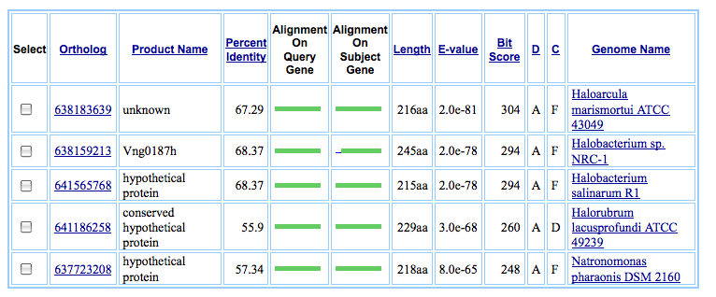

Structure-Based Evidence of Function:
Pfam-A
goto http://pfam.sanger.ac.uk/search
Number of significant Pfam-A matches:
Pfam name:
Pairwise Alignment:
HMM logo:
Key Functional Residues:
PDB
goto http://www.rcsb.org/pdb/search/searchSequence.do
Number of Significant structure hits:
Top hit- Length, Score, E-value, Identity, Positives, Gaps:
Alignment:
Horizontal Gene Transfer Evidence:
goto http://www.ebi.ac.uk/tcoffee/
Tree
Phylogenetic tree diagram:
Gene Context
Ortholog Neighborhood Region and examples of similarities or differences:
Comment:
Chromosome View GC Heat Map
Characteristic GC% of genome: 63
Average GC% of gene: 66
Pathways:
KEGG
goto http://www.genome.jp/kegg/pathway.html
Map Image:
EcoCyc
goto http://ecocyc.org/
EC Number:

