Brittany Elek

EC: 2.6.1.85
para-aminobenzoate synthetase
BLASTed using Vitis vinifera (wine grape) as the query

Blast results:
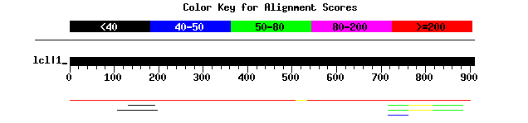

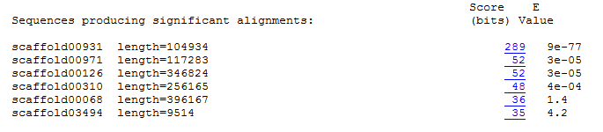

2.6.1.85 found in Scaffold 00931 (query sequence starts at base 79725 on scaffold)
1)
For Primer TAGCCCTAGTTGTGGTGTTGTG
Rev Primer ATTGCACACCACATTCAGTCTC
Repeats (ag) x 18 PCR product = 260 bp & start at base 56084

2)
For Primer TCCCTTAGCCTATAAAAGGGGA
Rev Primer CGGATAGGAAGGATGATGAAAG
Repeats (ctt) x 15 PCR product = 299 bp & start at base 100054

3)
For Primer TGATGTATGACGGTTAGATGCC
Rev Primer CGTCTCTCTCTCTCTCTCTCTCTCT
Repeats (gt) x 11 PCR product = 177 bp & start at base 79816

2.6.1.85 found in Scaffold 00971 (query sequence starts at base 84910 on scaffold)
1)
For Primer TAACTAGTGCAGTCTTGCTGCC
Rev Primer TCAATACTCATTCGGTGAAACG
Repeats (ga) x 20 PCR product = 209 bp & start at base 45900

2)
For Primer TGGAAACAACGCAAACTATCAC
Rev Primer TGCCATCAGACTGTCTACCATC
Repeats (ct) x 14 PCR product = 179 bp & start at base 98363

3)
For Primer CATGCATTCTTGAGAAAGGTGA
Rev Primer GGTCCACCACACCAAAATTACT
Repeats (ag) x 13 PCR product = 289 bp & start at base 105790

2.6.1.85 found in Scaffold 00126 (query sequence starts at base 304201 on scaffold)

1)
For Primer CCAAACTCCAAGTTGTCCTTTC
Rev Primer GGCCTGAATTATTTTCTGATGG
Repeats (ag) x 19 PCR product = 154 bp & start at base 227731

2)
For Primer GGACGTTATGGAGCGAAGTTT
Rev Primer TCAGCCTTTTCCTTTCCTGATA
Repeats (tc) x 16 PCR product = 231 bp & start at base 255378

3)
For Primer CCAAACTCCAAGTTGTCCTTTC
Rev Primer GGCCTGAATTATTTTCTGATGG
Repeats (ga) x 15 PCR product = 154 bp & start at base 227681

2.6.1.85 found in Scaffold 00310 (query sequence starts at base 199378 on scaffold)
1)
For Primer GAGACGAAAGACATTAGACATGC
Rev Primer CCTGACGAAAAACGTTACAACTC
Repeats (ga) x 17 PCR product = 298 bp & start at base 254186

2)
For Primer GGCAAATTCTCCAAACAACTTC
Rev Primer CAAACCAAACAAGGAAGTCACA
Repeats (ct) x 16 PCR product = 280 bp & start at base 242713

3)
For Primer TATTGCTCATCCAACATTCGAC
Rev Primer TTACTCCTGACATTAAAGCGCA
Repeats (tc) x 12 PCR product = 161 bp & start at base 243187

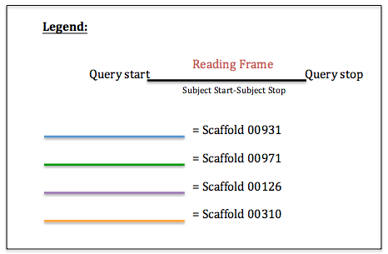
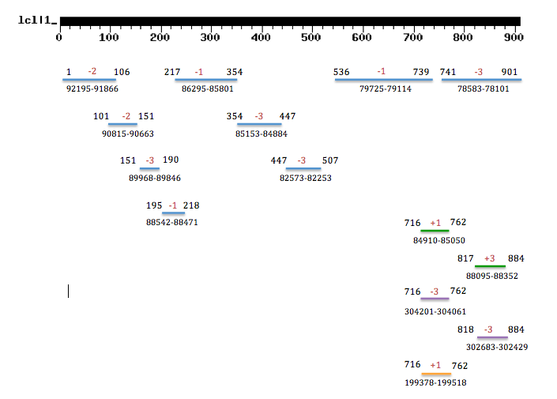

Figure: Results of tBLASTn of para-aminobenzoate synthetase [EC:2.6.1.85] using Vitis vinifera as the query against Vaccinium corymbosum 454-scaffolds. There were four significant scaffolds (shown in diagram above). The fragments within scaffolds are due to frame shifts.

