Gene Annotation Lab Notebook

Alternate Open Reading Frame
The alternative ORFs page is available via the JGI gene homepage, can be accessed by clicking on “Gene details”. This function allows you to examine the codons around the proposed start codon, possibly locating a more appropriate or likely place for the gene to start.

Enter proposed DNA coordinates: 4326..7301 (+)

Reasoning: Shine Dalgarno sequence is ACGAAG and the start codon is ATG and it is 31 bp downstream from the Shine-Dalgarno sequence.

Basic Information
DNA Coordinates: 4326..7301 (+)
DNA Sequence:
ATGCCGGTCGAAGGGTCTGGTGAGATCACTGTCCTGCACGTCGACGACGA
CCCGGACCTCGCGGCGGTCGCCGGCGAGTACGTGGCGCGTGAGGACGACC
GGATATCCGTCGACGTTGCGACCAGCGCCGACGAGGGCCTCACGATGCTC
GCCGACGCGTCGATCGACTGTATCGTCTCGGACTACGACATGCCCGGCCA
GGACGGCATCGAGTTCCTCGAAACAGTCCGCGAGGCACACCCGGACCTTC
CGTTTATCCTGTACACGGGGAAGGGATCAGAGGAAGTCGCCAGCGACGCG
ATCGGCGCTGGCGTGACGGATTACCTCCAGAAGGAGTCCGGCCCCGACCA
CTACCGACTCCTGGCCAACCGGATCGTGAACGCGGTCGAGCGATACCGGG
CGGGCGAGCGCGTCGAGCGGGCCGAGCAGCGCTATCGATCGCTGTTCGAG
GAGATGAACGAGGGGGCGGCGTTGCACGAACTCGTCTACGAGGCGGGCGA
GCCGGTCGGGTACGAGATCATCGACGTCAACCGGAACTTCGAGGCGATCC
TCGACATTCCGGCCGAGCAGGCCATCGGCCAGCGTGCGGTCGACGTCTAC
GACGTCGAGGAGCCGCCGTTCCTCGACCGGTACGCTCAGGTGGCCGAGAC
GGGCGAGTCGATGGAGTTCGAGACCTCCTTTCGGCCGCTGGAGATGCACT
TCCACGTCTCGGTGTTTGCACCGAGAGAAGGCCAGTTCGCGACCGTGTTC
TCGGACGTGTCCGACCAGCGAGAGACCGAACAGCACCTCCGCCACGAGCG
GGCGTTGTACCACGCCCAGAGCGAGGCCACCCTCGATGGGTATCTCGTCG
TCGACGAGGAGCGCCGCATCGCCTCGTACAACTCCCGGCTGCTCGAGTTG
TGGGACATCCCCGAGGATCTCATCGAGAGTCGAGACGACGAGGCGGTCCT
CGATCACGTGGTCGAGAAAACGGTCGATCCCGATGAGTTCCGCGAGGTGG
TCGAGTCGCTCTACGACCAGCCAAACGCCGAGAGCAGAGACGAGATCGAA
CTGGCCGACGGGCGCTGGTTCGACCGGTACTCGACGCCGGTCGTCGGCGA
GGACGGAACCCGCTACGGCCGACTGTGGGTCTTTCGGGACGTCACCCAAC
GCAAGGAACGCGAACGCGAGCTGACCCGACTCTCGGAACGACTCGAACTC
GCCGTCGAAGGGGCGAATCTGGGAGTCTGGGACTGGGATATGACCACTGA
CGCGGTCGAGTTCAACGAGCAGTGGGCCGAGATGCTCGGCCACTCGGTAT
CGGAGATCGAACCACACCTCGACGCCTGGGAACGGCGGGTTCACCCTGAC
GACCTCCCGGCGGTCGAGGCGGCACTCGACGCCCACATCGAGGATGAAAC
ACCGCTGTACGACACCGAACACCGGATGCGGACGGCCGAGGGCGACTGGA
AGTGGATCAGGGACGTCGGCCGGGTCGTGGATCGCGGCGGGGACGGGGAA
CCACGTCGCGCGGTCGGTATCCACATCGACATCGACGACCGGAAGCGACG
CGAACGGCAACTGCAGTTGTTCCGAAAGGCGGTCGAACAGACCGCCCACG
CCGTCTACGTTACCGACGCCGACGGGACGATCGAGTACGTCAACCCGGCC
TTCGAGGACGTGACCGGGTATCCCGAACAAGAGGCGCTGGGCAGCGATCC
ACACATCCTCCAGTCCGGGGAGTACGACGAGGACTACTACGAGGCGTTCT
GGGAAACGATCACTGACGGCGAGCGCTGGCGCAAGGAGATGATCGACCGA
GACGCCGACGGCGAGCGGATCGTCCTCGAACAGTCGATCGCGCCGATCAC
GGACGCGGACGGTGACCCGGAGAAGTTCGTCGCCGTCGCCCAGGACGTCA
CCGAGCGCAAGGAGGCCGAACGCGACCTCGAGCGCGCTCGCGAGGAACTC
CGGCAGGTCATCGATCTCGTGCCGGATCTCATCTTCGCGAAGGACCGCGA
GGGACGGTACTTGCTGGCCAACGAGGCGACTGCCGAGGCGTACGGGCTCT
CGCCCGAGGATGTCGAGGGCGAGCTCGAATCGAACGTCATCCCGGACGTG
GAGGATTCCGAAGCGTTCCGCGAGGACGACCTCGCCGTGATCGAATCGGG
CGAGCGCCAGGTGATCCCCGAAGAAGAACTGACGACCGCCGACGGCGAGA
CCCGGATTCTGGAGACGACGAAGATCCCCTACGAGGTCTCGGGCAGCGGC
GAGGACGCCGTCCTCGGGTACGGGCGGGACATCACGGATCTCAAAGAGTA
CGAACGGGAACTCGAGCGCCAGCGGGACAACCTCGAAGTGCTCAATCAGG
TCGTCCGCCACGACATTCGCAACGAACTGCAACTCGTCGAGGCCTACGCG
GACCTGCTCCAGCGACACGTCGATGGCGTGGAGGAAAACTACGCAAACAG
AGTTCTCAGAGCCGCCCGTGGTGCCGCCGACATCCTCGAGACTGCCCGAG
ACGTGACGGATATCATGCTCCAGGCCGACGCCGATCAGCAGCCGGTCGAC
CTCGCGAGCACCCTCCGGAACGAGGTCGAGGACCTCCGATCGCAGTACGA
ACGGGTGGCCGTGACCGTCGAGGGGGCGATTCCGGACGTTTCAGTCCGCG
CCGACGACATGCTCGCGTCCGTCTTCCGGAACCTGCTGACCAACGCCGTC
CAGCACAACGACAGCGAGAGCCCGGACGTGACTGTCGCCGCCGACACCGA
CGGGGAGCGCGTGACGGTTCGGATCGCCGACAACGGGCCGGGGATCCCAG
AGGAACGCCGGGAACGTATCTTCCAGCAGGGGGAAACCGCCCTCAACAGC
GACGGGACGGGACTCGGGCTGTATCTCGTCGCGACGCTTGTCGAGCGCTA
CGGCGGGACGGTCGCCGTCGAGGACAACGATCCCACCGGAGCCGTGTTCG
TCGTTGAACTGCCGATGGCAGCGTGA
Protein Sequence:
MPVEGSGEITVLHVDDDPDLAAVAGEYVAREDDRISVDVATSADEGLTML
ADASIDCIVSDYDMPGQDGIEFLETVREAHPDLPFILYTGKGSEEVASDA
IGAGVTDYLQKESGPDHYRLLANRIVNAVERYRAGERVERAEQRYRSLFE
EMNEGAALHELVYEAGEPVGYEIIDVNRNFEAILDIPAEQAIGQRAVDVY
DVEEPPFLDRYAQVAETGESMEFETSFRPLEMHFHVSVFAPREGQFATVF
SDVSDQRETEQHLRHERALYHAQSEATLDGYLVVDEERRIASYNSRLLEL
WDIPEDLIESRDDEAVLDHVVEKTVDPDEFREVVESLYDQPNAESRDEIE
LADGRWFDRYSTPVVGEDGTRYGRLWVFRDVTQRKERERELTRLSERLEL
AVEGANLGVWDWDMTTDAVEFNEQWAEMLGHSVSEIEPHLDAWERRVHPD
DLPAVEAALDAHIEDETPLYDTEHRMRTAEGDWKWIRDVGRVVDRGGDGE
PRRAVGIHIDIDDRKRRERQLQLFRKAVEQTAHAVYVTDADGTIEYVNPA
FEDVTGYPEQEALGSDPHILQSGEYDEDYYEAFWETITDGERWRKEMIDR
DADGERIVLEQSIAPITDADGDPEKFVAVAQDVTERKEAERDLERAREEL
RQVIDLVPDLIFAKDREGRYLLANEATAEAYGLSPEDVEGELESNVIPDV
EDSEAFREDDLAVIESGERQVIPEEELTTADGETRILETTKIPYEVSGSG
EDAVLGYGRDITDLKEYERELERQRDNLEVLNQVVRHDIRNELQLVEAYA
DLLQRHVDGVEENYANRVLRAARGAADILETARDVTDIMLQADADQQPVD
LASTLRNEVEDLRSQYERVAVTVEGAIPDVSVRADDMLASVFRNLLTNAV
QHNDSESPDVTVAADTDGERVTVRIADNGPGIPEERRERIFQQGETALNS
DGTGLGLYLVATLVERYGGTVAVEDNDPTGAVFVVELPMAA

Isoelectric Point (pI): 4.0243

Sequence-based Similarity Data
BLAST
Gene product name:
Signal-transducing histidine kinase
Organism (top hit):
Natronomonas pharaonis
Length, Score, E-value, Identity, Positives, and Gaps:
617, 0.0, 378/618 (61%), 486/618 (78%), 1/618 (0%)
Alignment of top hit and query sequence:
Query 373 GRLWVFRDVTQRKERERELTRLSERLELAVEGANLGVWDWDMTTDAVEFNEQWAEMLGHS 432
G L RD+T+RKEREREL +RL++A++ + LGV+DWD+ +++ F+++ AE+LG
Sbjct 875 GLLVNSRDITERKERERELEVTKDRLDMALDASRLGVYDWDVADESITFDDRVAELLGFD 934

Query 433 VSEIEPHLDAWERRVHPDDLPAVEAALDAHIEDETPLYDTEHRMRTAEGDWKWIRDVGRV 492
E E L AW HP+DLP VE+ ++A + + +E+R+RT GDW+WIR GRV
Sbjct 935 PEEFEHDLSAWAELTHPEDLPRVESDVEAMLNGDRTSARSEYRVRTKNGDWRWIRSHGRV 994

Query 493 VDRGGDGEPRRAVGIHIDIDDRKRRERQLQLFRKAVEQTAHAVYVTDADGTIEYVNPAFE 552
V+ GDGEP R VG+H DI +RK RE++LQ FR+A+EQT HAVY+TD DGTIEYVNPAFE
Sbjct 995 VEWTGDGEPDRIVGVHQDITERKEREQRLQQFREAIEQTGHAVYITDRDGTIEYVNPAFE 1054

Query 553 DVTGYPEQEALGSDPHILQSGEYDEDYYEAFWETITDGERWRKEMIDRDADGERIVLEQS 612
++TGY E E LG P+IL SGEYDE +YE FWE + +GE+W EMID+ ADGE I+L Q+
Sbjct 1055 ELTGYSEAETLGETPNILSSGEYDESFYETFWEALENGEQWEAEMIDQRADGEEIILHQT 1114

Query 613 IAPITDADGDPEKFVAVAQDVTERKEAERDLERAREELRQVIDLVPDLIFAKDREGRYLL 672
I+P+ D D +P+K+VA+AQDVT+RKE E L+ AREELRQVIDLVPDL+F K+R+G YLL
Sbjct 1115 ISPLVDGD-EPQKYVAIAQDVTDRKEYEEALKTAREELRQVIDLVPDLVFVKNRDGEYLL 1173

Query 673 ANEATAEAYGLSPEDVEGELESNVIPDVEDSEAFREDDLAVIESGERQVIPEEELTTADG 732
ANEATA+AYG+SP+++EG+ ES+VIP+VEDSE FR+DD+ VIESGE + +PEE+LTTADG
Sbjct 1174 ANEATADAYGMSPDELEGKKESDVIPEVEDSEQFRKDDIEVIESGEPKEVPEEKLTTADG 1233

Query 733 ETRILETTKIPYEVSGSGEDAVLGYGRDITDLKEYERELERQRDNLEVLNQVVRHDIRNE 792
ETRILETTKIPY+ + + +DAVLGY RDIT+LKEYE+ LERQRD+LEVLNQVVRHDIRN+
Sbjct 1234 ETRILETTKIPYQSAETSDDAVLGYARDITELKEYEQTLERQRDDLEVLNQVVRHDIRND 1293

Query 793 LQLVEAYADLLQRHVDGVEENYANRVLRAARGAADILETARDVTDIMLQADADQQPVDLA 852
LQLV AYADLL+ HVD E + +VL+AAR A +I TARDVT+++LQ+ D +PV+L
Sbjct 1294 LQLVLAYADLLEDHVDEEGEEFIRQVLKAARDAVNITTTARDVTEVLLQSTDDPRPVNLR 1353

Query 853 STLRNEVEDLRSQYERVAVTVEGAIPDVSVRADDMLASVFRNLLTNAVQHNDSESPDVTV 912
L + ED+RS +ER VTVEG +P V AD ML SVFRNLL+NA+QHND P+V +
Sbjct 1354 RVLEEQAEDIRSSHERTLVTVEGPLPSCRVLADGMLESVFRNLLSNAIQHNDKALPEVAL 1413

Query 913 AADTDGERVTVRIADNGPGIPEERRERIFQQGETALNSDGTGLGLYLVATLVERYGGTVA 972
+A D + V VRIADNGPGIP++R+E+IF++GE L+S+GTGLGLYLV TLV+RYGG V
Sbjct 1414 SATADDDTVVVRIADNGPGIPDDRKEQIFEEGEKGLDSEGTGLGLYLVETLVDRYGGEVR 1473

Query 973 VEDNDPTGAVFVVELPMA 990
VEDNDP G+VFVVEL A
Sbjct 1474 VEDNDPDGSVFVVELQRA 1491

CDD
goto http://www.ncbi.nlm.nih.gov/Structure/cdd/cdd.shtml
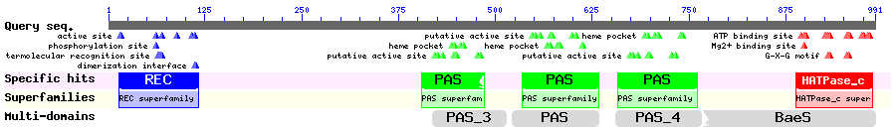
HATPase_C (histidine kinase-like ATPases)
CD length (cd00075): 103, 98.08 bits, 8e-21
REC signal receiver domain
CD length (cd00156): 113, 83.37, 2e-16
PAS domain
CD length (cd00130): 103, 60.67, 1e-09
PAS_3, PAS fold
CD length (pfam08447): 97, 67.35, 1e-11
PAS, PAS fold
CD length (pfam00989): 112, 64.70, 9e-11
PAS_4, PAS fold
CD length (pfam08448): 110, 60.82, 1e-09

Number of Significant COG hits: 1
COG Name: COG0642

Score: 122.97
E-value: 3e-28

TIGRfam
goto http://tigrblast.tigr.org/web-hmm/
Number of Significant TIGRfam hits: 1
Model and Description:
TIGR00229-sensory box: PAS domain S-box
Score: 241.3
E-value: 2.8e-69
Model Description Score E-value
-------- ----------- ----- ------- TIGR00229 sensory_box: PAS domain S-box 241.3 2.8e-69
PF08448 PAS_4: PAS fold 167.9 3.4e-47
PF08447 PAS_3: PAS fold 160.0 8.5e-45
PF00989 PAS: PAS fold 146.8 7.9e-41
PF02518 HATPase_c: ATPase, histidine kinase-, DNA g 115.9 1.6e-31
PF00072 Response_reg: response regulator receiver d 81.8 2.8e-21
TIGR02938 nifL_nitrog: nitrogen fixation negative reg -117.7 1.4e-10
TIGR02966 phoR_proteo: phosphate regulon sensor kinas -156.1 2.5e-07
TIGR01386 cztS_silS_copS: heavy metal sensor kinase -219.8 0.00044
TIGR02875 spore_0_A: sporulation transcription factor -170.9 0.0018
TIGR01818 ntrC: nitrogen regulation protein NR(I) -225.3 0.0031
PF00512 HisKA: His Kinase A (phosphoacceptor) domai 14.7 0.0063
TIGR01924 rsbW_low_gc: anti-sigma B factor -93.1 0.16
TIGR01387 cztR_silR_copR: heavy metal response regula -152.7 0.2
TIGR02916 PEP_his_kin: putative PEP-CTERM system hist -495.5 0.22
TIGR01396 FlgB: flagellar basal-body rod protein FlgB 9.8 0.39
PF09321 DUF1978: Domain of unknown function (DUF197 -77.3 0.5
TIGR01925 spIIAB: anti-sigma F factor -48.2 0.61
TIGR02154 PhoB: phosphate regulon transcriptional reg -192.4 0.83
TIGR02040 PpsR-CrtJ: transcriptional regulator PpsR -256.5 0.88
Cellular Localization Data:
TMHMM
goto http://www.cbs.dtu.dk/services/TMHMM-2.0/
Number of Predicted TMH’s: 0
Transmembrane Topology graph:
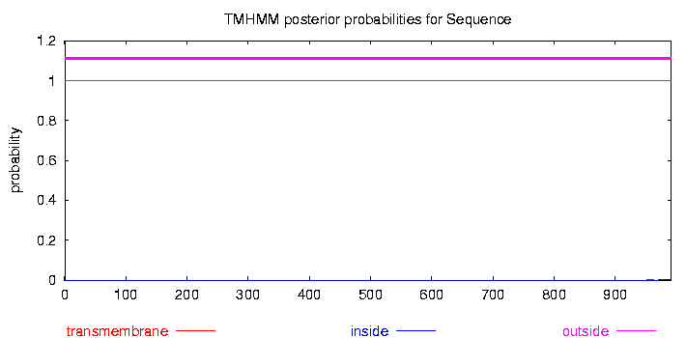
Comment:
It looks like it should be outside of the cell, but this may not be the case, based on comparison with other databasese.
SignalP
goto http://www.cbs.dtu.dk/services/SignalP/
Signal Peptide Probability: 0.000
Signal Peptide Graph:
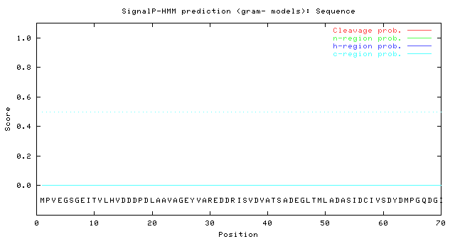
PSORT
goto http://psort.ims.u-tokyo.ac.jp/form.html
Cytoplasmic Score: .288
Periplasmic Score: 0.000
Outer Membrane Score: 0.000
Extracellular Score: 0.000
Final Prediction for Protein Location (CytoplasmicMembrane, Periplasmic, OuterMembrane, or Extracellular):
Cytoplasmic protein
Phobius
goto http://phobius.sbc.su.se/
Note: If the report states that the protein is non cytoplasmic or cytoplasmic, it simply predicts that no transmembrane helices are likely. It should not be used as a predictor of location.
Enter Graph:
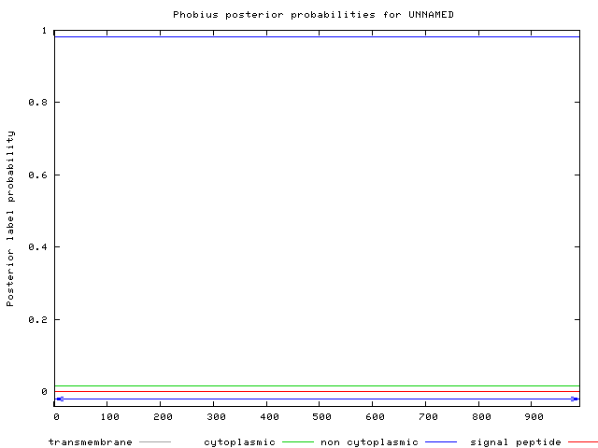
Final Hypothesis: Where do you expect to find this protein?
Cytoplasm
Duplication and Degradation:
Paralog:
Number of significant paralog hits:
Top hit Length, Score, E-value, Identity, Positives, and Gaps:
Top hit is PAS domain S-box
1045aa, 310 bits, 2.0e-82, 29.41

Signal transduction histidine kinase is 9th
387aa, 184 bits, 2.0e-44, 33.80

Alignment:
Structure-Based Evidence of Function:
Pfam-A
goto http://pfam.sanger.ac.uk/search
Number of significant Pfam-A matches: 5
Response_reg HATPase_C

Pfam name:
1. Response_reg 2.4e-21
2. PAS_3 2.7e-28
3. PAS 3.6e-23
4. PAS_4 4e-22
5.HATPase_C 3.4e-32

Pairwise Alignment:
1.
#HMM *->vLiVDDdplirellrqlLet.keGyevVaeaddgeeAlellkekrpDlillDirMPgmdGlellrrirrrrdepttPvivlTahgdeedavealkaGAddflsKPfdpeeLvaalr<-*
#MATCH vL VDDdp+++++ ++ ++++ + +V++a+++ e+l +l +D+i+ D +MPg dG+e+l++ r+ + p++P i+ T++g+ee a a+ aG d+l K ++p+ + ++
#SEQ VLHVDDDPDLAAVAGEYVAReDDRI-SVDVATSADEGLTMLADASIDCIVSDYDMPGQDGIEFLETV-REAH-PDLPFILYTGKGSEEVASDAIGAGVTDYLQKESGPDHYRLLAN 123

2.
#HMM *->iiywsprveeilGYtpeellgkssyedwldlvHPeDrervrealqealalkkgepysgEyRirrkdGeyrWveargrvirrDenGkpvrmiGva<-*
#MATCH + ++++ e+lG++++e+ ++ ++w +vHP+D++ v++al+++++ + y++E+R+r++ G+++W+++ grv+ r+ +G+p r +G++
#SEQ AVEFNEQWAEMLGHSVSEI--EPHLDAWERRVHPDDLPAVEAALDAHIEDETP-LYDTEHRMRTAEGDWKWIRDVGRVVDRGGDGEPRRAVGIH

3.
#HMM *->edlrailesnlpdgifvvDvedGrilyvNaaaeellGlsreeviGkslldlipeeddaeclvaelllqaleqgee.rgvevsfrvsgqrflvrdgrpihvevraspvrdaggeilgflgvlrDi<-*
#MATCH +++r +e+ ++ ++ v+D +dG i yvN+a+e+ +G++++e++G ++l + e+d + +e++++ + +ge+ r + ++++ dg+ i +e+ +p++da+g + f+ v++D+
#SEQ QLFRKAVEQ-TAHAVYVTD-ADGTIEYVNPAFEDVTGYPEQEALGSDPHILQSGEYDED--YYEAFWETITDGERwRKEMIDRDA--------DGERIVLEQSIAPITDADGDPEKFVAVAQDV 633

4.
#HMM *->ldslpdalavlkDpdgrvryaNaaaslsaaerlfglppeellGktlagellPpeledpdaarleralrrvlegeepidfleelll.pngeerhwelrlatPlrdpdGe.vigvlvisrDvTerrr<-*
#MATCH d +pd+++++ D++gr++ aN a ae ++gl+pe+++G + P+++ d +++++ + +v+e +e++ ++ee l++++ge+r++e+++ +P +++G + ++vl+++rD+T++++
#SEQ IDLVPDLIFAK-DREGRYLLANEA----TAE-AYGLSPEDVEGELES-NVIPDVE---DSEAFREDDLAVIESGERQVIPEEELTtADGETRILETTK-IPY-EVSGSgEDAVLGYGRDITDLKE 766

5.
#HMM *->gdedrLrqvlsNLldNAikhapag.geitvrlerdgdrlritVeDnGpGIppehkgsaedleriFepFyrtdgpaesladsrrkigGGLtGLGLaivkelvelhgGtitvesepggGttftltlPla<-*
#MATCH d L v++NLl+NA++h + ++ +tv +++dg+r+++++ DnGpGIp+ e +eriF+ + ++ + + G tGLGL++v lve++gGt+ ve++ + G++f+++lP+a
#SEQ RADDMLASVFRNLLTNAVQHNDSEsPDVTVAADTDGERVTVRIADNGPGIPE------ERRERIFQQGETALN-----------SDG--TGLGLYLVATLVERYGGTVAVEDNDPTGAVFVVELPMA 990

HMM logo:
1.
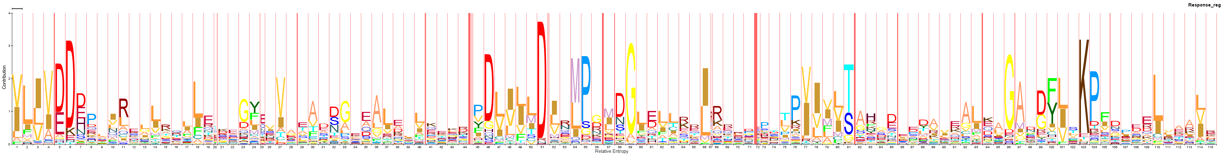
2.
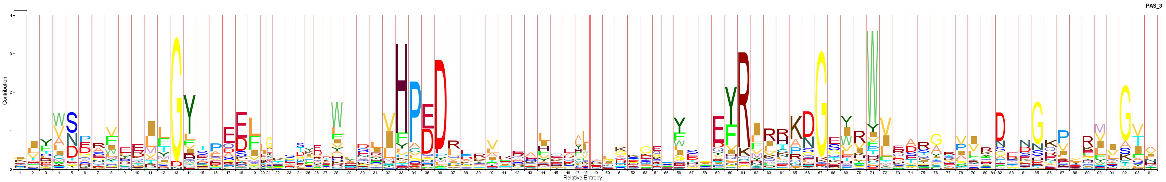

3.
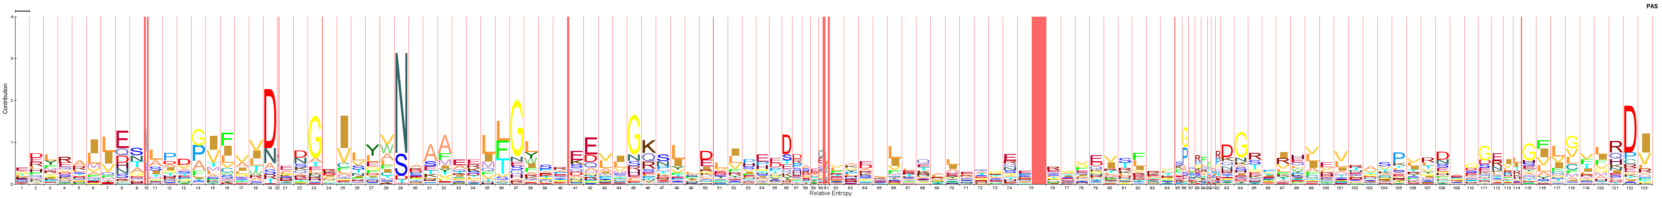

4.
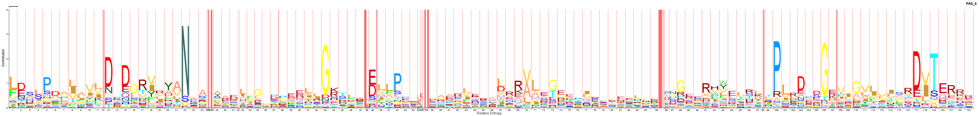

5.
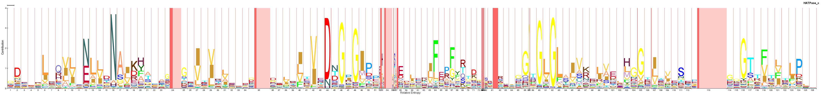

Key Functional Residues: Response Regulator, PAS_3, PAS, PAS_4 and HATPase_C
PDB
goto http://www.rcsb.org/pdb/search/searchSequence.do
Number of Significant structure hits: 184
Top hit- Length, Score, E-value, Identity, Positives, Gaps:
113, 67.781 bits, 2.85602e-11, 32/113 (28%), 58/113(51%), 0/113
Alignment:
522 530 540 550 560 570 580 590 600 610 620 630 634
| . | . | . | . | . | . | . | . | . | . | . | |
Query QLFRKAVEQTAHAVYVTDADGTIEYVNPAFEDVTGYPEQEALGSDPHILQSGEYDEDYYEAFWETITDGERWRKEMIDRDADGERIVLEQSIAPITDADGDPEKFVAVAQDVT
++FR+ VE A+ +TD I Y N AF +TGY +E LG + IL +G Y+A W + + W +++R D + E ++AP+ + G+ ++ + +D +
Sbjct EIFRQTVEHAPIAISITDLKANILYANRAFRTITGYGSEEVLGKNESILSNGTTPRLVYQALWGRLAQKKPWSGVLVNRRKDKTLYLAELTVAPVLNEAGETIYYLGMHRDTS
| | . | . | . | . | . | . | . | . | . | . | . |
5 10 20 30 40 50 60 70 80 90 100 110 117
Horizontal Gene Transfer Evidence:
goto http://www.ebi.ac.uk/tcoffee/
Tree
Phylogenetic tree diagram:
Gene Context
Ortholog Neighborhood Region and examples of similarities or differences:
Lots of multi-sensor histidine kinases.
Comment:
Chromosome View GC Heat Map
Characteristic GC% of genome: 63%
Average GC% of gene: 65%
Pathways:
KEGG
goto http://www.genome.jp/kegg/pathway.html
Map Image:
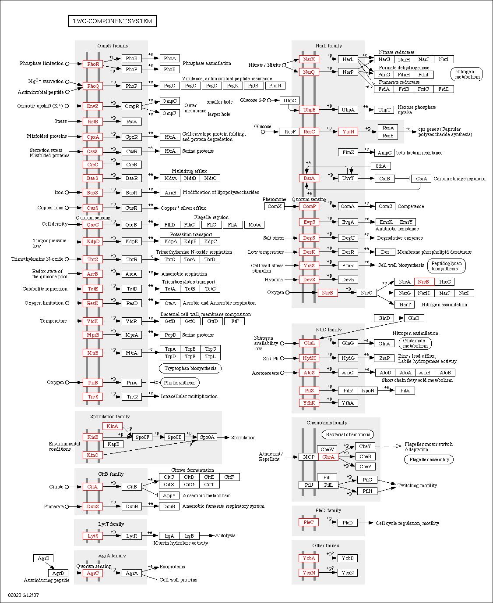
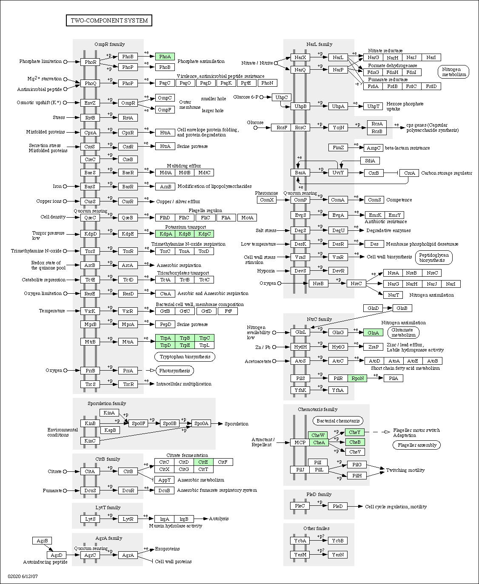
It looks like CheA are similar in both (General system and Halobacterium salinarum)
EcoCyc
EC Number: 2.7.13.3

