Ben Clarkson
Summer 2012 Research Proposal

Introduction
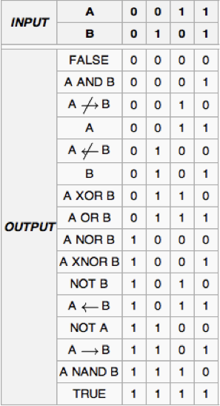One popular goal of synthetic biology is to make logic gates out of biological parts, with the future goal being the combination of many of these gates to form a biological computer. While we have read multiple papers this semester that have succeeded in forming these biological logic gates, they have all been constrained by the fact that they take many hours to perform their logic operations. In order to achieve the final goal of a biological computer, these logic gates must be able to quickly process their inputs, and also must be easy to link together. Therefore, our goal for the summer should be to develop a biological logic gate that is as fast as possible, as well as being easy to link with other gates. In reading various papers over the summer, it seems like the best way to do this would be by using optogenetics to induce transcription using light in the E. glowi strains of E. coli developed by a team at the University of Cambridge (1).
Figure 1. All of the types of logic gates, and their outputs for each combination of inputs. (2).

Logic Gates
Logic gates are Boolean logic operators that process one or more inputs and produce one output, and a basic computer can be made by combining many of these individual gates. A group of logic gates can also be used to construct a hash function to encrypt data (3). There are many types of logic gates, as shown in Figure 1, but we should focus on making a NOR (not OR) or a NAND (not AND) gate, as either one of these two gates can be used to construct all of the other types of gate functions (4).

Optogenetics
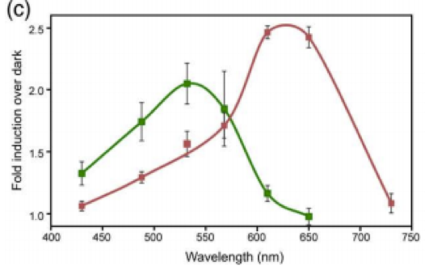Optogenetics refers to the combining of optical and genetic tools to monitor or control cellular processes. To monitor a cellular process, biosensors can be engineered from fluorescent protein reporters and proteins that can detect whatever changes are being monitored in order to convert physiological changes into a fluorescent output (5). To control a process, light activated channels, pumps, binding proteins, or others, can be used to dictate the timing and sequence of certain processes (5). The allure of optogenetics is that whereas other ways of controlling or reporting need to rely on diffusion through a medium, or a similarly slow process, optogenetic methods only rely on the speed of light to induce or report on the process of interest. Due to the extremely fast nature of the speed of light, one can see why this would be a useful way to control a process. The light activated proteins that we could use to control a process can also be engineered to respond to different wavelengths of light, and although there is some overlap in the wavelengths that these engineered proteins will respond to, there is enough of a difference between the wavelengths different proteins will respond to for it to be a non-factor (Figure 2).
Figure 2. “Despite the slight overlap…the separation in the action spectra of the two sensors could allow them to be combined for multiwavelength optical control of gene expression in a single cell.” (6).

Light-Induced Transcription
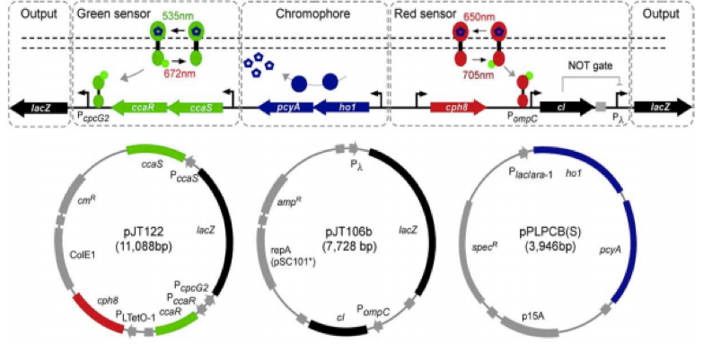For our experiment we want to be able to induce transcription of a gene using specific wavelengths of light. A team at the University of California San Francisco has made a light-induced transcription system in E. coli that is detailed in Figure 3. The way they achieved this result was by using phytochromes, a type of protein that is switched between an active and inactive state by shining red and far-red light on them (6). They engineered a phytochrome system in E. coli to induce transcription in response to 535 nm light, and to reverse the process in response to 672 nm light (6). They engineered it so that the application of green light increased the rate of autophosphorylation in CcaS, which in turn increased the rate of phosphotransfer to Ccar, as well as the rate of transcription of the promoter (6). They also engineered a tandem system that is “turned on” by 650 nm light and “turned off” by 705 nm light (6). This cascade takes place on the order of minutes, which would allow us to construct a logic gate that computes at much faster speeds than other current biological logic gates (6). We could replace the output of their system of lacZ with another output of our choice, depending on the specifics of the construction of our logic gates and how they’re linked together.
Figure 3. “Engineered two-color transcription induction system in E. coli. The green sensor and chromophore biosynthetic pathways are as described in the main text. The red light-sensing protein Cph8 is expressed from the PLTetO-1 promoter in the phosphorylated ground state. It is switched to the unphosphorylated state by 650-nm light and back to the phosphorylated state by 705-nm light. When phosphorylated, Cph8 passes a phosphoryl group to OmpR, which then binds to and activates transcription from PompC. Because it is inactivated by red light, Cph8 can be considered a NOT red sensor. A genetic inverter or NOT gate is used to invert the response of the NOT red sensor to that of a red light sensor. (Bottom) Plasmid maps of the green +red sensor plasmid pJT122, the red light inverter plasmid pJT106b, and pPLPCB(S), a variant of pPLPCB in which the kanamycin resistance cassette has been replaced by a spectinomycin resistance cassette). Note that the true configuration of the DNA encoding this system is represented by the plasmid maps, while the version shown atop this figure is simplified for clarity.” (6)

E. glowi
If we use this light-induced transcription system to make our logic gates, then we would need light to act as the input for each successive logic gate as we link them together. Since E. coli do not naturally produce light, the answer to how we would accomplish this lies in the work of a team at the University of Cambridge who engineered E. coli to fluoresce using genes from fireflies and bioluminescent bacteria, calling these new glowing E. Coli colonies E. Glowi. This team created 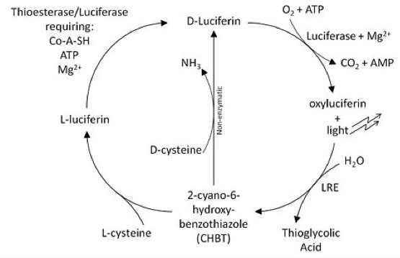BioBricks for luciferases of the Japanese firefly Luciola cruciata that they used to make E. coli glow different colors, and hence at different wavelengths. Luciferase is the enzyme that catalyzes the oxidation of luciferin, a pigment, into oxyluciferin, a chemically excited and unstable molecule. When oxyluciferin drops back down to its ground state, a photon of light is emitted, with very little energy being lost to heat (1). This cycle, the luciferin cycle, is detailed in Figure 4. One of the issues with using this cycle to produce fluorescence in colonies of bacteria is that the oxyluciferin that is generated from luciferin is not regenerated after it drops down to its ground state, and actually inhibits any further luciferase reactions. The Cambridge team got around this problem by using LRE (Luciferase Regenerating Enzyme), which converts the oxyluciferin into 2-cyano-6-hydroxybenzothiazole (CHBT), which can then be converted back into luciferin by D-cysteine and continue the cycle (1). This makes it so that the light output of the E. coli is brighter and sustained longer than without LRE and D-cysteine. They also found multiple factors that could increase the brightness of the light output. As was just discussed, the addition of D-cysteine increases the brightness of the light, as well as the addition of D-luciferin, increasing concentrations of arabinose in the media, and changing the pH of the media (1). The effects of these changes are shown in Figure 5.
Figure 4. The Luciferin Cycle (1).
Figure 5.
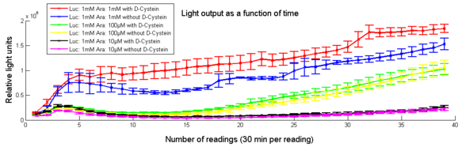

5a. Effect of varying D-Cysteine concentrations on light intensity. (1)

5b. “The interval between measurements is 30 min. Mean values and error bars are based on 3 time repeats.” (1)

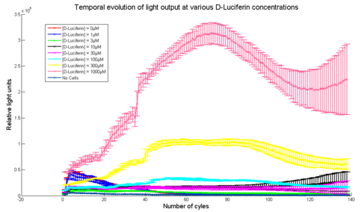

5c. Effect of arabinose concentration on light intensity. “The interval between measurements is 30 min. Mean values and error bars are based on 3 time repeats.” (1)

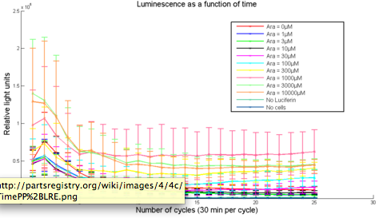

5d. “Maximum light output within 5 hours of D-luciferin injection at different pH values. These values are the mean of 3 readings. The corresponding error bars represent an interval of twice the standard deviation across the 3 data points centred around the mean value.” (1)

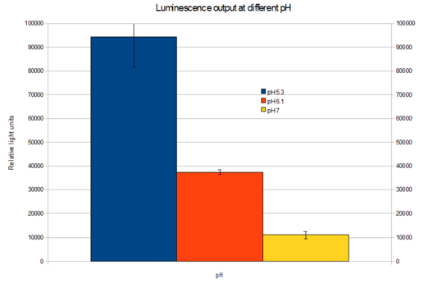
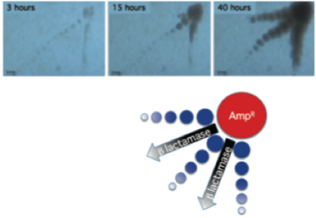
Figure 6. A) “Screen shots from time-delayed
colony growth at 3 hours, 15 hours, and 40 hours on an LB agar plate with 100 µg/mL ampicillin. B) Schematic drawing of time-delayed growth experiment. An ampicillin-resistant colony was inoculated in the top right corner of the image with ampicillin-sensitive inoculants placed in three linear paths away from the ampicillin-resistant colony.” (3).
Time Delayed Growth
Another important issue that we need to take into account is that the colonies need to perform their logic sequentially. If we simply spotted all of the colonies on the plate at once and let them grow simultaneously, they would all simultaneously perform their logic, making our construct fail since a colony at the end would be receiving no input from the previous colony before it performed its logic (3). In order to get around this problem, we need a method that allows the bacteria colonies to grow sequentially in a predictable manner. A team at Davidson College developed a mechanism to accomplish this by taking advantage of the diffusion of the enzyme ß-lactamase through the agar from ampicillin-resistant colonies to non-ampicillin-resistant colonies, as detailed in Figure 6. The ß-lactamase cleaves the ß-lactam ring of ampicillin, inactivating the antibiotic and allowing the non-ampicillin resistant bacteria to grow normally (3). The researchers also found that the bacteria had a linear growth rate, and that they could manipulate this rate using the initial concentration of ampicillin, the agar concentration, and temperature, all of which could be extremely helpful to know in our experiment (3). The graphs of this data are shown in Figure 7.
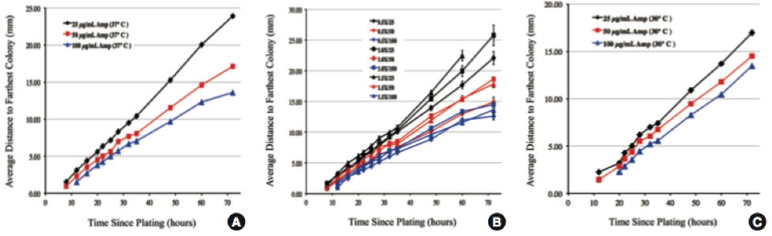
Figure 7. “Bacterial growth rate. (A) The effect of ampicillin concentration on growth rate in time-delayed growth at 37°C. (B) Effect of agar concentration on bacterial growth rate at 37°C. Media are described by agar concentration (0.5x=7.75 g/L) over ampicillin concentration (25=25 μg/mL). (C) The effect of ampicillin concentration on bacterial growth rate at 30°C. Error bars in all three panels are standard error of the mean, though many are smaller than the data point shapes.” (3)

Experimental Set-Up
Broadly speaking, our experiment will aim to construct a NOR or NAND logic gate using different wavelengths of light to induce light expression in colonies of E. glowi, which we will then try to connect to other gates, using the light output of one colony as one of the light inputs of another. This set up for a NOR gate is pictorially depicted in Figure 8.
Green light (558 nm) or no light
Red/Green/No Light

Red light (612 nm) or no light
Green light (558 nm) or no light
Red light (612 nm) or no light
Red/
Green/No Light

Green light (558 nm) or no light

Figure 8. Each gate is a colony made up of an equal mixture of Val239Ile (Green light producing) and His433Ser (Red light producing) E. glowi (1). (Right) A truth table for one of the individual NOR gates. Emission of light, either red or green or both, is represented by a 0, and an absence of a light output is represented by a 1.
Red light (612 nm) or no light
Red/Green/No Light
Inputs |  | Outputs
Green Light | Red Light
0 | 0 | 1
1 | 0 | 0
0 | 1 | 0
1 | 1 | 0

Each colony will consist of an equal mixture of green light and red light producing bacteria, all of which we will have the red and green light sensor constructs of Figure 3. Instead of lacZ as the output of each sensor, however, it will be the transcription of luciferase (there will already by LRE, D-cysteine, D-luciferin, and arabinose in the media). In this way, shining no light on a colony will result in no light output, since transcription of luciferase will not be induced by light. But when either green or red light shines on a colony, one or both of the sensor constructs from Figure 3 will induce the transcription of luciferase, and the colony will produce a light output. If we define a lack of a light output as a 1, and a presence of light as a 0, then we have constructed a NOR gate (as well as an OR gate if we reverse what we call each output). The light output (or lack thereof) from each gate will then act as one of the inputs for the next gate. The plates will also be spotted using the time-delayed growth method to link the gates, so the first colony will be ampicillin-resistant, with the successive colonies being non-ampicillin resistant so as to compute their logic in sequence (this also means the media must have ampicillin in it).

Initial Goals
Before we actually implement our experimental construct, there are a few things that we need to test to see if it is a viable idea first. We would need to insert the pJT122 plasmid for light-induced transcription of luciferase, as well as the plasmids for green and red light (from the BioBricks that the E. glowi team produced), into colonies of ampicillin resistant and non-ampicillin resistant E. coli. Then we would have to test our set-up to see if it was a viable idea to continue on with as an experiment (to make a series of logic gates):

1. First, we need to find out how what intensity of light we can generate using E. glowi. One key thing to notice on the graphs of the brightness of E. glowi colonies (Figure 5) is that they all use relative light units, so we don’t actually know just how bright the light that they generate is (which is why we’re testing it ourselves).

2. Then, we need to see how much light we can generate at different time points using the time-delayed growth method. While Figure 6 shows the linear growth of bacteria through the media, it doesn’t show exactly how many bacteria are present at different times. Since we are trying to construct a series of gates that computes its logic as quickly as possible, we need to test if the amount of bacteria that will be present after a shorter amount of time is enough to generate a response in subsequent colonies.

3. This leads into the next test, where we must find out how much light is needed to activate the green and red light sensor constructs from the light-induced transcription method (Figure 3). The team that designed the construct claims that very low intensities of light will induce transcription, but we need to test if their claims are true, as well as testing the construct with light generated by our colonies of E. glowi, rather than an artificial light.

4. We need to make sure that the “off” and “on” states of the E. glowi are different enough for us to easily differentiate between them for our experiment. If, as is highly probable, the “off” state still exhibits some light expression, we need to define what range of light intensities are “off” and what ranges are “on”.

Short Term Goals (if we can move forward after these tests)
If these initial experimental results are favorable, and we discover than we can generate enough light intensity with the E. glowi colonies to link the gates together, then we could move on to other goals to continue our research:

1. Now that we will have tested our construct with one logic gate, as well as with linking one to another, we should link a larger number of gates together to see if this has any undesirable effects, such as a decrease in signal strength with more linkages, or a limit to how many linkages we can make due to how long the light output lasts in the E. glowi. We also have to figure out what we will do when our linked colonies of E. glowi take up more space than a standard Petri dish so we can link larger numbers of gates together. This way we can discover what the limit to the modularity of our design is, by finding out just how large of a system of linkages we can create. Knowing this would be important if we were trying to make a computer or a complex hash function out of our logic gates.

2. Since we would have only come up with a NOR gate, we should design a NAND gate, and then make every other kind of logic gate (Figure 1) using a combination of gates. We should also design the other types of logic gates on their own (without using a combination of NOR and NAND gates). In this manner we can demonstrate the modularity of our construct in making any type of logic gate, as well as showing how easily it can be modified for different purposes (or different gates).

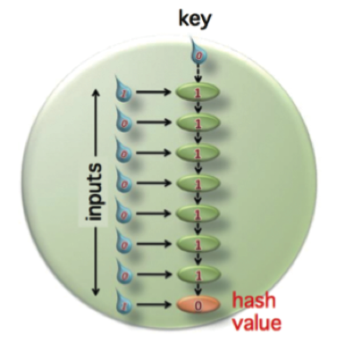Lofty/Future Goals
Figure 9. “Proof-of-concept bacterial hash function. Colonies (green) grow in a time-delayed manner. The key (blue drop on top) and the binary input message (blue drops on left) are applied manually. Each colony receives two bits of input.
The colonies respond sequentially with XOR logic to inputs and determine whether or not to generate an input to the next colony in the chain. The final colony in the chain will determine the hash value of the input message by ex- pression of a fluorescent reporter.” (3)
Realistically, we can only do so much work in one summer, but if we complete all of the previous goals, there are a couple interesting projects we could pursue either in the summer or in the future:

1. Since the end goal of creating a faster logic gate that is easy to link to other gates is to create a viable biological computer, we could construct a very simple computer out of a series of our logic gates. Even if it’s just a proof-of-concept, extremely simple, “computer”, this is one of two primary directions we could take our research in once we have constructed all of the different types of gates.

2. The second primary direction we could take our research in once we have constructed this fast, easily linkable logic gate, is to construct a hash function using our design. A hash function is used to authenticate documents, or protect passwords, transactions, software, and other materials, by encrypting an input into a “message digest” code that is of a much smaller size in a way such that the input cannot be inferred from the output (3). The hash value is the output of a string of inputs and is the “fingerprint” that protects a document from document tampering (3). Figure 9 depicts a proof-of-concept hash function that the team at Davidson College developed (3). An ideal hash function must have 3 characteristics: preimage resistance, second preimage resistance, and collision resistance (3). Preimage and second preimage resistance refer to the difficulty of, given a certain output, finding an input that hashes to it, and a second input that hashes to that same output, respectively (3). Collision resistance is a measure of the chance of a certain hash value being produced by two different inputs, and an ideal hash function is designed to minimize collisions, as well as to be completely irreversible (3). But perhaps the most compelling reason to use our experimental construct for designing a hash function is that with an ideal hash function “it should be quick and easy to extract an output from a given input message” (3). Since messages between successive logic gates are delivered at the speed of light, and, based on the fact that the team that developed the light-induced transcription method claims it takes somewhere on the order of hours to achieve stable levels of expression of the gene of interest, our construct has the potential to be far superior in processing speed to other DNA-based bacterial hash functions.

Alternative goals
If in doing our initial experiments we find that we can’t generate enough light with our E. glowi colonies, our research will take on a different tack, with the following objectives:

1. Our first, and most obvious, objective would be to increase the intensity of the light generated by our E. glowi colonies. There are two different ways of potentially solving this problem: manipulating the E. glowi themselves, or by manipulating the time-delayed growth construct to achieve more E. glowi growth more quickly.
a) In manipulating the E. glowi themselves, we could take advantage of the factors that the University of Cambridge team explored to manipulate the intensity of light. Although we would perform the initial experiments using the optimal concentrations of D-cysteine, D-luciferin, and arabinose that they found, we probably want to also do these experiments at a neutral pH of 7. This is because for one thing, we don’t want to have too many variables in our experiment that could potentially contribute to experimental errors; so making the media acidic or basic from the start may just convolute and complicate our analysis of the factors contributing to the results we see. We also can’t be sure that an acidic environment wouldn’t have unwanted effects that could mask other aspects of our results, such as a lack of light emission due to cell death due to an acidic environment rather than a lack of inputs. But if we aren’t getting enough intensity in our light outputs we could lower the pH of the media to increase the intensity of the light, as the University of Cambridge team showed in Figure 5d (1). We could also attempt to increase the intensity of the light output using a synthetic ribosomal binding site to greatly increase translation rates, and therefore increase the activity of luciferase.
b) We could also manipulate the time-delayed growth design to increase the speed that ß-lactamase is transported to the non-ampicillin-resistant bacteria colonies so that more cells will grow in a shorter amount of time, increasing the intensity of light simply by the sheer number of cells present. Since molecules move faster at higher temperatures, we could try increasing the temperature of the medium in order to speed up the diffusion of the ß-lactamase from the ampicillin-resistant colony of E. glowi to the other colonies. We could also try combining our design with a microfluidic set-up 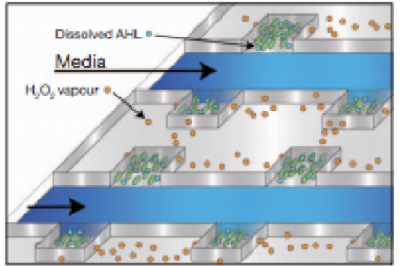similar to the one developed by a team at the University of California San Diego for use in “biopixels” (7). Their set-up is depicted in Figure 10. Ours would be similar, but in place of the dissolved AHL, we would have our colonies of E. glowi, there would be no H₂O₂ vapor, and the media flowing from colony to colony would contain ß-lactamase. Ampicillin would also be present in E. glowi colonies, perhaps in place of the H₂O₂ vapor in the UCSD design. This could allow us to transport the ß-lactamase to other colonies much more quickly than by simple diffusion, which would increase how quickly the colonies would grow, thereby increasing the intensity of light they produce due to the higher amount of cells producing the light.
Figure 10. “Conceptual design of the sensing array. AHL diffuses within colonies while H₂O₂ migrates between adjacent colonies through the PDMS. Arsenite-containing media is passed in through the parallel feeding channels.” (7)

2. If all of our manipulations do not result in enough intensity of the light output to achieve a response in subsequent bacterial colonies, then we will be forced to attempt to link the logic gates together manually. While this would be far more labor intensive, it still could be a much quicker way to make a series of logic gates than other designs, as constructs like the UC San Francisco team’s require periodic spotting of plates to link together gates, but still rely on diffusion to send signals between colonies (4). Just because the intensity of the generated light is not enough to induce transcription of luciferase in sequential bacterial colonies does not mean that the light output is too small to be seen. If the difference in the intensity of the light output from the “on” to the “off” state of the colonies is great enough to be seen with the naked eye, then we can observe the output of each gate ourselves and manually provide the input to the next gate with another light source. If the difference, however, is very slight, we would have to use special equipment to sense the light, such as a lock-in amplifier and a chopper wheel, which when used together would allow us to amplify the difference in light signals to better tell when a colony is “on” or “off”.

How does the math fit in?
Most of the mathematical portion of this research will be in modeling. It would be helpful, ideally, to develop a program to model our experimental design in which we could vary different factors and see how they will affect our experiment without having to spend the money and time necessary to do it in a lab. We also could model the rates of transcription, or growth of colonies, or the intensity of light production in order to better predict our results, as well as to calculate how efficient our system is. The formulating of each type of logic gate also falls under the umbrella of mathematical topics, and is extremely important for this experiment.

List of special materials needed
- Order or make ourselves:
  - pJT122 plasmid for light-induced transcription (6)
  - Green and red light generating E. glowi plasmids (parts BBa_K325229 and BBa_K325249) (1)
  - Ampicillin-resistant E. coli
  - D-cysteine
  - D-luciferin
  - ß-lactamase
  - ampicillin
- light source that can provide specific wavelengths/colors of light to a small, specific area (either light+filter or laser)
- Spectrophotometer
- Optional/possible materials:
  - Lock-in amplifier
  - Chopper wheel
  - Microfluidic device
  - Synthetic ribosomal binding sites

References
1. Cambridge 2009 iGem team. (2009). E. Glowi Cambridge. Accessed 6 May 2012.
2. Wikipedia. (2012). Logic Gate. [http://en.wikipedia.org/wiki/Logic_gate]. Accessed 6 May 2012.
3. Pearson, B., et al. (2011). Bacterial Hash Function Using DNA-Based XOR Logic Reveals Unexpected Behavior of the LuxR Promoter. Interdisciplinary Bio Central 3(10) 1-10.
4. Tamsir, A., Tabor, J.J., and Voigt, C.A. (2011). Robust multicellular computing using genetically encoded NOR gates and chemical ‘wires’. Nature 469 212-215.
5. Knöpfel, T., Lin, M.Z., Levskaya, A., Tian, L., Lin, J.Y., and Boyden, E.S. (2010). Toward the Second Generation of Optogenetic Tools. The Journal of Neuroscience 30(45) 14998-15004.
6. Tamsir, A., Tabor, J.J., and Voigt, C.A. (2011). Multichromatic Control of Gene Expression in Escherichia coli. Journal of Molecular Biology 405(2) 315-324.
7. Prindle, A., Samayoa, P., Razinkov, I., Danino, T., Tsimring, L.S., Hasty, J. (2012). A sensing array of radically coupled genetic ‘biopixels’. Nature. 481 39-44.

