A pathway in Vaccinium corymbosum homologous to the TMV resistance pathway in Tobacco at the genomic level, as well as other viral resistance genes

Tim C. Keating
Davidson College
Biology 343 Research Group

Abstract
Blueberries are becoming increasingly important from an economic and health standpoint, and the expansion of their production warrants actions to reduce cost and increase production of their cultivation. This investigation served to produce SSR markers on genes involved with virus resistance, most significantly a pathway homologous to the TMV resistance pathway found in tobacco. With these SSR markers, it will be easier to allele-type strains of blueberries and make more informed selective breeding decisions. These improved plant offspring will increase the viral resistance of blueberry crops, and reduce the costs and environmental impact associated with traditional pest control.
Introduction to blueberries
The health benefits of blueberries (Vaccinium) have been recognized for centuries. In pre-colonial America, Native American tribes in the Northeast used the berries, leaves and roots of the blueberry plant for herbal remedies (Demchak, 2008). As oxidative stress has been recognized more and more as the underlying cause of aging, cardiovascular death, lung dysfunction, and other serious health concerns (Kelly, 2003), blueberries have held an important place in the public spotlight for their antioxidant properties. The antioxidants found in blueberries reverse and prevent oxidative damage, and studies have shown that consumption of blueberries increase neuronal signal transduction, cognition, and reversal of motor deficits (Joseph, 1999).
Consumption of blueberries offers a promising solution to the oxidation of increasing pollution and high-cholesterol diets, and is an industry that continues to grow (Figure 1). Economic and health benefits of blueberry make their production an important target for expansion, but the blueberry industry faces many of the same obstacles as any other form of agriculture. Among concerns about soil type and irrigation, plant pests demand a large
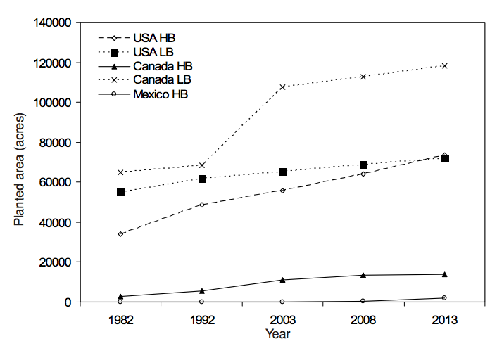
influx of time and resources to combat. Blueberry cultivation is no exception, and experiences a significant amount of crop loss to diseases such as Mummy-rot, stem blight, and plant death from viruses (Moore, 1993). Common blueberry viruses include Blueberry Shock Virus (BlShV), Blueberry Scorch Virus (BlScV), and Blueberry Fruit Drop Virus. All three of these viruses are devastating to blueberry farmers, and severe infections can lead to a total loss of crop for up to two years (Martin, 2009). Losses of this type are of the utmost importance to prevent, and detecting virus resistant alleles within different blueberry strains would be an extremely valuable tool to farmers.
Figure 1: Production of blueberries from 1982-2013. Production of lowbush (LB) and highbush (HB) continues to rise in both the US, Canada and Mexico. From Strik, 2006.
Introduction to plant viruses
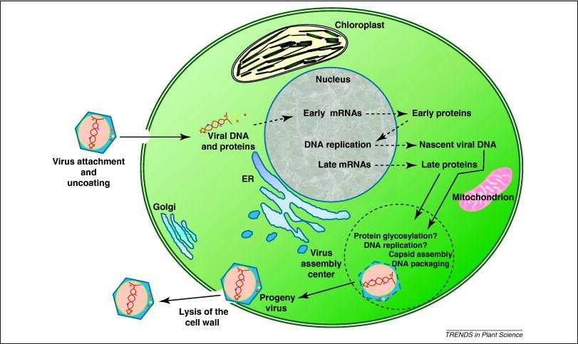
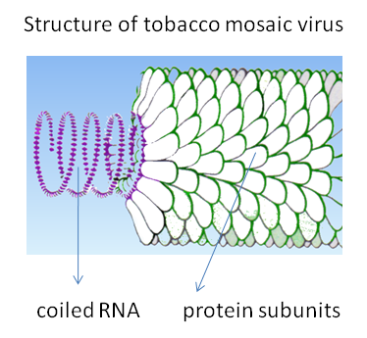
An understanding of virus resistance in blueberry demands an understanding of plant viruses in general. Viruses are simple biological machines with relatively few genetic components that are designed to override natural cellular machinery of their host for their own use. The tobacco mosaic virus, TMV, is the most prominent viral pest of tobacco, and can be seen in Figure 2a (From Pfleger, 2008).
Figure 2: Plant virus structure and life cycle. A) Most plant viruses consist of a protein capsid surrounding a nucleic acid center that encodes cellular machinery not provided by the host. B) The viral life cycle consists of infiltration, transcription of viral DNA, and assembly of viral progeny, followed by host cell lysis and viral exodus. (a Pfleger, 2008; b Van Etten, 2008))
Figure 2b
Figure 2a
Like TMV, most viruses are made up of a nucleic acid core and protein capsid. In the viral life cycle (Figure 2b, Van Etten, 2008) a virus first adheres to the outside of a host cell. Usually targeting surface proteins, the virus then infiltrates the cell wall and the viral nucleic acid is unsheathed. The viral genome is transcribed by host machinery, and then viral proteins assemble into new viruses. Newly assembled virions then leave the cell to infect new cells, usually leading to apoptosis. Throughout plant evolution, defenses against plant viruses have developed. The biggest advantage a plant has against a virus is that the virus must utilize the plants own cellular machinery. This means that any mutation that allows machinery to function normally within the plant but makes it unrecognizable or non-functional to viruses creates a resistant strain. Other defenses have also evolved, most notably resistance genes, or R genes, which specifically confer resistance to a plant. Knockout techniques have been used to explore R-gene functionality, and one of the most significant R genes is N, which is found across a number of plant species (Liu et al., 2004). The gene N mitigates resistance by initiating a response pathway after a “recognition event” of a protein belonging to the virus, called the avirulence, or avr, protein. The downstream effects of a recognition event activate transcription of genes that interferes with viral viability, mostly through mechanisms that are not yet completely understood but have been demonstrated to confer viral resistance (Liu et al., 2004).
Davidson College group
This investigation is a product of student work from a class titled “Lab Methods in Genomics,” at Davidson College in Davidson, North Carolina. Working in close collaboration with researchers at NC State University and a number of other institutions, students were assigned a particular pathway, the pathway explored here being viral resistance in Vaccinium. The Vaccinium genome is one of the most recently sequenced plant genomes, and this research effort aims to better understand pathways that have substantial application value to blueberry farmers around the world. The initial focus of the current study was to develop SSR primers for R genes within blueberry, which led to a close focus on orthologs to the N-mediated pathway of viral resistance. The ultimate goal of this study was to generate primers capable of efficiently identifying alleles of R genes which may confer variable resistance in order to more systematically breed viral resistant blueberry strains.
Methods
Given the topic of viral resistance in Vaccinium, my research began with a primary literature search. The topic of viral resistance is extremely important to agriculture across many species of plants, and is therefore a well-published topic. A primary literature search yielded two reviews that were particularly applicable to my research; Kang et al. 2005 and Hammond-Kosak et al., 1997, which are both reviews of plant viral resistance. It was these reviews that directed further research, as they contain a wealth of information about known viral resistance genes. Correspondence with Dr. James Polashock, a USDA plant pathologist who focuses on disease resistance in blueberry, further steered the direction of research with the suggestion to pursue a class of R-genes known as NBS-LRR. Nucleotide binding site (NBS), and leucine-rich repeats (LRR) are regions unique to a particular type of R-gene. LRR sites serve to facilitate protein-protein interactions, such as activation, while NBS are sites of ATP-binding and hydrolysis that are able to catalyzes downstream signaling in a pathway (Belkhadir et al., 2004). Ultimately, the current study focused primarily on a pathway known to function in tobacco, Nicotiana tabacum, against tobacco mosaic virus (TMV). This pathway, shown in Figure 3, includes many genes of known sequence, which made the pathway an excellent target for investigating any possible homology in Vaccinium.
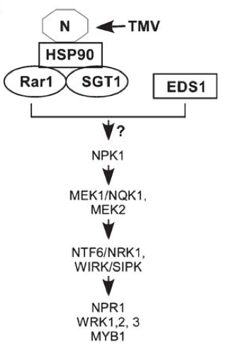
Once a list of genes has been compiled, both from the TMV resistance pathway and from the reviews on general plant viral resistance -- with a particular focus on NBS-LRR genes -- the next phase of investigation could begin. Gene names were used to discover protein sequence by searching the NCBI protein database (NCBI, 2013). Proteins from the search results were preferentially selected first by how closely the organism is related to Vacciunium, and then based on a mention of their involvement in anti-viral activity somewhere in the related publications section of the protein summary. All protein sequences were compiled (which can be found in the online supplemetary materials), and then a local tBLASTn was run on amino acid sequences using the terminal command line prompt in Figure 4. Within the BLAST results, only the sequence homology with the lowest E value was recorded. For sequences that had hits on multiple scaffolds with E=0 (up to four for some proteins), all E=0 hits were recorded. Scaffold hits with the lowest E value for a particular protein sequence that did not exceed 0.0001 were deemed significant and run through the SSR tool of the Vaccinium Genome Database (Vaccinium, 2013).
Figure 3: known TMV resistance pathway in tobacco. The known sequence of these proteins was used to find homologous genes in blueberry. (REF)
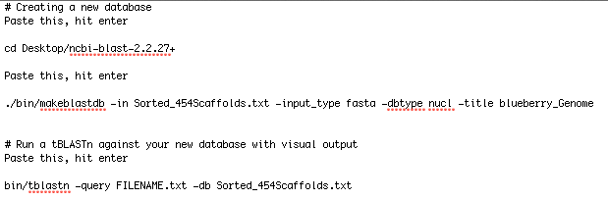
Once SSR primers for the blueberry genome were generated for scaffolds of interest – particularly the main proteins of interest from the TMV pathway – sequence location taken from the Terminal tBLASTn results was used to select primers that were both close to the gene, and had a high number of repeats. The primers generated from this investigation can be found in Table 1 of the appendix.
Figure 4: Terminal command-line prompt. I used the above coding instructions to perform a local tBLASTn on the blueberry scaffolds using sequences found on NCBI of known R-proteins. The first prompt creates a database from the NCBI folder on the desktop, while the next prompt creates a bin capable of BLAST with FASTA output. The third command is a search function that BLASTs a file in FASTA format. Shown is a tBLASTn command, which can be changed to “bin/blastn”.
Results
Table 1 harbors the results of the current study, which includes which genes were successfully found on which scaffolds, as well as which genes have already been matched to appropriate primers, which currently includes all the proteins found from the TMV pathway.
Discussion
The search for a homologous sequence in Vaccinium yielded encouraging results, with each protein within the pathway found with great confidence. The current study has taken this investigation to the brink of what is capable with purely genomic data, and wet-lab research now necessary. Wet-lab tests will be able to conclude whether the sequence
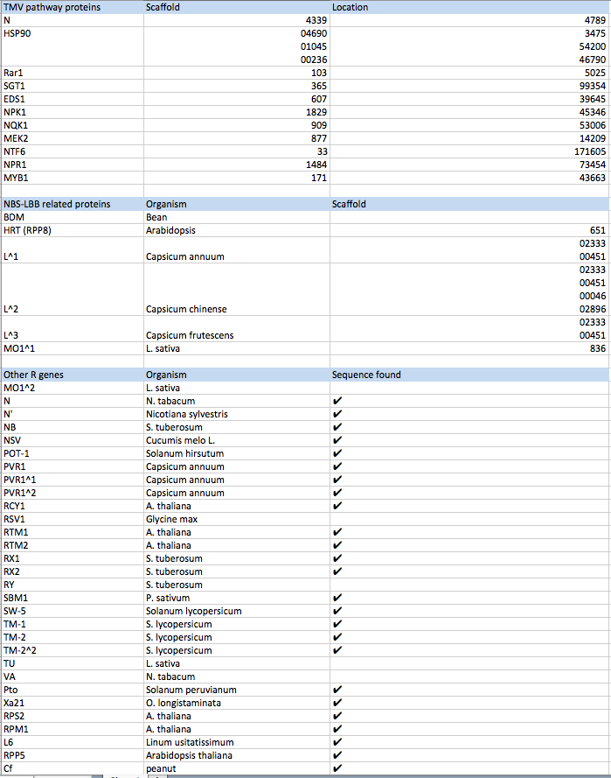
Table 1: Results from ortholog search including pathway, NBS-LRR genes, and other R genes of interest.

homology within Vaccinium is purely an inactive remnant of an ancestral shared pathway, or if these proteins do indeed play a roll in viral resistance. The extremely high sequence conservation would suggest that these proteins have not diverged greatly since their common ancestor with tobacco, but their activity is only speculative with the current genomic methods. Depending on the research interests of future scientists, R genes outside the pathway can also be explored based on the sequences available in the online supplementary materials.
Conclusion
The ability to breed blueberry cultivars that are naturally viral resistant would save time and money currently devoted to pest control. The primers generated during this study could potentially be used to genotype blueberries for different alleles of R-genes, which would streamline selective breeding. Genotyping will occur when the plant is still very young, which saves time and resources by eliminating the need to wait and see what phenotype it is as a mature plant. Wet-lab research will determine whether or not the pathway explored in the current study is active and serves to suppress viral infection like it does in tobacco, as well as if the other R-genes found are active in blueberry. Future researchers are encouraged to use data from this study, which is available online. Blueberries offer a wide array of potential health benefits, and it is likely that their production will continue to rise. The proposed method of blueberry screening and accelerated breeding selection will eliminate many harmful aspects of current pest control that may have unknown effects on long-term human health and the environment, as well as reduce the push for genetically modifying crops, which has received public backlash and may have unintended health effects. In a world of ever-increasing oxidative stress, blueberries serve as an effective and delicious antioxidant with the capacity to reduce mortality from cardiac events and other diseases related to oxidative damage around the world.
Acknowledgments
I would personally like to thank Dr. Malcolm Campbell at Davidson College, Dr. Allan Brown at NCSU, Dr. Jeannie Rowland with the USDA, and Dr. Doreen Main at WSU for both their assistance throughout the semester and knowledge in the topic of blueberry genomics. Without them this study could not have happened.

References

Belkhadir Y, Subramaniam R, Dangl JL. (2004). Plant disease resistance protein signaling: NBS-LRR proteins and their partners. Curr. Opin. Plant Biol. 7, 391 – 399. (doi:10.1016/j.pbi.2004.05.009)
Demchak, K., et al. (2008). Mid-Atlantic Berry Guide for Commercial Growers. University Park: The Pennsylvania State University.
Hammond-Kosack K, Jones J. (1997). Plant disease resistance genes.Annu. Rev. Plant Physiol. Plant Mol. Biol. 48:575–607
Joseph, J.A., Shukitt-Hale, B., Denisova, N.A., Bielinski, D., Martin, A., McEwen, J.J., and Bickford, P.C. (1999). Reversals of age-related declines in neuronal signal transduction, cognitive, and motor behavioral deﬁcits with blueberry, spinach, or strawberry dietary supplementation. J.Neurosci., 19:8114–8121.
Kang, B.C., Yeam, I. & Jahn, M.M. (2005). Genetics of plant virus resistance. Annu. Rev. Phytopathol. 43, 581–621.
Kelly FJ. (2003). Oxidative stress: its role in air pollution and adverse health effects. Occup Environ Med. ;60:612–616.
Liu Y, Schiff M, Dinesh-Kumar SP (2004). Involvement of MEK1 MAPKK, NTF6 MAPK, WRKY/MYB transcription factors, COI1 and CTR1 in N-mediated resistance to tobacco mosaic virus. Plant J , 38:800-809.
Martin, Bob (2009). Blueberry Viruses: Shock, Scorch and More or Just Shock and Awe. Eastern Washington Blueberry Workshop. Prosser, WA. http://mountvernon.wsu.edu/small_fruit_hort/presentations/2009/Blueberry%20Virus%20Prosser.pdf
Moore JN (1993) The blueberry industry of North America. Acta Horticulture 346:15–26
Pfleger, F. L. and Zeyen, R. J. (2008). Tomato-Tobacco Mosaic Virus Disease. Plant Pathology. University of Minnesota.
Strik, B. 2006. Blueberry production and research trends in North America. Acta Hort. (ISHS) 715:173-184. http://www.actahort.org/books/715/715_25.htm
Research tools:
National Center for Biotechnology Information, protein search (http://www.ncbi.nlm.nih.gov/protein/)
Genome Database for Vaccinium- SSR generator tool
(http://www.vaccinium.org/node/5897)
Online Supplementary Materials can be found at <http://gcat.davidson.edu/mediawiki-1.19.1/index.php/Disease_resistance_to_viral_diseases>

Appendix

Table 1: Primers for homologous TMV resistance pathway
MYB1 | scaffold=00171 | starts at base=43663
SSR 1
Forward primer | TGGCAATCAACCCTAAGAGATT
Reverse primer | CCTCATCTCTTCTCCCCTCTCT
 | Repeats= 23 x (ga) | PCR product= 152 | Start at base= 72875
SSR 2
Forward primer | GACTATAGGACACGGTTGGCTC
Reverse primer | TTATTTTGATGTGGGGGTCTTC
 | Repeats= 10 x (ga) | PCR product=286 | Start at base= 27939
SSR 3
Forward primer | AACCAAAACCCTAAACCCTAGC
Reverse primer | CAGAGATTGAACACAGCGGTAG
 | Repeats= 9 x (ag) | PCR product= 169 | Start at base= 51956
NPR1 | scaffold= 01484 | starts at base= 73454
SSR 1
Forward primer | GCATCAAAACACCGAAAAACN
Reverse primer | AGAGACGCCGTTGAGAAAAG
 | Repeats= 14 x (ct) | PCR product= 286 | Start at base= 29027
SSR 2
Forward primer | AATTCTTCCCATCAAGAACCCT
Reverse primer | CGAAGGGGTTGTCTAGATTCAG
 | Repeats= 8 x (ga) | PCR product= 234 | Start at base= 66440
SSR 3
Forward primer | AACGTATATGAGTGCCCAAACC
Reverse primer | CCTACCATTAGAGAGGTTCCCC
 | Repeats= 5 x (ca) | PCR product= 249 | Start at base= 68443
NTF6 | scaffold= 00033 | starts at base= 171605
SSR 1
Forward primer | GGAGCCACTATTCACTCCCTAA
Reverse primer | TCCTCCCTAAAAAGATTGGTGA
 | Repeats= 14 x (tg) | PCR product= 229 | Start at base= 164593
SSR 2
Forward primer | AATTCTAGGGTTTTGCTGTTCG
Reverse primer | CTCTGCGATTCTTCTCTGGAAT
 | Repeats= 19 x (ct) | PCR product= 264 | Start at base= 128933
SSR 3
Forward primer | TGGAGGAAGAGAAGAGTTGAGG
Reverse primer | CTGCATTTCTATGGTTCTTCCC
 | Repeats= 7 x (ag) | PCR product= 153 | Start at base= 170437
MEK2 | scaffold= 00877 | starts at base= 14209
SSR 1
Forward primer | AGCTGCATATCTTTGTCCGAAT
Reverse primer | CAAAAGCGAGAATATAGTGCCC
 | Repeats= 10 x (tc) | PCR product= 270 | Start at base= 22487
SSR 2
Forward primer | CGAGTGCCAGATAAAGAGAAGG
Reverse primer | GAGATAGATTTGTTGGGTTGGG
 | Repeats= 9 x (att) | PCR product= 291 | Start at base= 13465
SSR 3
Forward primer | ATCTATCTCCGGAAACCTCCTC
Reverse primer | TGGAGAAAGGACGAAAAAGAGA
 | Repeats= 8 x (tc) | PCR product= 228 | Start at base= 13679
NQK1 | scaffold= 00909 | starts at base= 53006
SSR 1
Forward primer | TGAGCTCCCCTTCATATCCTTA
Reverse primer | ATGGTATTCTGGGAACAACCAC
 | Repeats= 12 x (aca) | PCR product= 225 | Start at base= 58799
SSR 2
Forward primer | TAATCTTCCGGGATAATGTTGG
Reverse primer | TTGAATCTTGAGTTTGGGGAGT
 | Repeats= 6 x (ct) | PCR product= 294 | Start at base= 69944
SSR 3
Forward primer | CTGGTCCGAATAACCAAGTCAT
Reverse primer | TCAATCCGACAGTACAATTTGC
 | Repeats= 16 x (ag) | PCR product= 108 | Start at base= 76864
NPK1 | scaffold= 01829 | starts at base= 45346
SSR 1
Forward primer | GCACAAATATGGGACACAAATG
Reverse primer | TCAACTGCTTTGAACTGAGGAA
 | Repeats= 17 x (ag) | PCR product= 264 | Start at base= 48878
SSR 2
Forward primer | AACCCGAAACCAGATTATGATG
Reverse primer | AGGTGAAATAACTTGCAGCCAT
 | Repeats= 9 x (ca) | PCR product= 214 | Start at base= 49977
SSR 3
Forward primer | GTGTAGATCCAAAGCTCAAGGG
Reverse primer | TCACGCGAGTGAAGTTACTTGT
 | Repeats= 6 x (ct) | PCR product= 282 | Start at base= 47295
EDS1 | scaffold= 00607 | starts at base= 39645
SSR 1
Forward primer | AATAAAATACGGTTGTCCACGG
Reverse primer | GATATGGTTCGGTTCACGAAAT
 | Repeats= 4 x (aag) | PCR product= 250 | Starts at base= 40592
SSR 2
Forward primer | TGATGATTTTAGTTGCAGGTGG
Reverse primer | CACAAACACATGCATGAACAAG
 | Repeats= 6 x (ct) | PCR product= 226 | Starts at base= 35204
SSR 3
Forward primer | CAGAGGAGCTTCCGTTATCCTA
Reverse primer | GGTTAGGTACTCGCCCTCTTTT
 | Repeats= 5 x (tc) | PCR product= 246 | Starts at base= 28118
EDS1 | scaffold= 00607 | starts at base= 39645
SSR 1
Forward primer | 0
Reverse primer | 0
 | Repeats= 4 x (aag) | PCR product= | Starts at base= 40592
SSR 2
Forward primer | 0
Reverse primer | 0
 | Repeats= 6 x (ct) | PCR product= | Starts at base= 35204
SSR 3
Forward primer | 0
Reverse primer | 0
 | Repeats= 5 x (tc) | PCR product= | Starts at base= 28118
SGT1 | scaffold= 00365 | starts at base= 99354
SSR 1
Forward primer | AACTACGAGACTATACACGAGGACC
Reverse primer | CCAGCCCTACCATGGATATAAA
 | Repeats= 16 x (ct) | PCR product= 141 | Starts at base= 107277
SSR 2
Forward primer | TAATGTGGTCTATCTTGCCGTG
Reverse primer | GGTGAGTATCAACTTTCCCAGC
 | Repeats= 9 x (ct) | PCR product= 166 | Starts at base= 113622
SSR 3
Forward primer | CACCAGTTCATGTTAGAAGGCA
Reverse primer | CAAGACTCACTTCTCCGTTGTG
 | Repeats= 7 x (tg) | PCR product= 185 | Starts at base= 94333
RAR1 | scaffold= 00103 | starts at base= 5025
SSR 1
Forward primer | TAACGCACTACCTTACGGTTCA
Reverse primer | AAATACCAGCAGGGTTCTTTCA
 | Repeats= 7 x (tc) | PCR product= 221 | Starts at base= 19511
SSR 2
Forward primer | CACTCACCTTTTTCATCTTCCC
Reverse primer | TGAGAGAGAGAGAGAAGGCAGG
 | Repeats= 6 x (ct) | PCR product= 239 | Starts at base= 19376
SSR 3
Forward primer | TAACGCACTACCTTACGGTTCA
Reverse primer | AAATACCAGCAGGGTTCTTTCA
 | Repeats= 7 x (tc) | PCR product= 221 | Starts at base= 19511
HSP90(1) | scaffold= 0236 | starts at base= 3475
SSR 1
Forward primer | CTATGGTCCCCTGAAGAAGATG
Reverse primer | TGTAATTTGTCTGAACAACCCG
 | Repeats= 10 x (ct) | PCR product= 202 | Starts at base= 39334
SSR 2
Forward primer | CCCTAAATCTCTCTCCTCCCAT
Reverse primer | ACGTAGTTCGTACAAGACGGGT
 | Repeats= 11 x (ct) | PCR product= 140 | Starts at base= 74239
SSR 3
Forward primer | GCTCATTGCCATCTGATATTTG
Reverse primer | AGCTCTGAGTTCCCTACTGGTG
 | Repeats= 23 x (tg) | PCR product= 196 | Starts at base= 28348
HSP90(2) | scaffold= 01045 | starts at base= 54200
SSR 1
Forward primer | CAGTAGAGGGCTAAAAGGCAAA
Reverse primer | AGTCTGGTTCTCGTTGCTCTTC
 | Repeats= 9 x (ag) | PCR product= 293 | Starts at base= 57275
SSR 2
Forward primer | TCCTCCTCTCTCTCTCTCTCTCTG
Reverse primer | ACCTCATATCCTACCTCGCTGA
 | Repeats= 30 x (gt) | PCR product= 181 | Starts at base= 31408
SSR 3
Forward primer | AAGAAGGGTTGAAACTGGATGA
Reverse primer | CCATGTTAGCAGTCCAACCATA
 | Repeats= 4 x (aga) | PCR product= 195 | Starts at base= 55248
HSP90(3) | scaffold= 04690 | starts at base= 46790
SSR 1
Forward primer | AGAAAGAGAGTGCGTGTTAGGC
Reverse primer | AACGGGCGATACAAGAGAGATA
 | Repeats= 7 x (tc) | PCR product= 234 | Starts at base= 1435
SSR 2 not found
SSR 3 not found
N | scaffold= 04339 | starts at base= 4789
SSR 1
Forward primer | TCAGCATGTGTTTGTGATTGAG
Reverse primer | CTCAAGTTTCCACTTTCTCGCT
 | Repeats= 8 x (ga) | PCR product= 150 | Starts at base= 6948
SSR 2 not found
SSR 3 not found

