Using ClustalW to Generate a Multiple Sequence Alignment and Phylogenetic Tree

- Why Make a Phylogenetic Tree?
- About ClustalW
- Submitting Sequences and Choosing Parameters
- Understanding Output
  - Score Table
  - Multiple Sequence Alignment
  - Phylogenetic Tree

Why Make a Phylogenetic Tree?
A phylogenetic tree is a visual depiction of evolutionary relationships based on DNA or protein sequences among different taxonomic groups, the “leaves” of the tree. Evolutionary time is determined by how different the DNA or amino acid sequences of the samples are from each other. Branches from a common node (branch point) represent descendents of a common ancestor (or hypothetical ancestral sequence). Trees can be rooted or unrooted. A rooted tree structures the nodes and branches based on inferences about common ancestors. In order to root a tree, there must be an input sequence to act as a relevant outgroup – a sequence close enough to the others to make an inference on evolutionary distances, but far enough to be its own separate branch. An unrooted tree structures the leaves based only on relatedness without making inferences about common ancestors.

About ClustalW
ClustalW is a free online tool through the European Bioinformatics Institute (EBI) used to align multiple sequences and generate phylogenetic trees. You can access the second version of ClustalW at: http://www.ebi.ac.uk/Tools/clustalw2/ . When the user inputs the desired sequences to align, ClustalW generates a sequence alignment, and a rooted phylogram or cladogram. A phylogram explicitly represents the number of sequence character changes through the horizontal branch length. The sum of the horizontal distances between two leaves is the predicted evolutionary difference in sequences. A cladogram only depicts branching patterns, not evolutionary time by branch length. In a cladogram, branch length is arbitrary; only groupings of leaves are relevant.

Submitting Sequences and Choosing Parameters
- The user must collect sequences from an annotation service, gene database, sequence file, or so on. If you retrieve a sequence from a database, retrieve it in the FASTA format if possible.

- Go to the ClustalW page: http://www.ebi.ac.uk/Tools/clustalw2/ . If the link does not work, go to the EBI main page, http://www.ebi.ac.uk/ . In the grey menu at the top, select: Tools > Sequence Analysis > ClustalW2. On the ClustalW page, you should see a coloured drop-down menu box to edit parameters, and below that box is an open dialogue box to enter sequences.

- In the open dialogue box, paste all of your DNA or amino acid sequences (Maximum 500). Although not listed as an option, ClustalW will align RNA sequences as well. On inputing sequences:
  - Provide a name line before each sequence, followed by a return and the sequence.
  - Begin name lines with a ‘>’. Example: ‘>SpeciesName’ is an appropriate name line. This is essentially FASTA formatting.
  - Use a very distinct name for each sequence. You can use numbers as well. Do not use spaces. For example, use ‘>GenusTrivial’ or “G-Trivial’ instead of ‘G. Trivial’.
  - ClustalW will truncate any names with over 30 characters, so your names must be distinct within the first 30 characters.

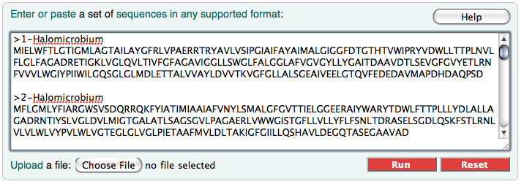
Sample dialogue box of amino acid sequences. Note the ‘>’ and name with a distinct beginning and no spaces. Be sure the sequence begins on the next line.

- You can edit the parameters for your multiple sequence alignment using the drop down menus above the open dialogue box. If you are not sure of which parameters may be better for your alignment project, use the Defaults (def); do not alter anything in the drop-downs.
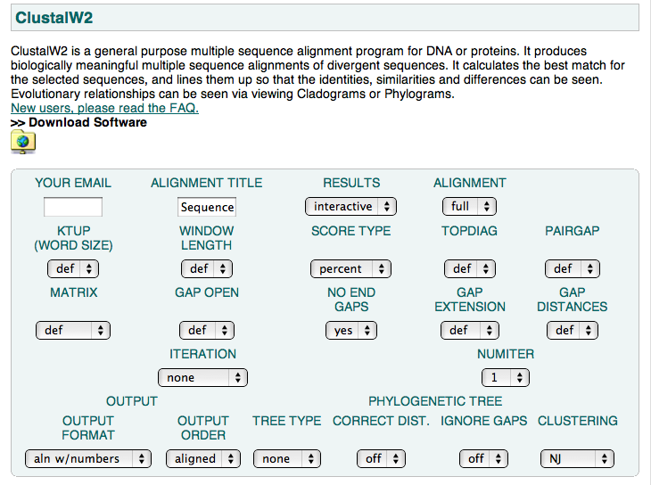
Parameter boxes for alignment and output.

  - If you would like the results sent to your email address, Select: Results > Email. Also enter your email address to the left, and give your alignment a distinct project name.
  - Keep alignment on default “full”. Options in the row beginning with KTUP all refer to fast alignment; leave as defaults.
  - There are 3 different alignment matrices from which to choose. The default is blosum30, believed to be the most reliable. Choose pam or gonnet from the MATRIX Option if you prefer either of those. The id matrix gives a score of +10 to two identical amino acids, or else a score of 0.
  - Edit alignment parameters on this same line beginning with MATRIX if you prefer. These parameters define the scoring for making gaps in the alignment. See the default values here: http://www.ebi.ac.uk/Tools/clustalw/faq.html#27
  - For ITERATION, there appeared to be no observable difference in the output alignment or trees.
  - NUMITER is number of iterations after each step of the alignment. Default is 3. There appeared to be no observable differences in output by increasing NUMITER.
- Press Run to run the multiple sequence alignment.

Understanding Output
First ensure that the “Number of sequences” listed in the “Results of Search” summary table does match the number of sequences you input. If it does not, return to the main page and attempt to run your sequence alignment again.
The ClustalW output will give you two main result forms – the multiple sequence alignment and a phylogram/cladogram. Below is an example of the results using the default parameters.

Score Table
The score table is the first section of the page below the results summary box. The score table shows the scoring of the pairwise alignment of all sequences.
ClustalW FAQ explains how these alignment scores are calculated: “Pairwise scores are calculated as the number of identities in the best alignment divided by the number of residues compared (gap positions are excluded). Both of these scores are initially calculated as percent identity scores and are converted to distances by dividing by 100 and subtracting from 1.0 to give number of differences per site. We do not correct for multiple substitutions in these initial distances.”

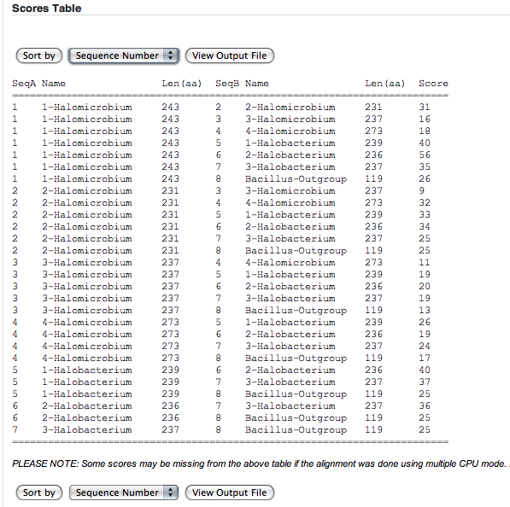
Take a screen shot of this table, or download by right-clicking the Output File (.output) found in the result summary box at the top of the page.

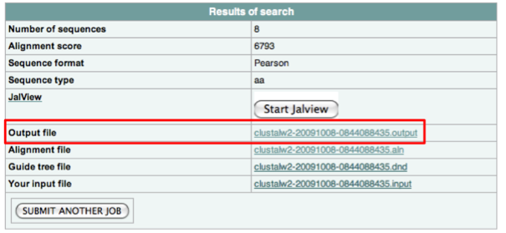

Multiple Sequence Alignment
Aligns all of the input sequences. An HTML text version is listed just below the Scores Table, and a more extensive view of the alignment can be seen using JalView.

Under Alignment, you can click “Show Colors” to view a coloured version of an amino acid alignment. This feature is only available for output formats ALN (default) and GCG, found under OUTPUT FORMAT on the submission page under the parameters.

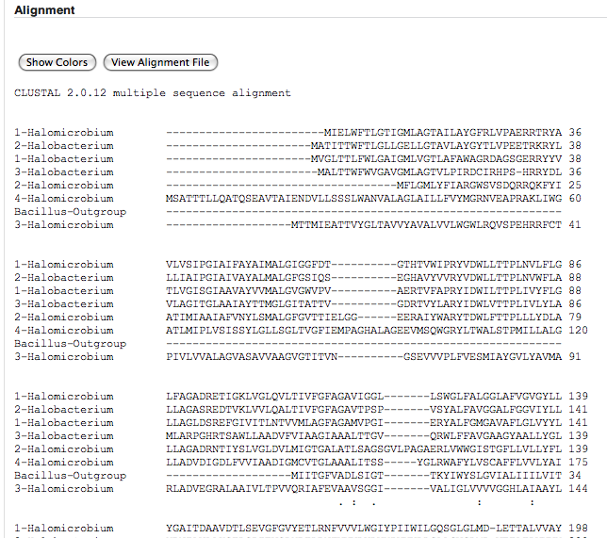 | 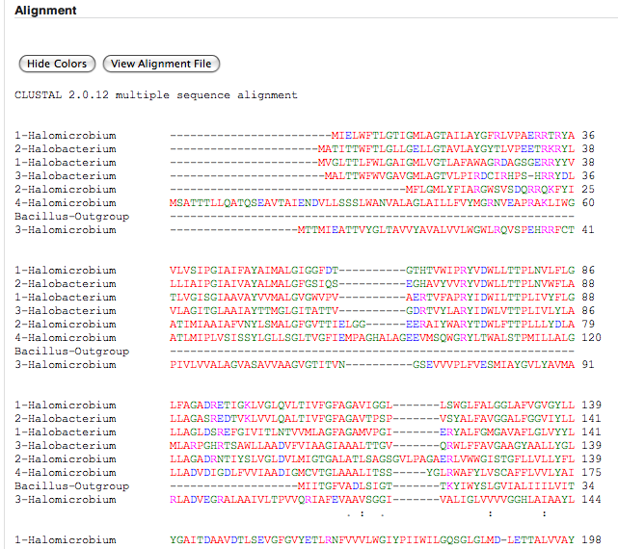
Normal View of Alignment | Coloured View of Alignment
In the row below the last sequence of the alignment, there may be symbols:
" * " – the residues or nucleotides in that column are identical in all sequences
" : " – conserved substitutions have been observed, according to the colour data
" . " – semi-conserved substitutions are observed

The colours tell information about the amino acid (left column below) at the given position. To see the 1-letter code for amino acids, see: http://gcat.davidson.edu/conversions_04/amino_acids/index.html

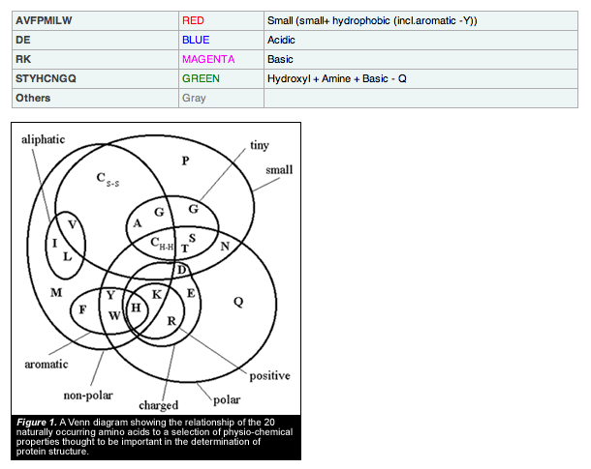

Take a screenshot of this alignment, or download the file by right-clicking the Alignment File (.aln) found in the result summary box at the top of the page.

To access JalView, click “Start JalView” in the results summary box at the top of the page.
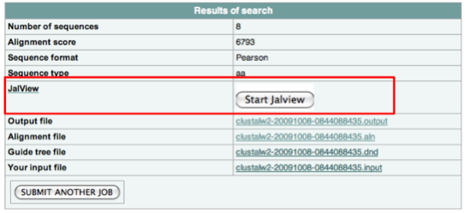
The JalView output shows a highlighted alignment of the sequences. It also provides a Consensus sequence and scoring of conservation. There are dropdown windows at the top of the result window to alter the view or show calculations.

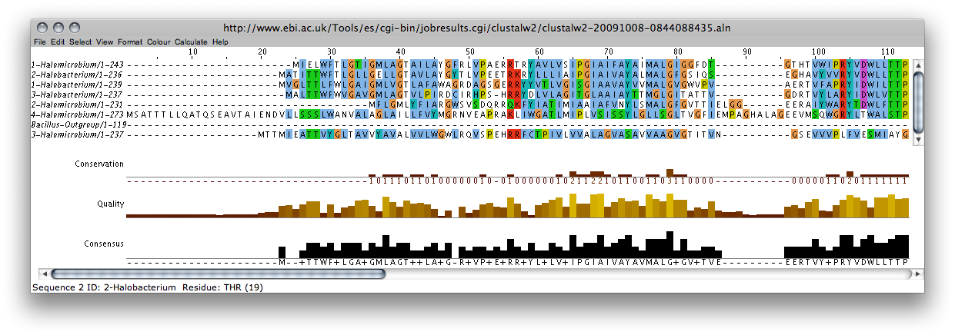
Take a screenshot of this alignment to record the colours and features of the annotation. To download just the alignment in JalView, go to: File > Output to Textbox > “PileUp” or “PFAM” are probably the most useful views.

Phylogenetic Tree
The generated phylogenetic tree is at the very bottom of the results page. You’ll notice above this is a “Guide Tree” section. You can save the Guide Tree in order to submit to another tree-construction program to have it generate the same tree.
The tree can be viewed as a phylogram or a cladogram.

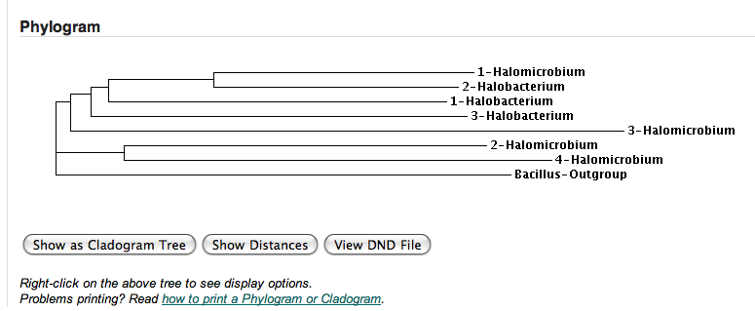

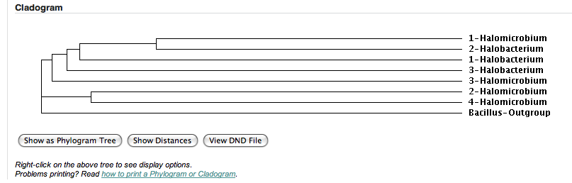

You can alternate between these two views by clicking the leftmost button “Show as ____gram Tree” Right-click the tree to change view options. The generated trees do not have a measuring scale, but if you click “Show Distances”, the distance will be displayed to the right of the leaf name.

Take a screen shot of these trees. You can download the Guide Tree by right-clicking the Guide tree file (.dnd) in the results summary window at the top of the page.
You can get a text file of your input sequences by downloading the Input file (.input) in the results summary window at the top of the page as well.
For presentation of these phylogenetic trees, you can edit your screenshot picture to better format the leaf names. Be sure not to disrupt the length of the branches in editing your phylogram – this is misrepresenting you data.

(Olivia Ho-Shing, Fall 2009)

