Molybdopterin Biosynthesis Protein CNX2 [EC: 2.2.24]
Went to Kegg Pathway and chose gene MOCS1-MoaA for Vitis vinifera. Protein Blasted the amino acid sequence on NCBI and matched with molybdopterin synthase (CNX2) for Arabidopsis thaliana. Then Blasted the AA sequence (390 letter query) against Vaccinium corymbosum 454 Scaffolds (tblastn) and found 1 scaffold.
- 1 sequence:
  - Scaffold00806
    - E-value: 2e-73
    - Length: 145300

Alignments

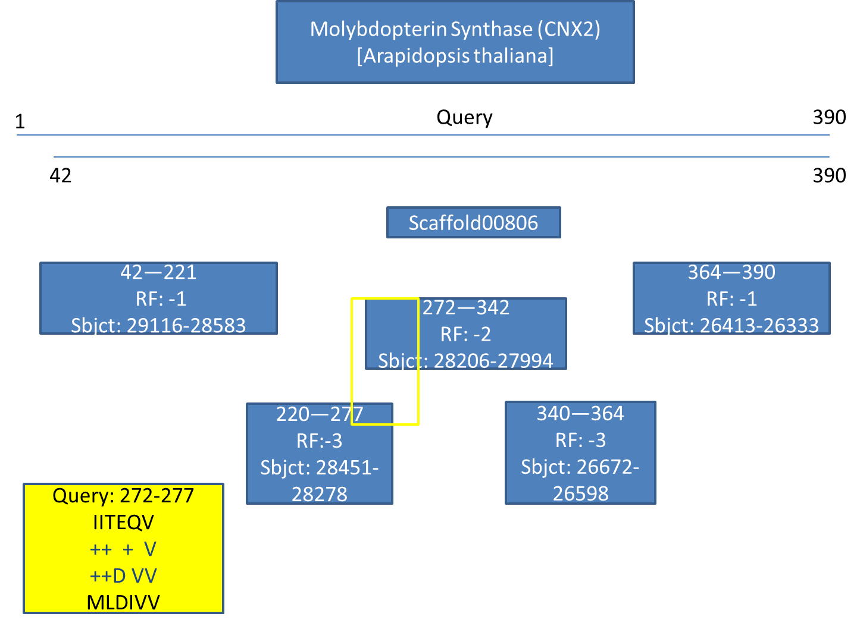
Found overlap of Query at 272-277
  - IITEQV
++ + V
++D VV
MLDIVV

Molybdopterin Synthase (CNX2) found in Scaffold00806 (Query starts at base 29116)

1)
For Primer ACCACCACAGAGCAACACATAC
Rev Primer GAATACCGCAAATGAGAGAAGC
Repeats (ga) x 12 PCR Product = 216 bp & starts at base 66 on scaffold

2)
For Primer TGGGAGCATCTTCCAATAACTT
Rev Primer ATTAAGGAAAAATCGGTGGAGG
Repeats (ac) x 13 PCR Product = 260 bp & starts at base 29266 on scaffold

3)
For Primer CCTGAAGTAGCTCTTCTCCCAA
Rev Primer AGAGAAACAAAGGGCAAGAGTG
Repeats (tc) x 12 PCR Product = 186 bp & starts at base 88878 on scaffold

