Nisha Crouser
Gamma-glutamyl hydrolase EC 3.4.19.9

I performed a BLASTp of the aa sequence for 3.4.19.9 from Vitis vinifera and found the sequence for the enzyme in Arabidopsis thaliana, which is evolutionary more closely related to the blueberry. I then used this aa sequence (347 aa) for 3.4.19.9 to do a tBLASTn against V. corymbosum 454- Scaffolds. Reliable hits were only found in Scaffold 00210.

3.4.19.9 found in Scaffold 00210 (query sequence starts at base 243033 on scaffold)

1)
For Primer TTTTCCTCAAAGACTGCTCTCTC
Rev Primer AGCAGTCACCATCTTTTTAGGG
Repeats (tc) × 27 PCR product = 236 bp & start at base 256014

2)
For Primer ATTCACCCCGTGTAAGTAATGG
Rev Primer CGACAACACTAAGAGACACCCA
Repeats (ga) × 15 PCR product = 201 bp & start at base 176902

3)
For Primer GTCGGTTTACCAAAAACTGCTC
Rev Primer CAGGATCTATGAGATGTGGACG
Repeats (ac) × 10 PCR product = 263 bp & start at base 285048

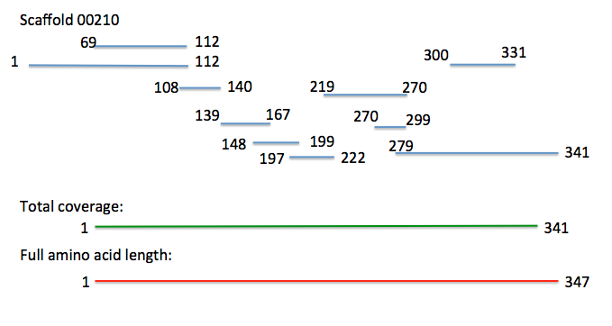
Figure 1. Alignment of 3.4.19.9 on Scaffold 00210 in V. corymbosum. Many different fragments found based on different reading frames, but overall coverage of amino acid sequence was very high.

Bifunctional purine biosynthesis protein EC 2.1.2.3
Phosphoribosylaminoimidazolecarboxamide formyltransferase

I performed a BLASTp of the aa sequence for 2.1.2.3 from Vitis vinifera and found the sequence for the enzyme in Arabidopsis thaliana, which is evolutionary more closely related to the blueberry. I then used this aa sequence (596 aa) for 2.1.2.3 to do a tBLASTn against V. corymbosum 454- Scaffolds. Reliable hits were found only in Scaffold 02368.

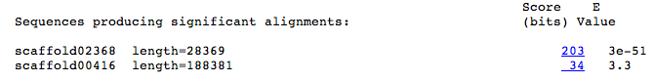

2.1.2.3 found in Scaffold 02368 (query sequence starts at base 19669 on scaffold)

1)
For Primer TTAAAGGGCACCATTCATATCC
Rev primer TGAGGCAGTACTTCTCCAGTCA
Repeats (ag) × 12 PCR product = 253 bp & start at base 9455

2)
For Primer AAATTGGTGTAGTGGGTTTTGG
Rev Primer TTCACAGTTTGACGGTTTATGC
Repeats (ga) × 13 PCR product = 239 bp & start at base 72

3)
For Primer TCAGTGCAAATCATAAAGTGGG
Rev Primer TACTCGTAGGAAGGATGTGGGT
Repeats (ct) × 11 PCR product = 293 bp & start at base 13762
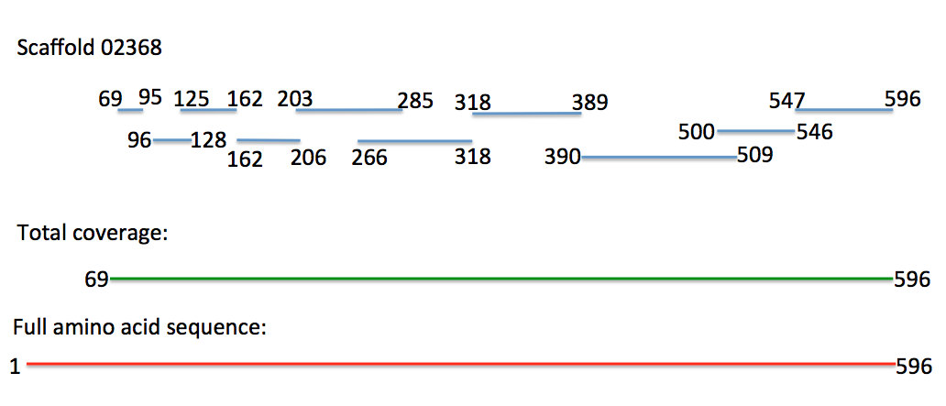

Figure 2. Alignment of 2.1.3.2 in Arabidopsis thaliana against Scaffold 02368 in V. corymbosum. Many different fragments found based on different reading frames, but overall coverage of amino acid sequence was very high.

