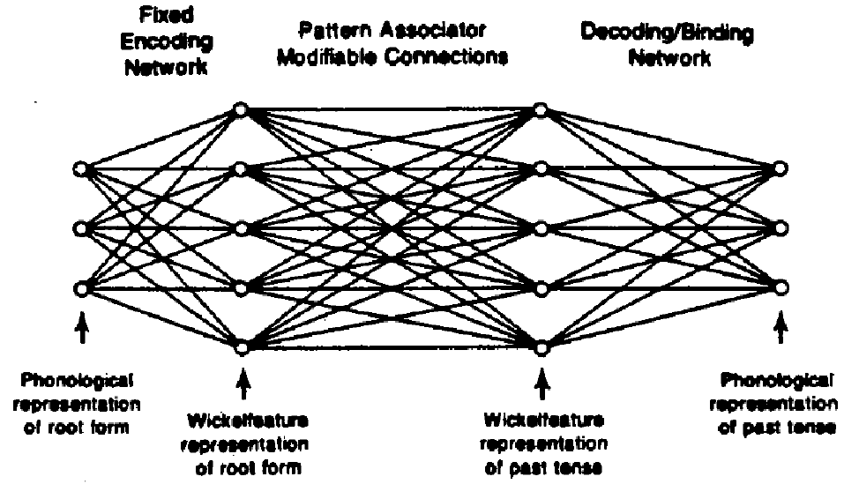
McClelland 1988; Connectionist Models and Psychological Evidence
This is an illustration from an article given to me by an instructor for Cognitive Psychology Dr. Mary Still. It is a little old, but I think that in this case it isn’t the timeliness of the article that makes it relevant. As we have said we are looking for parts of ideas to take and not necessarily try to reproduce these ideas completely using bacteria.
The concept being illustrated by the image is intended to model how we learn a specific tense form of language. All of the nodes in between the start and stop represent associations and mental representations that emerge before a word can go from its root to past tense version.
This probably seems a little odd, that’s because it is. It is stated in this 23 year old article that this is not a functional model of how we produce language in proper form; it is an attempt to help us think about it. This is all we really intend to use it for anyway.

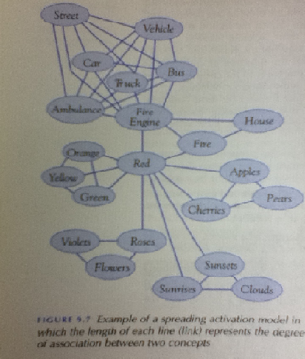
This image is one out of my cognitive psychology text book. The concept it represents is the Spreading Activation model. The spreading activation model is a lot like what Caleb was talking about at our last research meeting. Dr. Eckdahl in turn drew some things on the white board. Different shapes, or similar shapes with one colored and one not and asking for an output that tells us whether or not it recognizes the thing. The model tries to show the associations that might be made when you think about one thing which is very much others.

The image is off of a google search on neural networks.

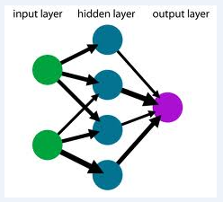
The image is referred to as a one-layer feedforward Artificial Neural Network(ANN).
Wikipedia page: http://en.wikipedia.org/wiki/Artificial_neural_network
There is a section on the page that describes the algorithms that are used to train various neural networks. This could possibly help in the math area of our project should it prove to have merit.

Learning algorithms (As usual, caution used in Wikipedia)
Training a neural network model essentially means selecting one model from the set of allowed models (or, in a Bayesian framework, determining a distribution over the set of allowed models) that minimizes the cost criterion. There are numerous algorithms available for training neural network models; most of them can be viewed as a straightforward application of optimization theory andstatistical estimation.
Most of the algorithms used in training artificial neural networks employ some form of gradient descent. This is done by simply taking the derivative of the cost function with respect to the network parameters and then changing those parameters in a gradient-related direction.
Evolutionary methods, simulated annealing, expectation-maximization, non-parametric methods and particle swarm optimization are some commonly used methods for training neural networks.

