R2D2 Camera Stand

At least 5”

Between 5-10”

We need to elevate the camera 25” from the base of the stand. Thus, we need some form of support (two or three pieces of wood) that can hold up a wooden platform 25” above the base. I am not sure what exactly the best way to build that is. The support should be relatively lightweight and be able to support a small platform that will hold a one pound camera. The platform should be between 0.5-0.75” thick with the following dimensions:

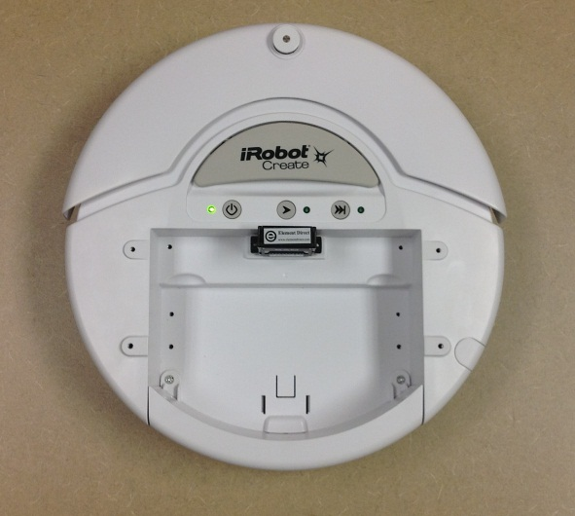

The base of the stand will be made of a thin piece of wood. We can take care of screwing it into the robot (circles represent screws)

Thickness of wood: 0.5”

10”

8”

1.5”

1”

1”

5”

5”

1.5”