GTP cyclohydrolase I (E.C. 3.5.4.16)

ALIGNMENTS:
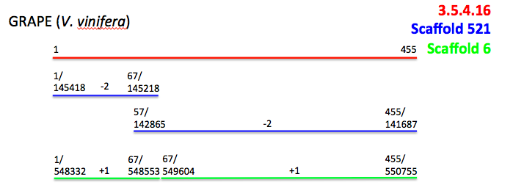
Fig. 1: Alignment results for a tblastn comparing the blueberry scaffolds to the amino acid sequence for GTP cyclohydrolase I (E.C. 3.5.4.16) from the grape genome. Numbers at either end of the lines represent the location (top = location in 3.5.4.16 sequence; bottom = location in scaffold sequence). Numbers in the middle of scaffolds indicate reading frame values.

Query = 455 aa sequence for enzyme 3.5.4.16 (GTP cyclohydrolase I) in Vitis vinifera
Subject = V. corymbosum 454-Scaffolds
Results: Significant hits on scaffolds 6 and 521

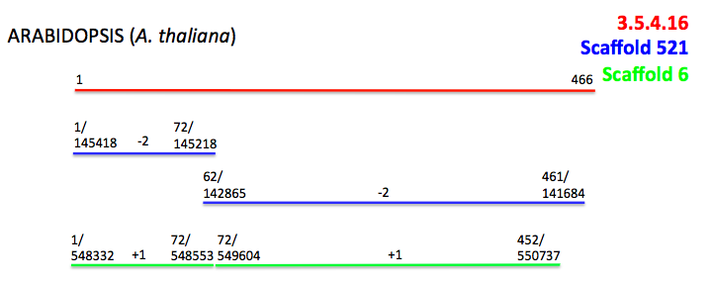
Fig. 2: Alignment results for a tblastn comparing the blueberry scaffolds to the amino acid sequence for GTP cyclohydrolase I (E.C. 3.5.4.16) from the Arabidopsis thaliana genome. Numbers at either end of the lines represent the location (top = location in 3.5.4.16 sequence; bottom = location in scaffold sequence). Numbers in the middle of scaffolds indicate reading frame values.

Query = 466 aa sequence for enzyme 3.5.4.16 (GTP cyclohydrase I) in Arabidopsis thalian
Subject = V. corymbosum 454-Scaffolds
Results: Significant hits for scaffolds 6 and 521

PRIMERS:

E.C. 3.5.4.16 in Scaffold 6 (query sequence starts at base 548332 on the scaffold)
1)
For Primer: AGCGCTCCAGATTCTTTAGTTG
Rev Primer: GATTGTAGCAGTGCCTCTACCC
Repeats (tc) x 30 PCR product = 279 bp & start at base 490223

2)
For Primer: TAGAAGAGAACGGAGTGAAGGG
Rev Primer: AGGAAAACCCATAAAGAGGAGG
Repeats (tc) x 24 PCR product = 297 bp & start at base 548595

3)
For Primer: GATGGTTTCTTGAACGTGATGA
Rev Primer: GCGCCTCCTGCTTCTTATAGTA
Repeats (ag) x 13 PCR product = 160 bp & start at base 471712

E.C. 3.5.4.16 in Scaffold 521 (query sequence starts at base 145418 on the scaffold)
1)
For Primer: CTCTTCCTGATCCAGAAGCTGT
Rev Primer: GTTTTTCTTGCGTCTTTCTGCT
Repeats (ag) x 16 PCR product = 267 bp & start at base 155555

2)
For Primer: TCGAATATAGGTCCACCTCAGC
Rev Primer: TGAGTTTACCTTCAGACCAGCA
Repeats (ct) x 12 PCR product = 210 bp & start at base 103449

3)
For Primer: TTGTTGTACGGTTGTACCAAGG
Rev Primer: GTTAAGACTTGCGAGAGGAGGA
Repeats (ag) x 11 PCR product = 139 bp & start at base 135665

5-formyltetrahydrofolate cycloligase (E.C. 6.3.3.2)

ALIGNMENT:
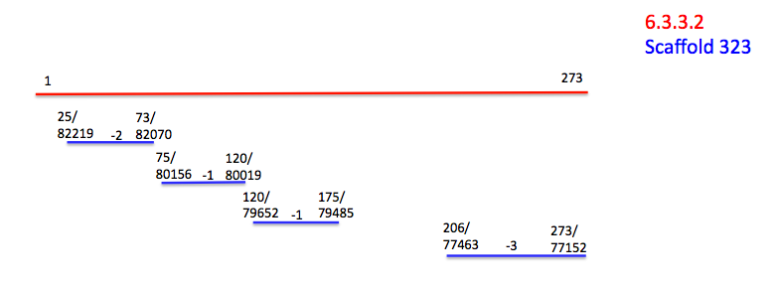
Fig. 3: Alignment results for a tblastn comparing the blueberry scaffolds to the amino acid sequence for 5-formyltetrahydrofolate cycloligase (E.C. 6.3.3.2) from the grape (Vitis vinifera) genome. Numbers at either end of the lines represent the location (top = location in 6.3.3.2 sequence; bottom = location in scaffold sequence). Numbers in the middle of scaffolds indicate reading frame values.

Query = 273 aa sequence for enzyme 6.3.3.2 (5-formyltetrahydrofolate cycloligase) in Vitis vinifera
Subject = V. corymbosum 454-Scaffolds
Results: Significant hits on scaffold 323

PRIMERS:

E.C. 6.3.3.2 in Scaffold 323 (query sequence starts at base 82219 on the scaffold)
1)
For Primer: TACTCGATCAATGTGGGCTATG
Rev Primer: TGGACTAGGTTCACAGATGCAG
Repeats (ct) x 16 PCR product = 271 bp & start at base 78798

2)
For Primer: CTCCTCCGGTATGAATATCGTC
Rev Primer: GAGAGAGAGAGCACAATCAGCA
Repeats (tc) x 15 PCR product = 168 bp & start at base 101841

3)
For Primer: TATTGCCACGTTACCTGAGTTG
Rev Primer: CAATTGGCAATGAGTGAAGAGA
Repeats (tg) x 13 PCR product = 292 bp & start at base 71649

