**Emily Keator, Davidson College**

**2-amino-4-hydroxy-6-hydroxymethyldihydropteridine diphosphokinase / dihydropteroate synthase [EC: 2.7.6.3]**

Went to [Kegg Pathway](http://www.genome.jp/kegg-bin/show_pathway?map=map00790&show_description=show), then chose *Vitis vinifera* (wine grape), and chose gene 2.7.6.3. Blasted the AA sequence (509 letter query) against V. *corymbosum* 454 Scaffolds (tBLASTn) and got the following results:

scaffold00003 length=874192 793 0.0

scaffold01432 length=89430 570 e-161

Scaffold 00003:

803754 (17) to 805232 (509)

Frame: +3, 89% positives

Scaffold 01432:

62299 (17) to 60917 (498)

Frame: -3, 73% positives

2.7.6.3 found in Scaffold 00003 (query starts at base 803754 on scaffold)

1)

For Primer AGTTCAGACAATTCAACGTCCA

Rev Primer TCTTTCTTAGGCGTTTTTGAGG

Repeats (ag) x 16 PCR Product = 207 bp & starts at base 743328

2)

For Primer AAAGCCCTCACCAATATCTGAA

Rev Primer CTTGAGGGAACCCTTAAAAACA

Repeats (at) x 12 PCR Product = 242 bp & starts at base 834119

3)

For Primer CCTACAGACTGCCGTTTCTTCT

Rev Primer TCGTGACAAAATACACAGAGGG

Repeats (ga) x 11 PCR Product = 257 bp & starts at base 780006

2.7.6.3 found in Scaffold 01432 (query starts at base 62299 on scaffold)

1)

For Primer CAGTATCCTGGGATTTAGGTGG

Rev Primer GGTGAGTGTAACACCCCAAACT

Repeats (ga) x 10 PCR Product = 234 bp & starts at base 77019

2)

For Primer TACACACCTTTGGAGCTTGGTA

Rev Primer GGAATCACATATCAACCAAGGG

Repeats (tg) x 9 PCR Product = 290 bp & starts at base 77578

3)

For Primer GTTTGAAGCAAGAGTTGGCTTT

Rev Primer CTGTAAAGAAACATGCAGGCAA

Repeats (tc) x 8 PCR Product = 249 bp & starts at base 88928

EC 2.7.6.3

(Query)

Scaffold 00003

Scaffold 01432

1

509

17

803754

509

805232

17

62299

498

60917

**formyltetrahydrofolate deformylase [EC: 3.5.1.10]**

Went to [Kegg Pathway](http://www.genome.jp/kegg-bin/show_pathway?map=map00790&show_description=show), then chose *Vitis vinifera* (wine grape), chose one carbon pool by folate, and chose gene 3.5.1.10. Blasted the AA sequence (329 letter query) against *V. corymbosum* 454 Scaffolds (tBLASTn) and got the following results:

scaffold00259 length=245031 99 1e-51

Scaffold 00259:

74518 (166) to 74354 (220)

Frame: -3, 89% positives

3.5.1.10 found in Scaffold 00259 (query starts at base 74518 on scaffold)

1)

For Primer CTTTAGGTCATCCGGAAGAGAA

Rev Primer CTGCCATTTTGAACAACTTCAC

Repeats (ga) x 19 PCR Product = 215 bp & starts at base 148790

2)

For Primer CGAGCTTCAAATTCTTCTCTGC

Rev Primer TGGTTTGTGCTCTATGATGTCC

Repeats (at) x 14 PCR Product = 295 bp & starts at base 128604

3)

For Primer AATTTGTAGAGTCGTTGCGGAT

Rev Primer TTTGATGCCGACGTAGATACAC

Repeats (tg) x 11 PCR Product = 240 bp & starts at base 98423

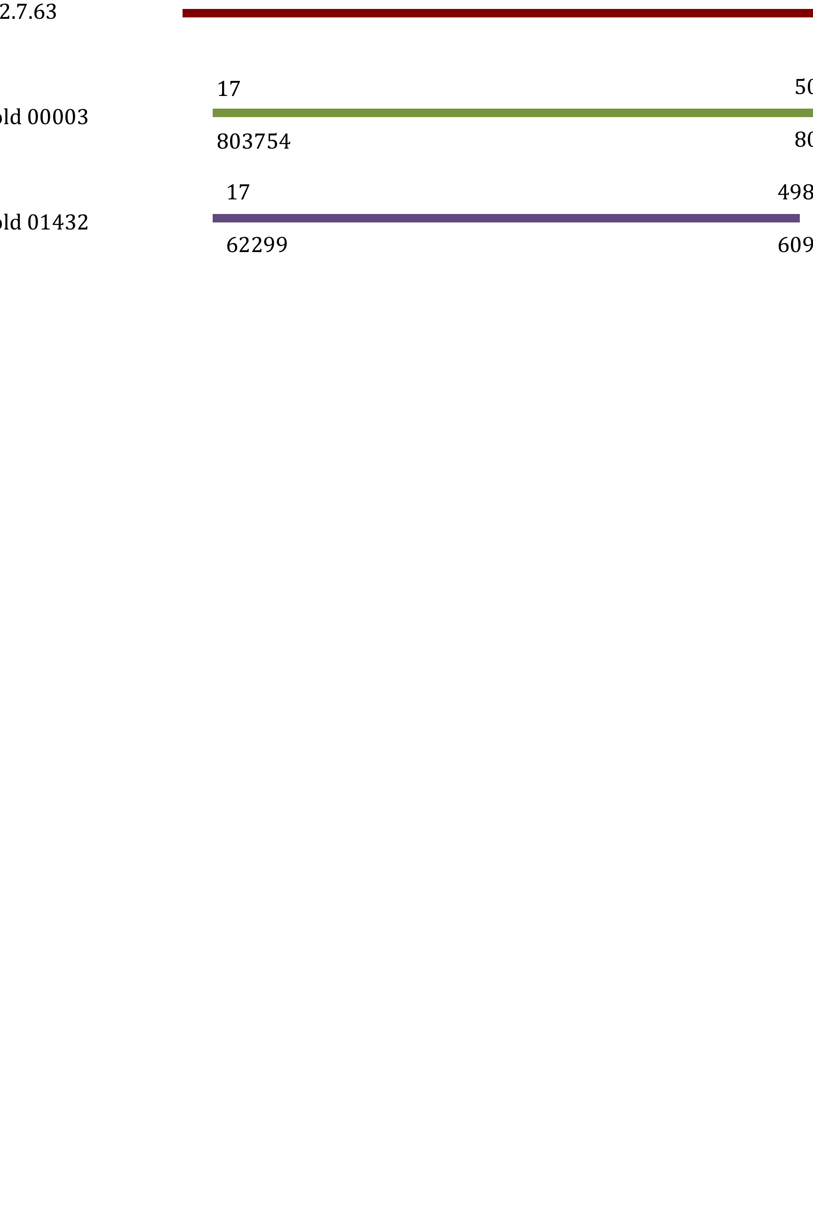

EC 3.5.1.10

(Query)

Scaffold 00259

1

329

166

74518

220

74354