Bioconversion of Glycerol for Bioethanol Production Using Isolated Escherichia Coli SS1
http://www.scielo.br/pdf/bjm/v43n2/11.pdf

What: Production of bioethanol from the fermentation of glycerol.

- “Species of Escherichia coli were found to be able to ferment glycerol under appropriate conditions, i.e., acidic pH, and with appropriate medium composition to produce bioethanol with minimum hydrogen accumulation.”
- Highest ethanol yield 1.0 mol ethanol: 1.0 mol glycerol
- Ferment glycerol 1,3 – propanediol
- E. coli can ferment glycerol in acidic pH and an appropriate medium
- Klebsiella planticola from rumen red deer naturally produce ethanol from glycerol fermentation

Anaerobic Fermentation of glycerol by Escherichia coli: a new platform for metabolic engineering
http://www.ncbi.nlm.nih.gov/pubmed/16715533

- Glycerol can be converted intro dihydroxyacetone (DHA) by glycerol dehydrogenase (GldA) (1104 bp)
- Resulting DHA can be phosphorylated by DHA kinase
- Conversion of formate into CO₂ by formate hydrogen lyase (FHL) is required for glycerol fermentation at acidic pH.

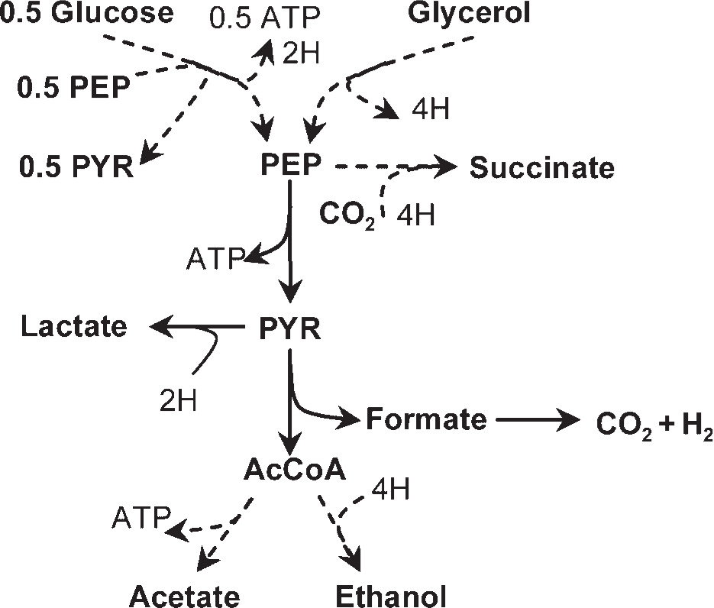

Figure 3. Schematic representation of the anaerobic fermentation of glucose and glycerol in E. coli. Converting glycerol into phosphoenolpyr- uvate or pyruvate results in the generation of twice the amount of redox equivalents generated during the conversion of glucose. Note that conversion of glycerol into ethanol or succinate are redox-balanced processes (ethanol being more energetically favorable). Conversion of pyruvate into acetyl- CoA is assumed to proceed through enzyme pyruvate-formate lyase (PFL). Broken lines represent linear pathways composed of several reactions. Abbreviations: H, reducing equivalents (2H 1⁄4 1NADH/NADPH/FADH2); AcCoA, acetyl coenzyme A; PEP, phosphoenolpyruvate; PYR, pyruvate.

