Mark Angel
Laboratory Methods in Genomics
May 8, 2013

Investigation of Blueberry Genome for Genes
Associated with Fungal Gene-for-Gene Resistance

Abstract

The common highbush blueberry (Vaccinium corymbosum) has many health benefits for humans, as it contains high levels of important antioxidants, vitamins, and minerals (Courteau, 2012; Balk et al., 2006; Safra-Stone et al., 2007). Fungal diseases are common threats to the harvesting of healthy blueberries, an agriculturally important industry in the United States. In this investigation, I identified simple sequence repeats (SSRs) in the Vaccinium genome near genes associated with fungal gene-for-gene resistance. I focused primarily on R genes that encode proteins containing nucleotide-binding sites and leucine-rich repeat domains (NBS-LRR proteins) because they are more closely associated with gene-for-gene resistance pathways. Of the 29 genes I identified, 27 produced at least one primer pair for SSRs, with 24 producing three primer pairs.

Introduction

Vaccinium corymbosum, the highbush blueberry, is the species of blueberry most often cultivated for the commercial distribution of blueberries. Blueberries, rich in essential vitamins and minerals, are an important food source for many birds and mammals, including humans (Courteau, 2012). Additionally, blueberries have many health benefits for humans, including high antioxidant capacity, protection against gastrointestinal diseases, and prevention of neurodegenerative diseases (Balk et al., 2006; Zafra-Stone et al., 2007). Blueberry cultivation is a significant industry in the United States, which produced 60% of the 312,047 metric tons of blueberries harvested commercially worldwide in 2010. An undocumented amount of blueberries are also harvested locally each year (Courteau, 2012). The many health benefits of blueberries and the large economy associated with their production indicate the importance of maintaining healthy blueberries.
A major threat to blueberry health in the United States is fruit rot caused by fungal pathogens (Anco and Ellis, 2011). Infections can destroy a blueberry harvest and make the fruit unsellable. In order of severity and frequency of occurrence, the most common fungal fruit rots in blueberries are Alternaria, caused by Alternaria tenuissima; anthracnose, caused by Colletotrichum acutatum; and Botrytis, caused by Botrytis cinerea (Anco and Ellis, 2011). In order to combat these harmful fruit rots, scientists must understand the fungi that cause these diseases and the induced pathogen defense mechanisms within the blueberry.
Gene-for-gene resistance characterizes the primary pathogen (including fungal) defense response of plant cells. In what DeYoung and Innes (2006) call “effector-triggered immunity,” resistance (R) genes encode proteins that recognize the gene products of fungal avirulence (avr) genes, also known as effectors, which attack the plant (Glazebrook, 2001; Feys and Parker, 2000). R-Avr protein recognition elicits a localized defense response within the plant, causing the infected cell to produce reactive oxygen species quickly (Feys and Parker, 2000; Glazebrook, 2005). The resulting oxidative burst induces a hypersensitive response (HR) within the cell in contact with the pathogen, leading to the programmed death of the infected cell (Glazebrook, 2005).
The initial localized defense mechanism and associated HR leads to systemic pathogen resistance to protect the remainder of the plant (Glazebrook, 2001). In systemic acquired resistance (SAR), the signaling molecule salicylic acid accumulates in cells throughout the plant, activating the transcription of pathogenesis-related genes that lead to increased resistance (Glazebrook, 2001; Feys and Parker, 2000). Induced systemic resistance (ISR), normally associated with bacterial pathogens, requires the accumulation of jasmonic acid and ethylene, both growth hormones (Feys and Parker, 2000). The various molecules in pathways activated by SAR and ISR, initiated by localized gene-for-gene resistance, interact in both “synergistic and antagonistic” ways, suggesting a complex web of plant defense pathway interactions that is specific to each pathogen (Feys and Parker, 2000).
According to plant pathologist Dr. Jim Polashock (personal communication), little evidence exists to indicate an important role for the SAR/ISR pathways in fungal disease resistance in blueberries. With Dr. Polashock’s guidance, I investigated R genes. The proteins encoded for by most R genes contain leucine-rich repeat regions (LRRs) and nucleotide-binding sites (NBS), which help detect the Avr proteins (or effectors; Pan et al., 2000; DeYoung and Innes, 2006). Studies indicate that Avr-R protein interactions are extremely complex and occur in various forms. In direct interactions, multiple sites of an R gene, including the amino-terminal domain (the LRR domain), must liaise intricately to allow for the recognition of the Avr protein (DeYoung and Innes, 2006). However, recent evidence suggests that some R proteins interact indirectly with Avr proteins (DeYoung and Innes, 2006). The NBS-LRR proteins encoded by blueberry R genes associate with plant accessory proteins that together interact with fungal Avr proteins in order to confer disease resistance (Eitas and Dangl, 2010).
Gupta et al. (2010) reviewed the evidence for two models of indirect interactions between Avr and R proteins: the guardee and the decoy. In the “Guardee Model,” plants become resistant when the R protein “guards” a host protein (the “guardee”), preventing its interaction with the invading Avr protein (Gupta et al. 2010). In the proposed “Decoy Model,” plants generate decoy “guardee” proteins that bind the Avr proteins; rather than initiating a pathogenic resistance response, these decoy proteins hamper the pathogenesis induced by the Avr proteins (Gupta et al., 2010). Both models are important to understand when considering future directions of research related to disease resistance. Because I focused primarily on the resistance pathways initiated by R proteins in this study, a further understanding of R protein structure and signaling transduction capabilities is important.
Several signal transduction pathways initiated by R proteins lead to disease resistance. The activation of a particular pathway depends on the subcategory of R proteins activated (Glazebrook, 2001). R proteins categorized as NBS-LRR proteins can be divided into two subclasses. In Arabidopsis, NBS-LRR proteins that contain leucine-zippers (LZ-NBS-LRRs) require NDR1 to invoke resistance, while TIR-NBS-LRR proteins, which contain an amino-terminal domain similar to the mammalian interleukin 2 and Drosophila Toll receptors, require EDS1 and PAD4 (Fig. 1; Glazebrook, 2001; Eitas and Dangl, 2010). A third pathway to resistance in Arabidopsis, initiated by LZ-NBS-LRR proteins, exists as well that does not require NDR1 (Fig. 1; Glazebrook, 2001).

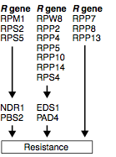

Figure 2. Schematic representations of LRR proteins associated with pathogen disease resistance (Pan et al., 2000).
Figure 1. Gene-for-gene resistance pathways identified in Arabidopsis as reviewed by Feys and Parker (2000).

The goal of my research was to find primer pairs for simple sequence repeats (SSRs) near orthologs of genes related to disease resistance (primarily fungal) in the blueberry genome. These primer pairs will allow for further investigation of disease resistance pathways specific to the blueberry, eventually leading to fungal resistant cultivars.

Methods

After conducting a thorough literature review, I identified pathways that contain or were associated with R genes encoding NBS-LRR proteins that lead to disease resistance (Fig. 1). In the NDR1-dependent disease resistance pathway, I investigated NDR1, PBS2, RPM1, RPS2, and RPS5. I also searched for genes associated with the EDS1/PAD4-dependent resistance pathway, including EDS1, PAD4, RPW8, RPP2, RPP4, RPP5, RPP10, RPP14, and RPS4. Three genes investigated (RPP7, RPP8, and RPP13) are not associated with any characterized resistance pathway but are involved in resistance (Glazebrook, 2001). When complete pathways were not available, I chose to analyze individual NBS-LRR genes previously identified in dicots by scientists, including L6, N, M, RPP1, I2C1, Prf, Mi, RGC2, Cf-2, Cf-4, Cf-5, and Cf-9 (Fig. 2). By typing the protein name and organism into the UniProt database, I obtained amino acid sequences for these proteins of interest (UniProt). After identifying the correct protein, I exported the completed amino acid sequence in FASTA format, never using partial amino acid sequences or proteins from species different from those reported in the literature. Using Mac terminal, I performed a local tBLASTn against the Vaccinium genome (previously generated using 454 sequencing) to determine the approximate location of this queried amino acid sequence on the scaffolds of this genome. See Appendix A for specific directions on using the terminal window in Mac.
I selected the blueberry scaffold with the best E-Value (expect value), for further analysis (no bigger than 1e-04). If two genes aligned at the same location on the same scaffold, I selected the next best scaffold for analysis. For example, the first hit for both RPP5 and N was on scaffold04339, starting near the base pair 3698. Because I had already found the SSRs at this location on this scaffold from RPP5, I went to the second most specific alignment (scaffold00311 at base pair 244627) for N. I ran each scaffold of interest through the Vaccinium SSR Tool on the “Genome Database for Vaccinium,” which generates PCR primer pairs for SSRs on that scaffold (Plants for Human Health Institute, year). I reported primer pairs for the three best SSRs, which had di- or trinucleotide motifs close to the aligment’s starting location with the most repeats that created a primer pairs product between 100-700 bps. When less the Vaccinium SSR Tool generated less than three SSRs, I reported all the available primer pairs. I repeated this process for each gene of interest. Again, see Appendix A for specific directions for using the Vaccinium SSR Tool and choosing PCR primer pairs.

Results

Of the 29 genes I investigated, 28 aligned with scaffolds on the Vaccinium genome and 27 produced primer pairs (Fig. 3). The N gene in tobacco, RPP5 in Arabidopsis, and M from flax appeared to align at the same location on scaffold04339. Additionally, the first three scaffold hits for M from flax overlapped with other genes (RPP5 and RPP4 from Arabidopsis and L6 from flax). Cf-4 and Cf-9 from tomato also appeared at the same location on scaffold00725. This overlap in scaffold location was noted, but unique primer pairs were found on a different scaffold for each gene investigated. RPW8 from Arabidopsis did not produce any hits in the Vaccinium genome and RGC2 from lettuce aligned with scaffold07696, which had no identifiable SSR primer pairs. For a full list of the primer pairs, please see Appendix B.

Gene | Scaffold | Location Start | No. of Primer Pairs
RPM1 | scaffold00004 | 534797 | 3
RPS2 | scaffold01086 | 62969 | 3
RPS5 | scaffold00276 | 132641 | 3
PBS2 | scaffold00103 | 5106 | 3
RPW8 (used RPW8.1) | no hits found | n/a | n/a
RPP2 | scaffold00365 | 99357 | 3
RPP4^ | scaffold00231 | 265344 | 3
RPP5* | scaffold04339 | 3713 | 1
RPS4 | scaffold00044 | 233001 | 3
EDS1 | scaffold00607 | 39214 | 3
PAD4 | scaffold00745 | 109010 | 3
RPP7 | scaffold00179 | 115488 | 3
RPP8 | scaffold00651 | 134208 | 3
RPP13 | scaffold02218 | 7749 | 3
LOV1 | scaffold02957 | 14585 | 2
RPP1 | scaffold00231 | 211033 | 3
L6+ | scaffold00327 | 219229 | 3
N* | scaffold00311 | 244627 | 3
M*+^ | scaffold02051 | 53365 | 3
I2C1 | scaffold02333 | 4782 | 3
Prf | scaffold00437 | 106724 | 3
Mi | scaffold01683 | 62510 | 3
RGC2 | scaffold07696 | 3642 | n/a
Pto | scaffold00539 | 139327 | 3
Cf-2 | scaffold11065 | 396 | 1
Cf-4# | scaffold00725 | 6768 | 3
Cf-5 | scaffold01395 | 14100 | 3
Cf-9# | scaffold00838 | 14981 | 3
NDR1 | scaffold01670 | 5027 | 3
Figure 3. Table of plant resistant genes investigated in the Vaccinium genome. Rows shaded in yellow denote genes with three primer pairs, rows shaded in orange represent genes with two primer pairs, and rows shaded in red denote genes with 1 primer pairs. *,+, ^, and # indicate genes that were located on the same scaffold. Note, however, that this table presents each gene’s first unique scaffold hit.

Discussion

My genomic investigation indicates many of the NBS-LRR proteins encoded by R genes associated with pathogen disease resistance are present in the blueberry genome. Some genes appeared at the same location on the same scaffold suggesting that the primer pairs may not be specific to the gene but rather recognize conserved regions in these various proteins (i.e. the TIR domain of L6, M, N, and RPP5). Studies have shown, however, that some NBS-LRR proteins exist in clusters in the genome and function in pairs to combat disease (Eitas and Dangl, 2010). Perhaps the genes that appeared at the same locus on the blueberry genome work in tandem to combat disease or they have converged into one functional gene in this organism.
Although 28 plant resistance genes associated with gene-for-gene disease resistance were found in the Vaccinium genome, the exact pathogens combatted remain unknown. These results are not specific to fungal disease resistace, but rather disease resistance in general, because the pathogen combatants in each of the gene-for-gene resistance pathways investigated in this study were not delineated; they may be fungal, bacterial, or viral.
A more helpful model for future studies in blueberry fungal disease resistance may include a further delineation between blueberry responses to necrotrophic versus biotrophic diseases. Necrotrophs kill the host’s cells and feed on dead tissue, while biotrophs survive by feeding on living tissue (Glazebrook, 2005). To ward off biotrophs, plants generally enlist salicylic acid-dependent pathways to fight biotrophs and enlist jasmonic acid- and ethylene-dependent pathways to fight necrotrophs (Glazebrook, 2005). Two of the most common blueberry fungi pathogens, Alternaria tenuissima and Botrytis cinerea, are necrotrophs; another common blueberry fungus, Colletotrichum acutatum, is a necrotroph at some life stages and a biotroph at others (Glazebrook, 2005; Wharton and Diéguez-Uribeondo, 2004). This characterization of the three most important fungal pathogens for blueberries thus suggest that genes involved with SAR/ISR pathways should be studied further in future investigations specific to blueberry fungal diseases.
Fungal disease resistance is important for blueberry cultivar survival. By locating 28 genes associated with local pathogen disease response in the blueberry genome, this study serves as an excellent launching pad for further investigations into the complex pathways that control blueberry disease resistance. By utilizing these SSR primer pairs, breeders can begin to identify the location of important fungal disease resistance genes in the blueberry genome. Once these alleles have been located, blueberry farmers can selectively breed for them, leading to more fungal disease resistance cultivars. Further laboratory investigations should determine how and when these genes are activated. This knowledge will eventually provide a better understanding of the mechanisms for fungal disease resistance in blueberries, ultimately leading to more resistant blueberries.

Acknowledgements
This study was done as part of an undergraduate biology course at Davidson College, Laboratory Methods in Genomics. I would like to thank the professor of that course, Dr. Campbell, for his continued support and guidance. I would also like to thank my fellow classmates, whose collaboration and feedback greatly improved this project. Additionally, thank you to Dr. Allan Brown of North Carolina State University, Dr. Jeannie Rowland of the United States Department of Agriculture, and Dr. Doreen Main of Washington State University for their additional input and advice. A final thank you to Dr. Jim Polashock of the United States Department of Agriculture, who provided the direction that I took in this project.

References
Anco, D.J. and Ellis, M.A. (2011). Fruit rots of blueberry: Alternaria, Antracnose, and Botrytis. The Ohio State University Extension.
Balk, E., M. Chung, G. Raman, A. Tatsioni, P. Chew, S. Ip, D. DeVive, and J. Lau. B vitamins and berries and age-related neurodegenerative disorders. Rockville, MD: Agency for Healthcare Research and Quality (US).
Courteau, J. (2012). Vaccinium corymbosum: highbush blueberry. In Encyclopedia of Life. Retrieved from http://eol.org/pages/583651/overview.
DeYoung, B.J. and Innes, R.W. (2006). Plant NBS-LRR proteins in pathogen sensing and host defense. Nature Immunology, 7(12), 1243-1249.
Eitas, T.K. and Dangl, J.L. (2010). NB-LRR proteins: pairs, pieces, perception, partners and pathways. Current Opinion in Plant Biology, 13(4): 472-477.
Feys, B.J. and Parkers, J.E. (2000). Interplay of signaling pathways in plant disease resistance. Trends in Genetics, 16(10), 449-455.
Glazebrook, J. (2001). Genes controlling expression of defense responses in Arabidopsis – 2001 status. Current Opinion in Plant Biology, 4: 301-308.
Glazebrook, J. (2005). Contrasting mechanisms of defense against biotrophic and necrotrophic pathogens. Annual Review of Phytopathology, 43: 205-227.
Gupta, S., Chakraborti, D., Basu, D., and Das, S. (2010). In search of decoy/guardee to R
genes. Plant Signaling and Behavior, 5(9): 1081-1087.
Pan, Q., Wendel, J., and Fluhr, R. (2000). Divergent evolution of plant NBS-LRR resistance gene homologues in dicot and cereal genomes. Journal of Molecular Evolution, 50:203-213.
Plants for Human Health Institute, North Carolina State University, and Washington State University. SSR Tool. Genome Database for Vaccinium. Retrieved from http://www.vaccinium.org/cgi-bin/vaccinium_ssr. 9 April 2013.
UniProt Consortium. Uniprot. Retrieved from http://www.uniprot.org/. 26 March 2013.
Wharton, P.S. and Diéguez-Uribeondo, J. The biology of Colletotrichum acutatum [Abstract]. Anales del Jardín Botánico de Madrid, 61(1): 3-22.
Zafra-Stone, S., T. Yasmin, M. Bagchi, A. Chatterjee, J.A. Vinson, and D. Bagchi. Berry anthocyanins as novel antioxidants in human health and disease prevention. Molecular Nutrition & Food Research, 51(6): 675-683.

Appendix A. Finding SSRs and Choosing Primer Pairs in the Vaccinium Genome

NOTE: This protocol follows the trajectory to obtain Vaccinium SSRs for the Arabidopsis gene ndr1 from the encoded protein’s amino acid sequence.

1) In the “Query” box at www.uniprot.org, type in the name of the organism and protein of interest. Make sure that you are searching in “Protein Knowledgebase (UniProtK).”

2) A list of search results will appear. Identify the protein you are interested in, assuring that the entry is for the correct organism, and click the related “Entry” link. Any entry with a gold star (in “Status” column) means that it has been reviewed. For this example, I chose the first entry because it was a reviewed entry for NDR1 found in Arabidopsis thaliana.

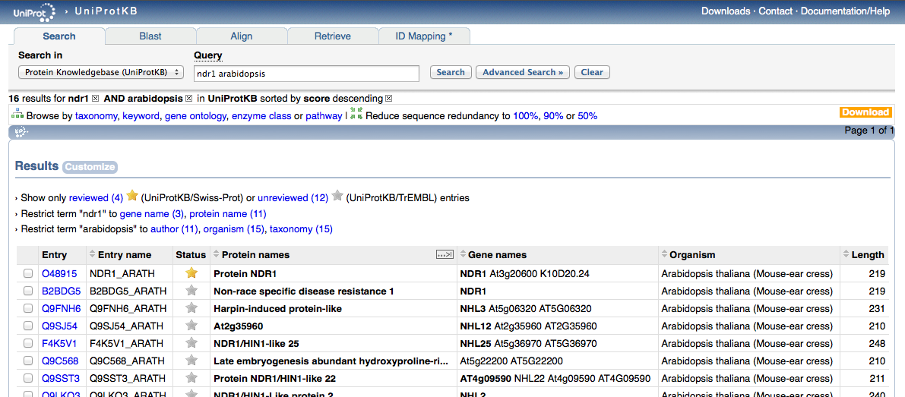

3) On the entry’s page, under “protein attributes,” check to make sure that the “sequence status” is “complete.”
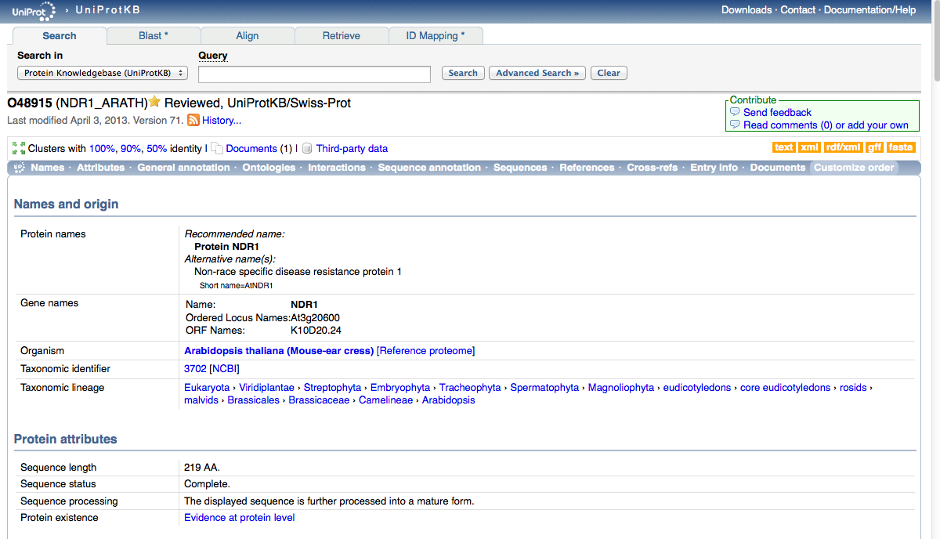

4) Scroll down to the “Sequences” section. You will see the amino acid sequence in fragments of 10. Clicking on the FASTA hyperlink, however, will automatically put the amino acid sequence in FASTA format, which is required for future steps in the protocol.

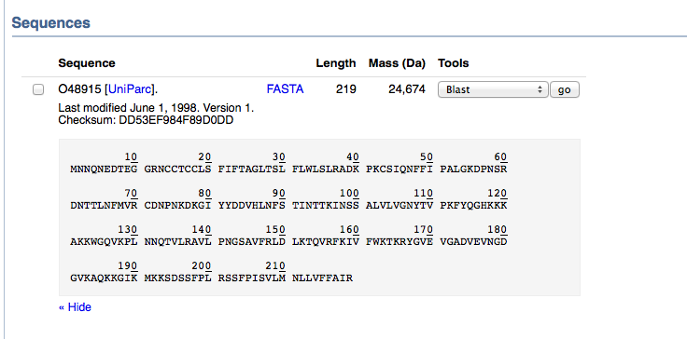

FASTA Format:

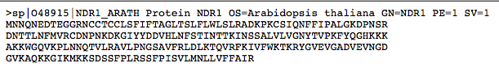
6) Using Mac TextEdit, make a text file with the amino acid sequence (FASTA format) in plain text (in the toolbar, “Format” “Make Plain Text”). Make sure to save it to the ncbi-blas-2.2.27+ folder.

7) Make sure that you have the blueberry genome scaffolds (produced from 454 Sequencing) set up as a database. In order to do this, insert the following code in Mac Terminal:

cd Desktop/ncbi-blast-2.2.27+

Hit ENTER.

Then inserts the following code in Mac Terminal:

./bin/makeblastdb -in Sorted_454Scaffolds.txt -input_type fasta -dbtype nucl -title blueberry_Genome

Hit ENTER. The database should now be set up so that you can run a tBLASTn queries against it.

(Make sure that the referent files are on the desktop, otherwise Terminal will not be able to access it to create the database.)

8) In order to run a tBLASTn against the database created in 7, insert the following code into Mac Terminal:

bin/tblastn -query 29_ndr1.txt -db Sorted_454Scaffolds.txt

NOTE: The highlighted portion is the name of file you created in 6. Every time you run another tBLASTn, this query should change to indicate the file with the amino acid sequence of interest.

9) Mac Terminal will present the results of the query, with your cursor at the bottom of them. Scroll up until you see something like this:
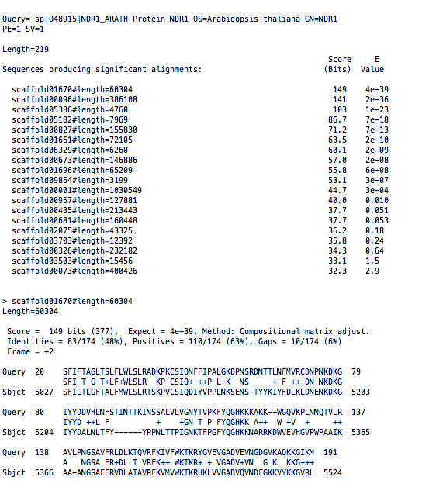

This is a list of scaffolds on which your query sequence produced “significant alignments,” or hits, ordered by specificity (most specific to least) as indicated by the ascending E-Value. I only considered E-Values that were less than 1e-05. If a gene aligned at the same location on the same scaffold as another gene, I used the next unique hit for analysis.

10) Scroll to the readout of the most specific alignment of your gene of interest with a unique scaffold, which should look as follows:

Note the length of the scaffold (dashed box) and the starting location of the aligment (solid box), which may either be at the beginning or end of the sequence identified.

11) Search for the scaffold of interest identified in 9 and 10 on the text file of the sorted 454 blueberry genome scaffolds (Sorted_454Scaffolds.txt).

12) Copy and paste the sequence of this scaffold into a plain text file.

13) Upload this text file of the scaffold to the Vaccinium SSR Tool on the “Genome Database for Vaccinium” (http://www.vaccinium.org/cgi-bin/vaccinium_ssr).

14) On this SSR Tool, under “Specify Motif Frequency,” change everything but dinucleotides and trinucleotides to 0. This will ensure the tool will only identify SSRs with two or three repeated base pairs on the scaffold. Hit SUBMIT.

15) You will receive an email with the SSR results. Open them in an Excel file.

16) Using the data on the second sheet of the Excel file titled “SSRs1,” select the three best primer pairs that designate specific SSRs close to the alignment’s starting location with as the most repeats and create a primer product between 100 and 700 bps.
17) Repeat this process for all of your genes of interest.
Appendix B. SSR Primer Pairs Details
RPM1 scaffold00004 location start: 534797

1)
For Primer TGGAAATGGTAAAATGGGTCTC
Rev Primer CAACTTGAAGGTTGGCATGAT
Repeats (ct) x16 PCR product: 253 start at base 488974

2)
For Primer CTTCAAAAAGGAATCAACCCAG
Rev Primer ATGGAAACATGGGTAGAGAGGA
Repeats (ct) x14 PCR product: 300 start at base 581363

3)
For Primer CCACATCTTCAGATCTCTCCCT
Rev Primer ACACGAGTTACACGACGAAGAA
Repeats (tc) x11 PCR product: 253 start at base 546065

RPS2 scaffold01086 location start: 62969

1)
For Primer GTGTGGGTTTGAGGAATGATTT
Rev Primer AACGAAGAAGGCCAGTGTAATC
Repeats (ga) x7 PCR product: 208 start at base 70923

2)
For Primer GAAAATGCCATCCAGCTAAAAG
Rev Primer CGGAGGTTCAAATTCATGGTAT
Repeats (gt) x10 PCR product: 229 start at base 38730

3)
For Primer CGATCTCGAACTAAAATCTCGC
Rev Primer TTGTTTGGACAGGTTGCTATTG
Repeats (ag) x10 PCR product: 262 start at base 89488

RPS5 scaffold002876 location start: 132641

1)
For Primer CCAACTTGTTAAGCAGACATGC
Rev Primer GCCAACCTATCACTGTCAACAC
Repeats (ta) x9 PCR product: 288 start at base 123432

2)
For Primer ATTCTACCCTTTGACACGTTGG
Rev Primer CTCAAACTAAGCGCTCTGAACA
Repeats (tc) x10 PCR product: 247 start at base 157234

3)
For Primer ATTCTACCCTTTGACACGTTGG
Rev Primer CTCAAACTAAGCGCTCTGAACA
Repeats (ag) x10 PCR product: 299 start at base 158100

PBS2 scaffold00103 location start: 5106

1)
For Primer GAAGAAAGAGTGGTGGGTTTTG
Rev Primer GTTCTCCTCTCTCTCCTCCCTC
Repeats (ag) x12 PCR product: 176 start at base 55610

2)
For Primer AGAAGAAGGAAGAGGTGGGAAG
Rev Primer TGCTACACCATAAACAGGTTGC
Repeats (ag) x9 PCR product: 220 start at base 32547

3)
For Primer TAACGCACTACCTTACGGTTCA
Rev Primer AAATACCAGCAGGGTTCTTTCA
Repeats (tc) x7 PCR product: 221 start at base 19511

RPP2 scaffold00365 location start: 99357

1)
For Primer AACTACGAGACTATACACGAGGACC
Rev Primer CCAGCCCTACCATGGATATAAA
Repeats (ct) x16 PCR product: 141 start at base 107277

2)
For Primer TGCTCTTCATCACCTTTTCTCA
Rev Primer AGTGAGTCATGCTCAAAACGAA
Repeats (gct) x5 PCR product: 203 start at base 99329

3)
For Primer TAATGTGGTCTATCTTGCCGTG
Rev Primer GGTGAGTATCAACTTTCCCAGC
Repeats (ct) x9 PCR product: 166 start at base 113622

RPP4 scaffold00231 location start: 265344

1)
For Primer GTATGCGTTAGCATCACGAAAG
Rev Primer AGAACCCCATTCCCTTATTGTT
Repeats (tc) x23 PCR product: 295 start at base 197095

2)
For Primer AGAGAAGGGGAGTTTTGGGTAG
Rev Primer ATATTTCCTGGGTTCTCTGGGT
Repeats (ga) x13 PCR product: 293 start at base 205822

3)
For Primer GCCATTGGAGAGAGAGAGAGAG
Rev Primer GTCAATTTACCCCTACCATCCA
Repeats (gt) x8 PCR product: 128 start at base 258687

RPP5 scaffold04339 location start: 3713

1)
For Primer TCAGCATGTGTTTGTGATTGAG
Rev Primer CTCAAGTTTCCACTTTCTCGCT
Repeats (ga) x8 PCR product: 150 start at base 6948

RPS4 scaffold00044 location start: 233001

1)
For Primer ACTGGGCTTTCCCTTACTTTTC
Rev Primer ATTTTGGTTACAACTGGATGGG
Repeats (tc) x5 PCR product: 218 start at base 220782

2)
For Primer GAACCTACTCCAACAAACTGCC
Rev Primer TCTAGACCATGTATGGGGTTCC
Repeats (ga) x5 PCR product: 181 start at base 242115

3)
For Primer TCGGTTGTCACCAAAGTAGAGA
Rev Primer TTATCCAGTTGAGGCATGATTG
Repeats (ag) x5 PCR product: 289 start at base 267683

EDS1 scaffold00607 location start: 39214

1)
For Primer CGGAAGTCCTAACCCAGTGTAG
Rev Primer GTTCGGTTACGGTTAGGTTACG
Repeats (tc) x24 PCR product: 267 start at base 21034

2)
For Primer CGGAAGTCCTAACCCAGTGTAG
Rev Primer GTTCGGTTACGGTTAGGTTACG
Repeats (tcg) x9 PCR product: 267 start at base 21080

3)
For Primer TGATGATTTTAGTTGCAGGTGG
Rev Primer CACAAACACATGCATGAACAAG
Repeats (ct) x6 PCR product: 226 start at base 35215

PAD4 scaffold00745 location start: 109010

1)
For Primer CACTGCCAGATGACACTTCCTA
Rev Primer ACATGTTTGGACAGCTCAAATG
Repeats (taa) x9 PCR product: 247 start at base 119981

2)
For Primer GCATAGAGACGAGGAAAAGGAA
Rev Primer CCGATACACTTTTAGAATGCCC
Repeats (ag) x9 PCR product: 138 start at base 87942

3)
For Primer TAAATACCAAATCCCCTCATGC
Rev Primer AGAGATCAGGGAGGAGGAATGT
Repeats (tct) x10 PCR product: 235 start at base 73881

RPP7 scaffold00179 location start: 115488

1)
For Primer CTTGTGAGTGTTGGACCAATGT
Rev Primer GTGGGTTTGGAATTAAGGATCA
Repeats (gt) x10 PCR product: 252 start at base 113637

2)
For Primer CTAGAGGGTTTCAGGCTATCCC
Rev Primer GAGATCAATTTGTCACAGGCAA
Repeats (tc) x16 PCR product: 231 start at base 164985

3)
For Primer AGGGTTTTGAGTGCTGATCAAT
Rev Primer TAATGAGTTGCCACCACGTAAG
Repeats (ga) x12 PCR product: 236 start at base 127514

RPW8 no scaffold

RPP8 scaffold00651 location start: 134208

1)
For Primer CGACACAGGTCCTCTCTCTCTC
Rev Primer ACCTGCAACTAATAGCTCGCTC
Repeats (ct) x24 PCR product: 277 start at base 133889

2)
For Primer AGAATAGCATGTCCCGACTCTC
Rev Primer CAACTAATAGCTCGCTCCCTTT
Repeats (ct) x14 PCR product: 300 start at base 133843

3)
For Primer GTACCGGTGAGTGTGTTGAAGA
Rev Primer AATAGTGGATTCTGGGGTGAGA
Repeats (ag) x14 PCR product: 231 start at base 120447

RPP13 scaffold02218 location start: 7749

1)
For Primer AGTTCATCCTGAGCTCACAACA
Rev Primer AAAAGCTCAAGACTGGACCAAA
Repeats (tg) x10 PCR product: 191 start at base 24422

2)
For Primer CCCTAGCTTCACTTGACAATCC
Rev Primer TGACGTTTAGGAACTCCGCTAT
Repeats (ct) x8 PCR product: 240 start at base 1090

3)
For Primer GTGTCACTCTCCCATTCGTGTA
Rev Primer TCACCTGAGAAAAGCAGACTGA
Repeats (ct) x8 PCR product: 281 start at base 27796

LOV1 scaffold 02957 location start: 14585

1)
For Primer ACCGTAAAACCATTCACCAGTC
Rev Primer GAGGAAGAGGAGGAGAGAGAGG
Repeats (tc) x12 PCR product: 100 start at base 13287

2)
For Primer CTGTCACAGGTTTGCTCCATTA
Rev Primer AGGTACTGCTATGCTCCGTCAT
Repeats (ttc) x5 PCR product: 100 start at base 359

RPP1 scaffold00231 location start: 211033

1)
For Primer GTATGCGTTAGCATCACGAAAG
Rev Primer AGAACCCCATTCCCTTATTGTT
Repeats (tc) x23 PCR product: 295 start at base 197095

2)
For Primer AGAGAAGGGGAGTTTTGGGTAG
Rev Primer ATATTTCCTGGGTTCTCTGGGT
Repeats (ga) x13 PCR product: 293 start at base 205822

3)
For Primer TCCAACAAAACATATGCAGCTC
Rev Primer TGGCATCATTATTCTTCGAGTG
Repeats (ga) x21 PCR product: 279 start at base 174854

L6 scaffold00327 location start: 219229

1)
For Primer TCCGCATGCTAGACACTAATTG
Rev Primer GTCCATCCACATAGGGACTTGT
Repeats (gt) x12 PCR product: 287 start at base 217849

2)
For Primer GGGAGAGAAAAGAGGAGAGAGG
Rev Primer GGCATGTGTAGACGCAAAATTA
Repeats (ag) x11 PCR product: 262 start at base 186588

3)
For Primer ATATGGAGGTGGCTAAGCATGT
Rev Primer TAAGTCGGCCTCAAGAAAAAGA
Repeats (tc) x9 PCR product: 136 start at base 194596

N scaffold00311 location start: 244627

1)
For Primer TCCCCGGAAGATAAGTGTAGAA
Rev Primer TGGTAAATTCAAGTTGGAACCC
Repeats (ag) x19 PCR product: 287 start at base 242728

2)
For Primer CGAGGAACAAGTTTAATACACGAG
Rev Primer TTTTAGCTCCTCCCTCTCTCCT
Repeats (ag) x11 PCR product: 113 start at base 209106

3)
For Primer TCCCCGGAAGATAAGTGTAGAA
Rev Primer TGGTAAATTCAAGTTGGAACCC
Repeats (ac) x6 PCR product: 286 start at base 242716

M scaffold02051 location start: 53365

1)
For Primer TGGCTGATAATATGGTGATGGA
Rev Primer NCTCTCACCACAACTTCAATTACAC
Repeats (tc) x11 PCR product: 221 start at base 41934

2)
For Primer GTGTGTGGTGTGAGCGTAGAAT
Rev Primer ATTTATAGAGCGGTCACAGGGA
Repeats (ac) x16 PCR product: 239 start at base 3200

3)
For Primer AGTTCCTCCCACCTAGAGAACC
Rev Primer CCAGACCCCAAAGAGAATGTAG
Repeats (ac) x12 PCR product: 143 start at base 20951

I2C1 scaffold02333 location start: 4782

1)
For Primer TTGTGTGTAGGAATGTTGTGGA
Rev Primer CCATGCACGAAATGTACTGAAG
Repeats (at) x6 PCR product: 228 start at base 405

2)
For Primer CAAATCCTCCAGTTGAAACTCC
Rev Primer TCGAAGCAATTGCGATAGATAG
Repeats (at) x5 PCR product: 203 start at base 28032

3)
For Primer GGTGTCCAACCTGATCCATAAT
Rev Primer AGATCCTATCAGGCACAGTGGT
Repeats (tc) x5 PCR product: 157 start at base 33827

Prf scaffold00437 location start: 106724

1)
For Primer CCCTAGAACATAGGACAGACGG
Rev Primer GACCGGAGAATACGAATCAGAC
Repeats (tc) x16 PCR product: 290 start at base 142814

2)
For Primer ACATACTCCAAACCACACCCTC
Rev Primer GGTCGCGATCTTCTTCTCTCT
Repeats (tc) x16 PCR product: 214 start at base 136033

3)
For Primer ACATACTCCAAACCACACCCTC
Rev Primer GGTCGCGATCTTCTTCTCTCT
Repeats (tc) x9 PCR product: 251 start at base 135150

Mi scaffold01683 location start: 70700

1)
For Primer AGACGATCTCCAAGCTTTTCTG
Rev Primer CTACAACCGTAAATCCACCCAT
Repeats (ga) x17 PCR product: 121 start at base 70043

2)
For Primer ACGGTTCTATTTCACGATCCAT
Rev Primer CGTTTCCTATGCATGAGGTGTA
Repeats (ct) x8 PCR product: 234 start at base 66680

3)
For Primer CTAATCTGTCGGACCAGCTCTT
Rev Primer GGAACCCTTACAGCTCTGTTCA
Repeats (tc) x6 PCR product: 244 start at base 64027

RGC2 scaffold07696 location start: 3642

no primer found

Pto scaffold00539 location start: 139327

1)
For Primer AACGCATAAAACCACTCCTCAT
Rev Primer TCAGATTTCGTTAGTGGGGTTT
Repeats (tc) x12 PCR product: 130 start at base 131860

2)
For Primer GACTACAGTGGCCAGACAATGA
Rev Primer CGGACATGTTTGACACCTCTAC
Repeats (ga) x8 PCR product: 279 start at base 145896

3)
For Primer CAGCAATACTTCCGCTCTCTCT
Rev Primer CTTGTATCTTGTTAGTGGATGTGTG
Repeats (tc) x15 PCR product: 279 start at base 55797

Cf-2 scaffold11065 location start: 396

1)
For Primer TGAAATTGTGACAGCTTGTGTG
Rev Primer CATCACAAAGCCTATTGATTGC
Repeats (at) x5 PCR product: 283 start at base 1720

Cf-4 scaffold00725 location start: 6768

1)
For Primer CCAGTATTGTTGAAAGAAGCCC
Rev Primer TACCTACCTACCTCCTCCTCCT
Repeats (ag) x24 PCR product: 247 start at base 27193

2)
For Primer GGCTTGTTGTTGTTGTTGACAT
Rev Primer CCACAAGATTAACCCAATCCAT
Repeats (ag) x13 PCR product: 298 start at base 39567

3)
For Primer CAATTGGTGCAGAAATCTGGTA
Rev Primer TACACATCTTCGTTTTTCTGCG
Repeats (tc) x13 PCR product: 173 start at base 69608

Cf-5 scaffold01395 location start: 14100

1)
For Primer GACGTAACTCCACACTGAACCA
Rev Primer AGATTACGCCTCATGTAAGGGA
Repeats (ga) x14 PCR product: 197 start at base 7332

2)
For Primer GACGTAACTCCACACTGAACCA
Rev Primer AGATTACGCCTCATGTAAGGGA
Repeats (ga) x14 PCR product: 197 start at base 44659

3)
For Primer TCCCCACTTTCTCAAGCTATGT
Rev Primer CCCAGAAAAAGCTTATGCACTC
Repeats (tc) x12 PCR product: 121 start at base 67039

Cf-9 scaffold00838 location start: 14981

1)
For Primer TGCTTGTGTTGGCTTATTGAAC
Rev Primer TTTAAGTTCCACAAGGGAGGAG
Repeats (ct) x10 PCR product: 250 start at base 46054

2)
For Primer GTGGAGGTTCTGGTTTGATCTC
Rev Primer TCTTTCTCATGTGACCCATTTG
Repeats (ga) x7 PCR product: 124 start at base 34104

3)
For Primer ACCAGGGTGACTTCATAGGAGA
Rev Primer CAAAACTTGGAGGCCTAAGTCA
Repeats (at) x8 PCR product: 190 start at base 67921

NDR1 scaffold01670 location start: 5027

1)
For Primer CCTCTCCCTCAATTCTCTCTCA
Rev Primer CTTGTTCTCGTTGTCGAGTTTG
Repeats (cgg) x5 PCR product: 287 start at base 4993

2)
For Primer GCGATGCAGAAGTTGTTGATAG
Rev Primer ACACCTTACCGATTCAAGTGCT
Repeats (ta) x6 PCR product: 223 start at base 31113

3)
For Primer GCAATTTCATCTTCGCTCTCTT
Rev Primer GAGCGTTTGTATGGAGTGAATG
Repeats (ct) x5 PCR product: 298 start at base 59874

