**Identification of Important Sulfur-related Genes near QTLs that Influence Sulfur Levels in *B. oleracea***

James Helzberg*, Michael Lorensten, Gracie Gordon

Davidson College

* denotes paper author and corresponding author—jahelzberg@davidson.edu

**Abstract**

Plants are major producers of organic sulfur molecules in the ecosystem. For humans, organic sulfur molecules serve many vital roles. Sulfur uptake, assimilation, and accumulation in *B. oleracea* is controlled by a number of genes and complex pathways. For this project, Dr. Allen Brown’s lab at N.C. State University provided us with quantitative trait loci (QTLs) shown to cause two to three fold increase in sulfur accumulation in the florets of *B. oleracea* not attributable to environmental factors. Through genomic analysis of the *B. oleracea* genome, we identified a number of candidate genes that could be responsible for these QTLs.

**Introduction**

Plants serve as a major primary producer of organic sulfur molecules in the environment. Animals cannot assimilate inorganic sulfur into organic forms. The importance of sulfur in human diets was recently reviewed by Nimini, *et al.* (2007). Sulfur-containing organic molecules that are produced by plants are vital to human nutrition. Plants provide animals with the sulfur-containing amino acids methionine and cysteine, which are necessary for protein synthesis. Methionine is an essential amino acid in humans from which most necessary organic sulfur molecules can be created. Glutathione, an important storage form of sulfur in humans, plays an important anti-oxidant role in the body (Nimni *et al.*, 2007). Additionally, glucosinolates, a class of organic, sulfur-containing compounds, have been shown to inhibit carcinogenesis **(**Tawfiq, *et al.*, 1995**)**. In plants and humans, sulfur-containing compounds play important detoxification roles. They also neutralize free radicals and reactive oxygen species (Nimni, *et al.*, 2007).

The main input of sulfur in plants is inorganic, anionic sulfate. In *Arabidopsis thaliana*, SULTR1 transporters co-transport sulfate molecules with protons from the soil into the root cells. The proton gradient is established by plasma membrane proton ATPases (Leustek, *et al.*, 2000). These SULTR1 transporters are also called AST transporters and are upregulated in sulfate starved *A. thaliana* roots (Takahashi, et al., 1997). Once sulfate has entered root cells, it can be transported through the xylem to other areas of the plant. SULTR2 transporters move sulfate in and out of the xylem and phloem for distribution throughout *A. thaliana*. In the stems and leaves, sulfate can re-enter cells. Intracellular sulfate can either be assimilated into organic sulfur compounds or can be transported into the vacuole for storage in its inorganic form (Leustek, *et al.*, 2000). SULTR4 transporters mediate vacuolar sulfate flux in *A. thaliana* (Buchner, *et al.*, 2004 ).

Assimilation of sulfate into organic forms occurs in the plastids. Sulfate transport into the plastids is suspected to involve multiple types of transporters. SULTR4;1 transporters likely use an H+ gradient similar to other SULTR transporters to move sulfate into plastids (Takahashi, *et al.*, 1999; Leustek, 2002). Orthologs of bacterial CysT genes have also been identified in *A. thaliana*, indicating that sulfate ATPases may also exist in the plastid membrane (Leustek, *et al.*, 2000). Enzymes in the plastids facilitate a number of reactions that results in the production of cysteine from sulfate. Cysteine serves as the primary precursor to a number of sulfur containing compounds. An alterative pathway that forms choline-*O*-sulfate from sulfate also exists (Leustek, *et al.*, 2000).

Regulation of the sulfate assimilation pathway is complicated and involves both compounds synthesized from cysteine and enzymes in the cysteine metabolic pathway. Among the most important of these is glutathione. Glutathione concentrations in the plant can reach up to 10 mM (Leustek, *et al.*, 2000). In addition to providing important anti-oxidant functions, glutathione is an important signaling molecule in sulfate transport. High levels of sulfur-containing compounds, like methionine and glutathione, serve as signals for plants to slow sulfate assimilation, store sulfate in the vacuole, and/or slow uptake (Mauruyama-Nakashita, *et al.*, 2004). High levels of O-acetyl serine (OAS), the non-sulfur containing carbon backbone that is used in the reaction to produce cysteine, serves as a signal that plant sulfate levels are low. Thus, high levels of OAS stimulate sulfate uptake (Mauruyama-Nakashita, *et al.*, 2004). Interestingly, sulfate sequestered in the vacuole is not coupled with sulfate assimilation (Koprivova, *et al.*, 2013), as sulfate in the vacuole does not contribute to sulfate signaling (Mauruyama-Nakashita, *et al.*, 2004). Koralewska *et al.* demonstrated that anionic sulfate can comprise about 50% of total sulfur content in the leaves of *B. oleracea* (2007).

Because sulfur-containing molecules are important for both human and plant health, researchers are interested in the processes that alter sulfate uptake and assimilation. For this project, Dr. Allen Brown’s lab at N.C. State University provided us with quantitative trait loci (QTLs) in *Brassica oleracea* shown to be responsible for a two to three fold increase in sulfur accumulation in the florets. These differences in accumulation were not attributable to environmental factors. The goal of our project was to perform genomic analysis of the unexplored broccoli genome in order determine which genes could be responsible for these QTLs. By gaining a better understanding of genes near the QTLs, we could provide significant evidence as to which genes may be important in regulating sulfur levels. The results of our analysis could subsequently be analyzed in wet-lab experiments using SSRs we identified, and ultimately could help farmers grow a better broccoli crop.

In addition to our main goal of finding genes responsible for the QTLs, we also wanted to provide support to researchers who create genomic analysis tools. In the course of our project, we used the BLAST feature on the Genome Database for *Vaccinium* (Washington State University, 2014). We also used the Integrated Genome Browser (IGB) to manually search the *B. oleracea* genome (Nicol *et al.*, 2014). By performing our search for genes in multiple ways, we hoped to provide researchers with information to improve their genomic analysis tools.

**Methods**

Dr. Allen Brown’s Lab at N.C. State University provided us with a list of QTLs (**Table 1.**) We compiled a list of proteins that are important in sulfate uptake and assimilation and found the amino acid sequence for each protein in *A. thaliana* (**Table 2.**).

**Table 1.** Chromosome and locations of QTLs in *B. Oleracea* (C) and *B. rapa* (A) provided by Dr. Allen Brown’s lab at N.C. State University.

|  |  |
| --- | --- |
| Chromosome (note: C denotes *B. oleracea* wheras A denotes *B. rapa*) | Location (bp) |
| C09 | 19,664,943 |
| C02 | 46,217,719 |
| C01 | 33,168,082 |
|  |  |
| A01 | 21-23 MBP |
| A02 | 20-22 MBP |
| A09 or A10 | could be near the end of 9 or the beginning of 10, possibly 2 copies? |

**Table 2.** List of proteins from *A. thaliana* that are important in plant sulfate uptake and/or assimilation. NCBI reference numbers or accession numbers are listed to reference amino acid sequences.

|  |  |
| --- | --- |
| Gene | NCBI Ref |
| GSH-dependent dehydroascorbate reductase | AAP13365.1 |
| GSH-dependent dehydroascorbate reductase | NP_001077564.1 |
| Glutathione peroxidase | NP_180080.1 |
| Glutathione reductase, cytosolic | AAP68309.1 |
| Glutathione transferase | NP_171791.1 |
| Glutathione transferase-like protein | NP_189966.1 |
| Putative glutathione transferase | NP_187538.1 |
| Serine acetyltransferase (Sat-1) | ABH04578.1 |
| Cysteine synthase oasC | BAH20427.1 |
| O-acetylserine (thiol) lyase; cysteine synthase | AAN72166.1 |
| Putative serine hydroxymethyltransferase | AAT72485.1 |
| S-adenosylmethionine synthetase like | NP_188365.1 |
| S-adenosylmethionine synthetase 2 | BAH20274.1 |
| S-adenosylmethionine decarboxylase | BAH19598.1 |
| Adenosylhomocysteinase | BAH19670.1 |
| Gamma-glutamylcysteine synthetase | NP_001190808.1 |
| Sulfate transporter AST68 (Sultr2;1) | NP_196580.1 |
| Sulfate transporter Sultr4;1 | NP_196859.1 |
| Sultr1;1 | NP_192602.1 |
| Sultr1;2 | NP_849899.1 |
| Sultr1;3 | BAB16410.1 |
| Sultr2;2 | NP_565165.2 |
| Sultr3;1 | NP_190758.2 |
| Sultr3;4 | AEE75760.1 |
| Sultr3;2 | NP_192179.1 |
| Sultr3;5 | NP_568377.1 |
| Sultr3;3 | AEE30335.1 |
| Sultr4;2 | NP_187858.1 |
| Sulfite Reductase | NP_196079.1 |
| APS Reductase | AAB57688.1 |

**BLAST:**

For each protein in **Table 2**, we ran a tBLASTn against the *B. oleracea* genome using the each protein’s amino acid sequence from *A. thaliana* as the query. Accession or NCBI reference numbers are provided in **Table 2** to indicate the amino acid sequence we used as the query. Any hits where E≤10-6 and that were located within 10 Mbp of a QTL were recorded according to the name of the protein in *A. thaliana.* All BLASTs were performed using the Genome Database for *Vaccinium* (Plants for Human Health Institute, N.C. State University, and Washington State University, 2014).

This same protocol was used to find genes near QTL’s given for *B. rapa*; however, because a QTL location range was provided for *B. rapa*, we assumed the QTL was in the middle of the given range and only recorded hits 10 Mbp from the center of the QTL range. Furthermore, we did not record any hits on A09 or A10 as the QTL range provided was too large for us to be able to provide significant data.

**Integrated Genome Browser (IGB):**

We performed a manual search of the *B. oleracea* genome using the genome visualization tool, IGB (Nicol *et al.*, 2014). We searched for genes within 1 Mbp of each QTL (2 Mbp search range with the QTL in the middle). We recorded the gene annotation and location of all genes that could affect sulfur uptake and/or assimilation based on annotations provided by IGB. A BLASTp was performed on any gene with ambiguous annotation using translated DNA sequences as the query.

We subsequently performed keyword searches in IGB. We searched words such as sulfur, thiol, SULTR, *etc*. to identify more genes involved in sulfur uptake or assimilation were located within 1 Mbp of our QTLs. This search method had very limited success as we found most genes of interest during our initial manual search.

For any gene within 1 Mbp of a QTL that was not annotated by IGB but identified via BLAST, we performed comparative protein-protein BLAST using the translated cDNA from IGB and amino acid sequence identified via BLAST. Comparative protein-protein BLASTs were performed in multiple reading frames

**SSR Identification:**

For each candidate gene within 1 Mbp of a QTL, we identified 3 polymorphic SSR markers near the gene of interest. Selection criteria for markers were a) a tri or tetranucleotide motif, b) within 100,000 bp of the gene of interest, and c) a high number of repeats. If this criteria could not be met for three SSRs, two were selected. If only one SSR was available to meet the criteria, we included the best dinucleotide repeat as an alternative or expanded the search range. SSR markers were selected from a spreadsheet provided by Dr. Allen Brown’s lab at N.C. State University.

**Results**

Both BLAST and IGB methods helped us identify genes possibly responsible for the QTLs we were given.

**BLAST:**

Using the BLAST method, we were able to match 19 proteins from **Table 2** to genes on chromosome 1 (**Fig. 1**). None of these genes were within 1 Mbp of the QTL on chromosome 1. All the SULTR proteins hit the same gene due to high sequence similarity. They are therefore represented together in **Figure 1** as the SULTR Transport Family. We identified two candidate genes on chromosome 2 by BLAST method (**Fig. 2**). Neither of these genes were within 1 Mbp of the QTL, however. We matched 6 proteins from **Table 2** to genes on chromosome 9 (**Fig. 3**). The locus for APS Reductase was our closest hit, lying 147,609 bp away from the QTL. The next closest hit on chromosome 9 was O-acetylserine (thiol) lyase; cysteine synthase, which was approximately 1.88 Mbp from the QTL.

**Figure 1.** Distance of sulfur-related genes from the QTL on chromosome 1 in *B. oleracea*. All genes were identified via BLAST using proteins from *A. thaliana* as the query in a tBLASTn against the *B. oleracea* genome.

**Figure 2:** Distance of sulfur-related genes from the QTL on chromosome 2 in *B. oleracea*. All genes were identified via BLAST using proteins from *A. thaliana* as the query in a tBLASTn against the *B. oleracea* genome.

**Figure 3.** Distance of sulfur-related genes from the QTL on chromosome 9 in *B. oleracea*. All genes were identified via BLAST using proteins from *A. thaliana* as the query in a tBLASTn against the *B. oleracea* genome.

**IGB:**

We also found candidate genes that correlate with our QTLs in *B. oleracea* using the Integrated Genome Browser (IGB) (Nicol *et al.*, 2014). On chromosome 1, we found three candidate genes. On chromosome 2 of *B. oleracea*, we found three candidate genes. On chromosome 9 of we found four candidate genes for our QTL on the chromosome. The annotations and locations of these genes are provided in **Table 3** and diagrammed in **Figure 6**.

**Table 3.** List of candidate genes identified using IGB, along with their locations and distance from the QTL on the same chromosome.



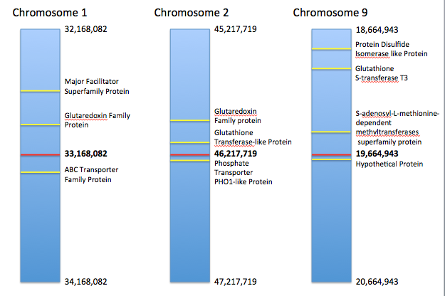

**Figure 6.** Location of candidate genes in a 2 Mbp range identified using IGB. Chromosome number is indicated above each bar. The red lines denote QTL location, and yellow denote candidate gene location with annotations provided to the right of each chromosome. Nucleotide numbers on the chromosome are provided at the top and bottom of the diagram. The bolded middle number adjacent to the red line is the QTL location. Gene locations are not drawn to scale.

**SSR Markers:**

APS reductase was the only gene we identified by BLAST method within 1 Mbp of a QTL. Additionally, we identified a total of 10 genes using IGB. SSR primers for each identified candidate gene within 1 Mbp of a QTL are presented in **Table 4**.

**Table 4.**  List providing two or three polymorphic SSR markers for each gene. This list includes the forward sequence, reverse sequence, PCR product size, start location, and motif.



**BLAST vs. IGB**

When comparing results from BLAST method and IGB, we found that the APS reductase protein, which we identified by BLAST, was not annotated in IGB. Translation of the DNA sequence from IGB in the area of the APS reductase gene on chromosome 9 (located by BLAST), followed by a comparative protein-protein BLAST, showed 100% identity between the amino acid sequence identified by BLAST method and the translated IGB DNA. This information indicates that the APS reductase gene is present, but not annotated in IGB. Figures presenting this discovery are located in **Appendix B**.

***Brassica rapa***

Results from BLAST method on *Brassica rapa* QTLs are presented in **Appendix A*.***

**Conclusion**

Using IGB and BLAST methods, we were able to identify several good gene candidates for further study in both *B. oleracea* and *B. rapa*. Since there was not time for follow-up on the *B. rapa* genes, and since the focus of our research was on *B. oleracea*, this conclusion will solely focus on genes found near QTLs in *B. oleracea*. We defined a good gene candidate as any hit from BLAST or IGB that lies within 1 Mbp of a QTL. For our three QTLs, we identified 11 gene candidates.

On chromosome 1, we did not find any hits using the BLAST method that were within 1 Mbp of the QTL; however, since the confidence intervals for QTLs locations are unknown, hits outside of 1 Mbp could still be significant. Hits within 1 Mbp of the QTL provide the most compelling evidence for further study and will be the focus of this conclusion.

Using IGB, we identified three candidate genes near the QTL on chromosome 1. The closest hit was an ABC transporter family protein. Research has shown that ABC transporter proteins may be involved in sulfate entry into the plastid. This evidence indicates that this ABC transporter gene could be important in the sulfate assimilation pathway (Hell *et al.*, 2008). A subsequent BLAST of the transporter did not help us narrow down the substance which this particular ABC transporter moves; therefore, further tests should be performed to see if this transporter happens to move sulfate or lies in the plastid membrane. The second candidate gene was a glutaredoxin family protein located approximately 227 kb away from the QTL. Genes in this family play a role in the glutathione system (The UniProt Consortium, 2014, a.). Glutathione is an important signaling molecule in sulfate uptake and transport (Leustek, *et al.*, 2000); therefore, this gene clearly warrants further study. Finally, we also identified a major facilitator superfamily protein gene 475 kb away from the QTL. Some bacteria possess a sulfate transporter related to the major facilitator superfamily proteins (Hell *et al.*, 2008). We chose to include this hit in our report as an unlikely candidate that could be examined further.

On chromosome 2, we found three good candidate genes, all using IGB method. The closest hit was annotated as a phosphate transporter PHO1-like protein. Phosphate transporters are very similar in structure to sulfate transporters. For instance, they both contain 12 membrane-spanning domains (Smith, *et al.*, 1999). Because of the high structure similarities between phosphate and sulfate transporters, we included this gene in our findings. The gene should be examined further to determine if the gene is misannotated and its protein product transports sulfate. We also identified a glutathione transferase-like protein gene approximately 76 kb away from the QTL on chromosome 2. Glutathione S-transferases react with glutathione and may help play a detoxification role in plants (The UniProt Consortiom, 2014, b.). These proteins exist in all eukaryotes and are important for detoxification functions (Hayes and Pulford, 1995). This gene may be involved in the glutathione response to foreign agents such as herbicides and heavy metals. How it would affect sulfur levels is unclear, but because glutathione S-transferases acts on the signaling molecule glutathione, it warrants further study. Finally, a second glutaredoxin family protein gene was identified 165 kb away from the QTL on chromosome 2, which should also be examined further due to its role in the glutathione system (The UniProt Consortium, 2014, a.).

We identified 5 good candidate genes for our QTL on chromosome 9. We identified the APS reductase gene, which lies 147 kb away from the QTL, by BLAST method. APS reductase is a key enzyme in the sulfate assimilation pathway. It reduces APS (sulfate attached to an AMP molecule) to sulfite (Leustek *et al.*, 2000). Researchers found that APS reductase is upregulated under sulfate starvation conditions (Takahashi *et al.*, 1997). Furthermore, other experiments have shown that APS reductase expression is altered at many levels under salt stress conditions (Koprivova *et al.*, 2008). The regulation of this gene under stressful conditions is consistent with the fact that many sulfur containing compounds, such as glutathione, are important in plants’ reactions to stressful conditions. Because this protein is important in assimilation of sulfate, it is a likely candidate to contribute to the QTL on chromosome 9.

Using IGB, we identified four more candidate genes for the QTL on chromosome 9. A second glutathione S-transferase gene was located 803 kb from the QTL on chromosome 9. Because this gene is relevant to the glutathione signaling system and we found annotations for this gene near multiple QTLs, it clearly warrants further study (The UniProt Consortium, 2014, b.). A protein disulfide isomerase like protein gene was 885 kb from the QTL. This protein likely regulates apoptosis of endothelial cells through inhibition of cysteine proteases in vacuole trafficking (The UniProt Consortium; c.). We are not confident that this protein disulfide isomerase like protein is responsible for our QTL on chromosome 9; however, because this protein’s function involves cysteine, we chose to include it in our report. Additionally, we found a gene annotated as S-adenosyl-L-methionine-dependent methyltransferases superfamily protein 140 kb from the QTL. Research indicates that S-methylmethionine plays major role in phloem transport of sulfur (Bourgis, *et al.*, 1999). For this reason, we believe this gene is a very interesting candidate for future study. Finally, we identified a hypothetical protein as a vacuolar amino acid transporter (using IGB followed by BLAST). Although unlikely, this protein could play a role in the transport of methionine or cysteine, or could be involved in the sulfate-signaling pathway.

Using IGB and BLAST, we identified a number of good gene candidates for future study. The fact that we found no SULTR transporters within 1 Mbp of the QTLs indicates that sulfate transport alone is likely not responsible for the QTLs. It is possible that the QTLs are the result of multiple gene interactions in the area of the QTLs. Furthermore, one of our identified genes could act as an intermediate in a signaling pathway involved in sulfur accumulation in the florets. Genes with same annotation that lie near multiple QTLs, such as glutaredoxin and glutathione S-transferase, are especially interesting and should be looked at very carefully. It would not be surprising if similar enzymes that were annotated with the same gene name contribute to multiple QTLs. Furthermore, the APS reductase and S-adenosyl-L-methionine-dependent methyltransferase genes are also likely candidates to influence their respective QTLs. Large bodies of evidence support these genes’ importance in sulfur assimilation and transport. Wet lab studies should be conducted on these candidate genes in *B. oleracea* using our polymorphic SSR markers to find which contribute to the QTLs.

The final goal of our study was to provide feedback on the genomic analysis tools we used. We found both BLAST and IGB to be good methods for finding candidate genes. Although both helped us identify candidate genes near the QTLs, there was not any overlap between genes found through BLAST and IGB. This lack of correspondence indicates that although both tools are helpful, neither is complete by itself. The fact that APS reductase was not annotated demonstrates the need for better annotation of the *B. oleracea* genome in IGB. Nonetheless, we found only one candidate gene within 1 Mbp of a QTL using BLAST, but we identified many candidate genes through IGB. Therefore, our results clearly demonstrate the usefulness of genome browsing tools in conducting genomic analysis of QTLs. For this reason, we conclude that IGB and BLAST methods are most powerful when used together.

**Appendix A.**

We also searched the *B. rapa* genome using the BLAST method. By the BLAST method, we matched 24 proteins from **Table 2**to genes on chromosome 1 of *B. rapa* (**Fig. 4**). All 12 SULTR genes were approximately 850,000 bp away from the QTL, indicating they hit the same gene because of high homology. S-adenosylmethionine synthetase was about 289,000 bp away from the QTL. S-adenosylmethionine decarboxylase was only 62,146 bp away from the QTL. Using this same method, we were also able to match 21 proteins from **Table 2** to genes on chromosome 2 in *B. rapa* (**Fig. 5**). S-adenosylmethionine decarboxylase was the only gene within 1 Mbp of the QTL on this chromosome at 778,202 bp away. SULTR transporters all hit the same gene due to high homology on chromosome 2 as well. In both **Figure 4** and **Figure 5**, all SULTR transporters from **Table 2** are grouped together and labeled as SULTR Transporter Family.

**Figure 4.** Distance of sulfur-related genes from the QTL on chromosome 1 in *B. rapa*. All genes were identified via BLAST using proteins from *A. thaliana* as the query in a tBLASTn against the *B. rapa* genome.

**Figure 5.** Distance of sulfur-related genes from the QTL on chromosome 2 in *B. rapa*. All genes were identified via BLAST using proteins from *A. thaliana* as the query in a tBLASTn against the *B. rapa* genome

**Appendix B.**

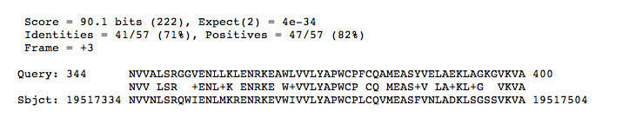

**Figure 6.** Location of APS Reductase gene on chromosome 9 identified via BLAST.

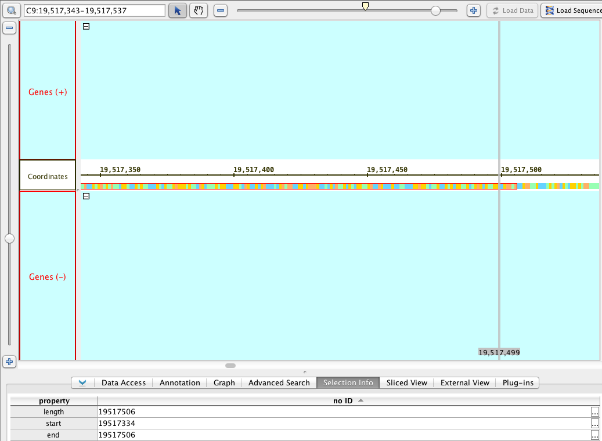

**Figure 7.** On IGB, no gene annotation is present in the location of the APS reductase gene found by BLAST.

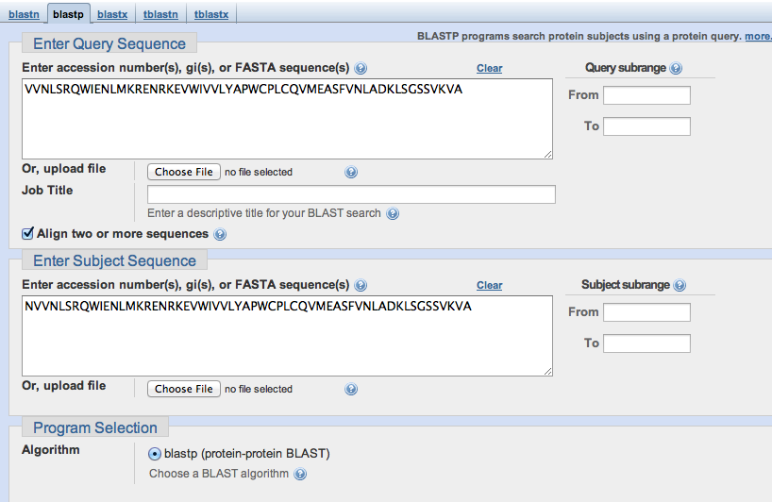 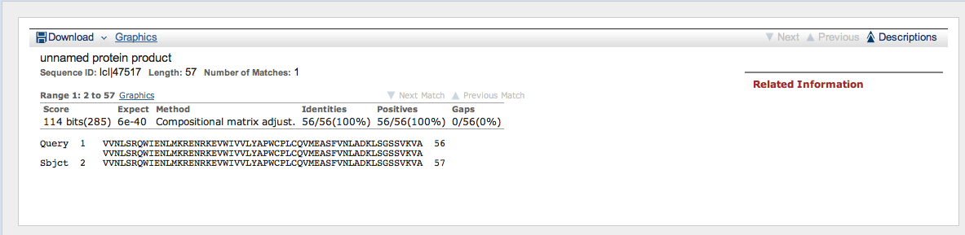

**Figure 8.** . Translation of the DNA sequence from IGB in the area of the APS reductase gene on chromosome 9 (located by BLAST), followed by a comparative protein-protein BLAST, shows 100% identity between the amino acid sequence identified by BLAST method and the translated IGB DNA.

**Acknowledgements.**

Thank you to our professor, Dr. A. Malcolm Campbell, for instruction and guidance throughout the project. We would also like to acknowledge Dr. Charles David for his instruction and technical support. Finally, we would like to thank Dr. Allen Brown and his lab at N.C. State University for their collaborative efforts and for providing us with the QTLs, the *B. oleracea* genome, and SSR markers which we used to conduct this project.

**References.**

Buchner, P., Stuiver, C., Westerman, S., Wirtz., Hell, R., Hawkesford, M., and De Kok, L. 2004. Regulation of Sulfate Uptake and Expression of Sulfate Transporter Genes in *Brassica oleracea* as Affected by Atmospheric H2S and Pedospheric Sulfate Nutrition. Plant Physiology 136:3396-3408.

Bourgis, F., Roje, S., Nuccio, M.L. Fisher, D.B., Tarczynski, M.C., Li, C., Herschbach, C., Rennenberg, H., Pementa, M.J., Shen, T.L., Gage, D.A., Hanson, A.D. 1999. S-methylmethionine plays a major role in phloem sulfur transport and is synthesized by a novel type of methyltransferase. Plant Cell 11:1485-98.

Hell, R., Dahl, C., Knaff, D., Leustek, T. *Sulfur Metabolism in Phototrophic Organisms: Advances in Photosynthesis and Respiration*. Spinger: 2008. Dordrecht, The Netherlands.

Koprivova, A., Giovannetti, M., Baraniecka, P., Lee, B., Grondin, C., Loudet, O., and Kopriva, S. 2013. Natural Variation in the ATPS1 Isoform of ATP Sulfurylase Contributes to the Control of Sulfate Levels in Arabidopsis. Plant Physiology 163:1133-1141.

Koprivova, A., North, K.A., Kopriva, S. 2008. Complex Signaling Network in Regulation of Adenosine 5’-Phosphosulfate Reductase by Salt Stress in *Arabidopsis* Roots. Plant Physiology 146: 1408-20.

Koralewska, A. Posthumus, F.S., Stuiver, C.E.E., Buchner, P., Hawkesford, M.J., Kok, L.J. 2007. The Characteristic High Sulfate Content in *Brassica oleracea* is Controlled by the Expression and Activity of Sulfate Transporters. Plant Biology 9:654-661.

Leustek, T. 2002. Sulfate Metabolism. The Arabidopsis Book.

Leustek, T., Martin, M.N., Bick, J., and Davies, J.P. 2000. Pathways and Regulation of Sulfur Metabolism Revealed through Molecular and Genetic Studies. Annual Review of Plant Physiology and Plant Molecular Biology 51:141-165.

Maruyama-Nakashita, A., Nakamura, Y., Yamaya, T., Takahashi, H. 2004. A novel regulatory pathway of sulfate uptake in *Arabidopsis* roots: implication of CRE1/WOL/AHK4-mediated cytokinin-dependent regulation. The Plant Journal 38:779-789.

Nicol J.W., Helt G.A., Blanchard S.G. Jr., Raja A., Loraine A.E. The Integrated Genome Browser: free software for distribution and exploration of genome-scale datasets. http://bioviz.org/igb/download.html. accessed March 25, 2014.

Nimni, M., Han, B., and Cordoba F. 2007. Are we getting enough sulfur in our diet? Nutrition & Metabolism 4:24.

Plants for Human Health Institute, N.C. State University, and Washington State University. Genome Database for *Vaccinium*. <http://dev.vaccinium.org>. accessed May 6, 2014.

Smith, F.W., Rae, A.L., and Hawkesford, M.J. 2000. Molecular mechanisms of phosphate and sulfate transport in plants. Biochimica et Biophysica Acta 1465:236-245.

Takahashi H, Asanuma W, Saito K. 1999. Cloning of an Arabidopsis cDNA encoding a chloroplast localizing sulfate transporter isoform. *J. Exp. Bot.* 50:1713–14.

Takahashi, H., Yamizaki, M., Sasakuru, N., Watanabe, A., Leustek, T., Engler, J., Engler, G., Montagu, M.V., Saito, K. 1997. Regulation of sulfur assimilation in higher plants; a sulfate transporter induced in sulfate-starved roots plays a central role in *Arabidopsis thaliana*. Plant Biology 94:11102-11107.

Takahashi, H., Yamizaki, M., Sasakuru, N., Watanabe, A., Leustek, T., Engler, J., Engler, G., Montagu, M.V., Saito, K. 1997. Regulation of sulfur assimilation in higher plants; a sulfate transporter induced in sulfate-starved roots plays a central role in *Arabidopsis thaliana*. Plant Biology 94:11102-11107.

Tawfiq, N., Heaney, R.K., Plumb, J.A., Fenwick, G.R., Musk, S.R., Williamson, G. 1995. Dietary glucosinolates as blocking agents against carcinogenesis: glucosinolate breakdown products assessed by induction of quinone reductase activity in murine hepa1c1c7 cells. Carcinogenesis 16:1191-1194.

The UniProt Consortium. Activities at the Universal Protein Resource (UniProt).

a. <http://www.uniprot.org/uniprot/Q9SGP6>. accessed April 22, 2014.

b. <http://www.uniprot.org/uniprot/Q9FHE1>. accessed April 22, 2014.

c. <http://www.uniprot.org/uniprot/Q9XI01>. accessed April 22, 2014.