James Helzberg

Folypolyglutamate synthase [EC: 6.3.2.17] found in Scaffold 1575 (query sequence starts at base 17039 on scaffold)

1)
For Primer AATCCCAATCCACCTATCCTTT
Rev Primer GCATTCAGCAGATGATTACAGC
repeats (ct) x13 PCR product = 136 bp & start at base 16858

2)
For Primer TCGAAAGCAGCTAATTCTCCAT
Rev Primer GGGGCTGAGGTCTTTTAGTTCT
repeats (gt) x12 PCR product = 298 bp & start at base 39327

3)
For Primer TCTTTCTCTCCAATTCTCAGCC
Rev Primer TGGAGCATAAAAGGGGAATAGA
repeats (tc) x10 PCR product = 300 bp & start at base 74834

Folypolyglutamate synthase [EC: 6.3.2.17] found in Scaffold 343 (query sequence starts at base 203727 on scaffold)

1)
For Primer GGTTGGTGTAAGATTCGTCCAT
Rev Primer TTCAACTCTCACCAGTCTCGAA
repeats (ga) x10 PCR product = 108 bp & start at base 189380

2)
For Primer CAACACAGATCTGCAGACAACA
Rev Primer CTTGTGTCAGTGTGACTCCCAT
repeats (ac) x8 PCR product = 187 bp & start at base 234573

3)
For Primer AATCAGCATGGCAGAAGGTACT
Rev Primer CCTTCAGCAATATCAACCATCA
repeats (tc) x7 PCR product = 196 bp & start at base 203551

Folypolyglutamate synthase [EC: 6.3.2.17] found in Scaffold 772 (query sequence starts at base 35323 on scaffold)

1)
For Primer GAAGAAGCTGATGAAGTGGGTC
Rev Primer TCCTTCAACTCTTCGTTTTTCC
repeats (ga) x10 PCR product = 269 bp & start at base 29847

2)
For Primer TTCAGCACGACAAGCTGATATT
Rev Primer AAGTGGCGGGATACATAAGAGA
repeats (ct) x10 PCR product = 177 bp & start at base 49250

3)
For Primer TGTAACAAGCTGGGATTTTGTG
Rev Primer TTTGAGTGGGGTCTTCAAGATT
repeats (tc) x8 PCR product = 233 bp & start at base 25035

Experiments are shown on pages 3-5.

Experiment 1: tBLASTn against Vaccinium corymbosum 454-scaffolds (Query is 521 aa sequence of folypolyglutamate synthase from Vitis vinifera)

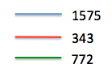
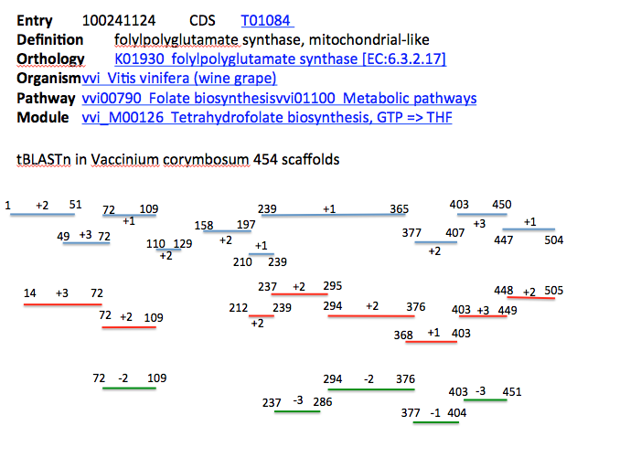
Legend: Results of tBLASTn of folypolyglutamate synthase [EC:6.3.2.17] using Vitis vinifera as the query against Vaccinium corymbosum 454-scaffolds. Results yielded three significant scaffolds (shown above). Scaffold 1575 is drawn as blue lines and contains many fragments due to frame shifts, but covers most of the protein. Scaffold 343 is drawn as red lines and also contains many fragments, but has good coverage as well. Scaffold 772 is shown as green lines and has less coverage.

Experiment 2:

I also ran a BLASTp using folypolyglutamate synthase [EC:6.3.2.17] from Vitis vinifera as the query and searched for the enzyme in Arabidopsis thaliana. Results are shown below:

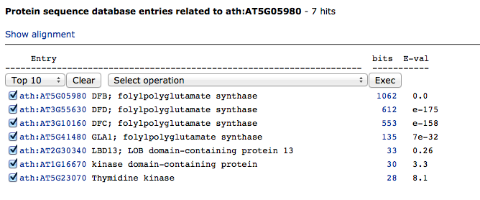
The top hit from Arabidopsis thaliana is folypolyglutamate synthase, which has a slightly different amino acid sequence than the enzyme in Vitis vinifera. I used the amino acid sequence for folypolyglutamate synthase from Arabidopsis thaliana (513 amino acids) as the query in a tBLASTn against Vaccinium corymbosum 454-scaffolds. Results from this experiment yielded the same three scaffolds (1575, 343, and 772), but with slightly less coverage. Results are shown below and on the next page:

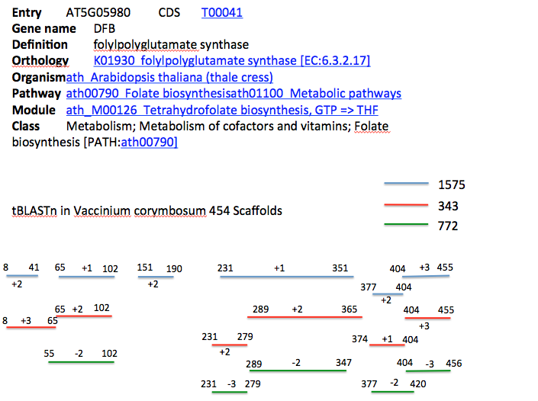

Legend: Results of tBLASTn of folypolyglutamate synthase [EC:6.3.2.17] using Arabidopsis thaliana as the query (513 amino acids) against Vaccinium corymbosum 454-scaffolds. Results yielded three significant scaffolds as shown above. Scaffold 1575 is drawn as blue lines and contains multiple fragments. Scaffold 343 is drawn as red lines and also contains many fragments. Scaffold 772 is shown as green lines.

