Hannah Itell
Davidson College

Enzyme: dihydrofolate reductase / thymidylate synthase (EC: 1.5.1.3)

Introduction:

I found Vitis vinifera (wine grape) enzyme 1.5.1.3 (Entry: 100255872) on Kegg Pathway for Vitis vinifera. I blasted grape 1.5.1.3 protein sequence (580 aa) against V. corymbosum 454-Scaffolds using tblastn:

Fig. 1 Hits from tblastn of grape EC 1.5.1.3 (query) and V. corymbosum scaffolds (subject).

I also found Arabidopsis thaliana enzyme 1.5.1.3 (Entry: AT2G16370) on Kegg Pathway for Arabidopsis thaliana, to see if a tblastn with Arabidopsis would be any different than with Vitis vinifera. I blasted Arabidopsis 1.5.1.3 protein sequence (519 aa) against V. corymbosum 454-Scaffolds using tblastn:

Fig. 2 Hits from tblastn of Arabidopsis EC 1.5.1.3 (query) and V. corymbosum scaffolds (subject).

When comparing the two sets of hits, I found that the same scaffolds had hits on both blasts with similar E-values. The grape blast had smaller E-values, so I used the grape results.

tBlastn Results

Subject: V. corymbosum 454-Scaffolds

Query: Vitis vinifera (wing grape) enzyme 1.5.1.3 (580 aa)

Alignments

Scaffold 00011 (E = 4e-90)

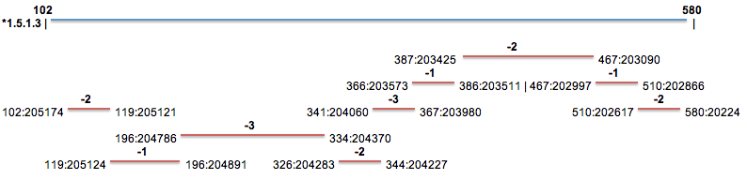

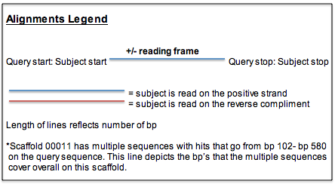
Scaffold 00117 (E = 6e-18)

+1
412:332617505:332916

Scaffold 00002 (E = 7e-06)

-2
412:314131 475:313961

Scaffold 00054 (E = 6e-05)

-2
398:421461:149

SSR Primers

EC 1.5.1.3 found in Scaffold 00011 (query starts at base 205174 on scaffold)

1)
For Primer: CGCACGCAAGTTAATAGATCTTC
Rev Primer: TTTTCCCAGATTATTGACAGCC
Repeats (at) x 24 PCR Product = 279 bp & starts at base 299383

2)
For Primer: TGCTTATTGTGTACCCATTGGA
Rev Primer: GTGGTTTGGGTCTCTCTGTGTA
Repeats (taa) x 15 PCR Product = 184 bp & starts at base 252504

3)
For Primer: CTTCATCATCGACTTCAGCAAG
Rev Primer: CCCGAGTCTTTATGGTGCTTAT
Repeats (ga) x 14 PCR Product = 276 bp & starts at base 268832

EC 1.5.1.3 found in Scaffold 00117 (query starts at base 332617 on scaffold)

1)
For Primer: AAAACAACTGCAACACATCAGG
Rev Primer: GGGAGGTAGGTAGGTAGGTTGG
Repeats (ct) x 15 PCR Product = 194 bp & starts at base 272344

2)
For Primer: ATGAGAAGCGCGTTAAAGAAAC
Rev Primer: GCTCTTGTTGGCTTTGTACCTT
Repeats (ga) x 10 PCR Product = 278 bp & starts at base 394372

3)
For Primer: ATGCCGTTAGTTTTCGTCACTT
Rev Primer: GGTAGTCATTTTGGTGGGAAAA
Repeats (ga) x 9 PCR Product = 141 bp & starts at base 317477

EC 1.5.1.3 found in Scaffold 00002 (query starts at base 314131 on scaffold)

1)
For Primer: GTATGCTGCTGCAAACAATGAT
Rev Primer: CTTGGAGAAGTGACAGAAAGCA
Repeats (tc) x 44 PCR Product = 236 bp & starts at base 341579

2)
For Primer: TTTGGCGAACGAACTATGTCTA
Rev Primer: TCTAGTCATGTGGCTTCATGGT
Repeats (tc) x 20 PCR Product = 261 bp & starts at base 361596

3)
For Primer: CAAGTACAGGCCTATCGAAACC
Rev Primer: ATAGAGAGTGTGAGGCTCGCTT
Repeats (ga) x 16 PCR Product = 283 bp & starts at base 394191

EC 1.5.1.3 found in Scaffold 00054 (query starts at base 421 on scaffold)

1)
For Primer: AGCTCCGACAACGATAACAACT
Rev Primer: ACAGAAAGACAACCGGAGAGAG
Repeats (ct) x 16 PCR Product = 264 bp & starts at base 99432

2)
For Primer: GTGTGTGTGTGTGTGTGTGTGA
Rev Primer: GTCCCACATTACCTGGCTACAT
Repeats (ag) x 13 PCR Product = 138 bp & starts at base 60988

3)
For Primer: ACATCTAATGGTTCGGATCGTC
Rev Primer: CTGAGCCCAAAGGTTTATATGG
Repeats (ta) x 10 PCR Product = 275 bp & starts at base 84700

