2/5/2013
Looking for anything related to drought stress related genes. Papers, figures, genes, proteins, QTLs, etc.
1. http://www.ncbi.nlm.nih.gov/pmc/articles/PMC3440228/
Roles of Four Arabidopsis U-Box E3 Ubiquitin Ligases in Negative Regulation of Abscisic Acid-Mediated Drought Stress Responses
AtPUB18 and AtPUB19 are homologous U-box E3 ubiquitin ligases. Mutants expressing these proteins are more sensitive to ABA and thus more resistant to drought. 18 and 19 linked. ABA (plant hormone abscisic acid) is a key mediator in drought stress response because it induces stomatal closing to minimize transpirational water loss. ABA turns on various genes necessary for triggering rapid and effective defense programs. ABA-induced genes are diverse and include U-box E3s. Studies suggest U-box E3s are necessary to induce ABA-mediated response. PUB44/SAUL1 prevent premature leaf senescence by down-regulating ABA levels and they inhibit seed germination under stressful conditions, such as high level of ABA, Glc, salt or mannitol, and therefore they are negative regulators of ABA-mediated cell death and seed germination processes. AtPUB 18 induced by ABA/drought
AtPUB18 sequence: http://www.ncbi.nlm.nih.gov/gene/837597
AtPUB19sequence: http://www.ncbi.nlm.nih.gov/gene/842314

A bit about ABA – plant hormone. Produced in terminal buds in preparation for winter. Slows plant growth and directs leaf primordial to develop scales to protect the dormant buds during winter. ABA inhibits division of cells in vascular cambium, adjusting to cold by suspending primary and secondary growth. ABA is also produced in the roots in response to decreased soil water potential, and other situations in which the plant may be under stress. ABA then moves from roots to leaves, where it alters osmotic potential of stomatal guard cells, causing them to shrink and stomata to close. Stomatal closure reduces transpiration, preventing further water loss. Also inhibits fruit ripening, inhibits seed germination, inhibits synthesis of kinetin – a cell division promoter, downregulates enzymes needed for photosynthesis, prevents growth of roots when exposed to salty conditions. In essence puts the plant into resource conservation mode. High levels of ABA inhibit overall plant growth. We want high drought response to ABA, not lots of ABA.

2. http://www.ncbi.nlm.nih.gov/pmc/articles/PMC3082259/
The MYB96 Transcription Factor Regulates Cuticular Wax Biosynthesis under Drought Conditions in Arabidopsis.
Drought stress activates defense responses like stomatal closure, maintenance of water uptake, synthesis of osmoprotectant. Deposition of cuticular waxes is also a drought response. ABA-responsive R2R3-type MYB transcription factor, MYB96 promotes drought resistance by upregulating translation of genes that promote deposition of cuticular waxes. MYB96 is a transcriptional activator of genes encoding very-long-chain fatty acid-condensing enzymes. MYB96 binds directly binds directly to conserved sequence motifs present in the gene promoters. Cuticle helps keep thin leaves from drying out. “seals” the environment.
MYB96 sequence data : http://www.arabidopsis.org/servlets/TairObject?id=131919&type=locus
3. http://www.ncbi.nlm.nih.gov/pmc/articles/PMC152917/
Arabidopsis Basic Leucine Zipper Proteins That Mediate Stress-Responsive Abscisic Acid Signaling.
ABRE (ABA-responsive elements) binding factors ABF3 amd ABF4 function in ABA signaling. Overexpression (transgenic plants) of ABF3 and 41 resulted in ABA hypersensitivity = reduced transpiration and enhanced drought tolerance. High levels of ABA inhibit overall plant growth.
ABF3 sequence data – http://www.ncbi.nlm.nih.gov/gene/829547
ABF4 dequence data - http://www.ncbi.nlm.nih.gov/gene/821463

4. http://www.annualreviews.org/doi/full/10.1146/annurev.arplant.57.032905.105444
More than 300 genes stress inducible. More than half of drought genes also induced by salt and vice versa. Only 10% of drought stress genes also induced by cold stress. There are at least 2 gene groups that share expression profile. In one, expression is rapid and transient, reaching a maximum at several hours, and then decreased. Most of these genes include regulatory protein factors such as zinc-finger protein, SOS2-like protein kinase PKS5, bHLH transcription factor, DREB1A, DREB2A, AP2/ERF domain-containing protein RAP2, and growth factor-like protein. In the other group, gene expression slowly and gradually increased after stress treatment within 10 hours. Most of these genes encode functional proteins such as LEA proteins, detoxification enzymes, and enzymes for osmoprotectant synthesis. Some of these genes are induced by ABA, whereas others are not. Several genes induced by ABA treatment, but also induced by cold or drought stress in ABA-deficient mutants. This indicates that both ABA-dependent and ABA-independent pathways can activate the same genes.
Induction of the dehydration-inducible RD22 is mediated by ABA. MYC and MYB binding sites on the RD22 promoter. MYC activated by AtMYC2 (rd22BP1) and MYB activated by AtMYB2 bind to those sites on the promoter. Those two transcription factors synthesized after the accumulation of ABA. Transgenic plants overproducing MYC and MYB had higher sensitivity to ABA and higher osmotic stress tolerance.
RD26 encodes a NAC protein and is induced by dehydration and ABA. Transgenic plants overexpression RD26 were highly sensitive to ABA.
ABA is synthesized de novo during dehydration, and degraded during rehydration. AtNCED3 (NCED enzyme) is a key enzyme in ABA biosynthesis and is strongly induced by drought and salt. Overexpression of AtNCED3 improved dehydration stress tolerance. CYP707A3 major catabolizer of ABA, rapidly induced by rehydration.

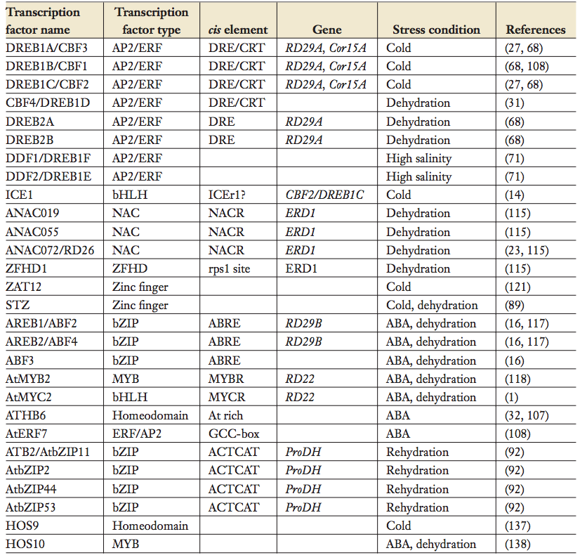

5. Role of arabidopsis MYC and MYB homologs in drought- and abscisic acid-regulated gene expression. PMC 157027

Induction of dehydration-responsive gene, rd22, is mediated by ABA and requires protein biosynthesis for ABA-dependent gene expression. 67 bp DNA fragment of rd22 promoter is required, contains two recognition sites for MYC and MYB.
6. Analysis of Cytokinin Mutants and Regulation of Cytokinin Metabolic Genes Reveals Important Regulatory Roles of Cytokinins in Drought, Salt, and Abscisic Acid Responses, and Abscisic Acid Biosynthesis. PMC3160038
All CK-deficient plants with reduced levels of various CKs exhibited a strong stress-tolerant phenotype associated with increased cell membrane activity and ABA hypersensitivity rather than ABA-mediated stomatal closure. Though CK deficiency increased sensitivity of plants to exogenous ABA, it caused a downregulation of key ABA biosynthetic genes, leading to a significant reduction in edogenous ABA levels in CL-deficient plants. CK and ABA metabolism interlinked.

ABA pathway, graphic and sequences of below genes at http://www.genome.jp/kegg-bin/show_pathway?ath04075

PYR/PYL are abscisic acid receptors, which when activated, inhibit PP2C, a protein phosphatase. The PP2C phosphatase dephosphorylates SnRK2, a serine/threonine-protein kinase, thereby inhibiting it. When SnRK2 Is active, it phosphorylates ABF (ABA-responsive binding factor) when is a transcription factor that then activates response genes.
Summary – ABA added, activates receptors PYR/PYL. PYR/PYL take down PP2C, which thus can’t take down SnRK2, which is thereby free to phosphorylate ABF transcription factors. In absence of ABA, PYR/PYL do not act on PP2C, which in its active state inhibits SnRK2, thus no transcription factors.

“Very little is known about the early events in the perception of stress signals”

THE MOLECULAR BASIS OF DEHYDRATION TOLERANCE IN PLANTS
http://www.ncbi.nlm.nih.gov/pubmed/15012294
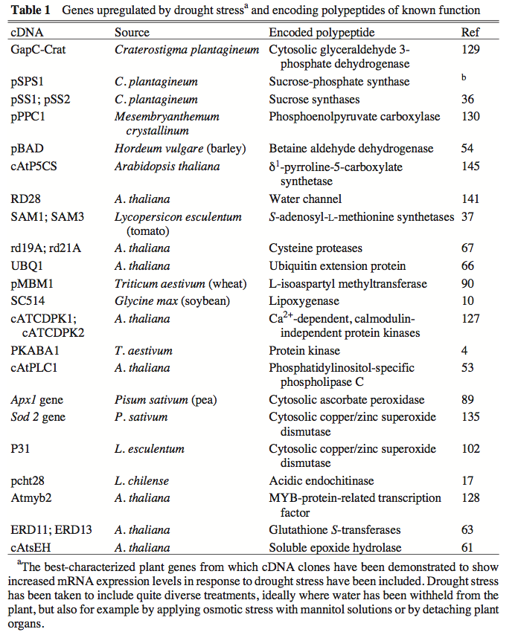

[upregulating] Proteases may also be an important feature of stress metabolism, dispensing with redundant proteins and depolymerizing vacuolar storage polypeptides, thereby releasing amino acids for the massive synthesis of new proteins. Ubiquitination proteins also upregulated.
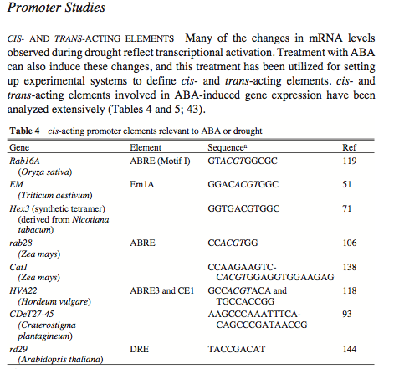
Enzymes for sugar metabolism also critical. Certain sugars may be central to protection against drought. Can serve as compatible solutes allowing osmotic adjustment.

“A different class of potential transcription factors with relevance to drought stress is represented by the A. thaliana gene Atmyb2. This gene encodes an MYB-related protein and is induced by dehydration or salt stress and by ABA (128). Plant myb-related genes comprise a large family that may play various roles in gene regulation. The ATMYB2 protein expressed in E. coli has been shown to bind the MYB-recognition sequence, PyAACTG, which supports its role as a DNA-binding protein. Another A. thaliana drought stress–induced gene, rd22 (56), has a promoter with no ABRE but with two recognition sites for the transcription factors MYC and MYB. Binding of the ATMYB2 protein appears likely but has not been proven experimentally.”

AREB1, AREB2, and ABF3 are master transcription factors that cooperatively regulate ABRE-dependent ABA signaling involved in drought stress tolerance and require ABA for full activation
http://onlinelibrary.wiley.com/doi/10.1111/j.1365-313X.2009.04092.x/full
“A myriad of drought stress-inducible genes have been reported, and many of these are activated by abscisic acid (ABA). In the promoter regions of such ABA-regulated genes, conserved cis-elements, designated ABA-responsive elements (ABREs), control gene expression via AREB/ABF transcription factors. Although all three members of the AREB/ABF subfamily, AREB1, AREB2, and ABF3, are upregulated by ABA and water stress, it remains unclear whether these are functional homologs. Here, we report that all three AREB/ABF transcription factors require ABA for full activation, can form hetero- or homodimers to function in nuclei, and can interact with SRK2D/SnRK2.2, an SnRK2 protein kinase that was identified as a regulator of AREB1. Along with the tissue-specific expression patterns of these genes and the subcellular localization of their encoded proteins, these findings clearly indicate that AREB1, AREB2, and ABF3 have largely overlapping functions. To elucidate the role of these AREB/ABF transcription factors, we generated an areb1 areb2 abf3 triple mutant. Large-scale transcriptome analysis, which showed that stress-responsive gene expression is remarkably impaired in the triple mutant, revealed novel AREB/ABF downstream genes in response to water stress, including many LEA class and group-Ab PP2C genes and transcription factors. The areb1 areb2 abf3 triple mutant is more resistant to ABA than are the other single and double mutants with respect to primary root growth, and it displays reduced drought tolerance. Thus, these results indicate that AREB1, AREB2, and ABF3 are master transcription factors that cooperatively regulate ABRE-dependent gene expression for ABA signaling under conditions of water stress.”

Regulation of abscisic acid-induced transcription
http://link.springer.com/article/10.1023%2FA%3A1006058700720?LI=true
“At present, more than 20 functional ABREs have been found in ABA-inducible promoters. The element is defined as a sequence of 8–10 base pairs with the core sequence
ACGT (Figure 2) [42, 86]. The sequence flanking the ACGT core is important for function in vivo [10, 83] and for protein binding in vitro [42]. Expression stud- ies indicate that the sequence (C/T)ACGTGGC is a strong ABRE [9, 86, 101] but other sequences are functional as well, and no clear consensus sequence for the ABRE can be derived [10]. The ABRE binds many basic domain leucine zipper (bZIP) transcription factors” Therefore, the ABRE is a subset of ACGT-containing elements that is defined by the function rather than by the flanking sequence.

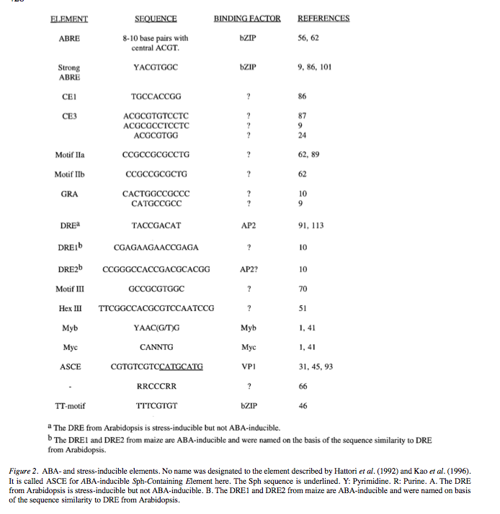

Early abscisic acid signal transduction mechanisms: newly discovered components and newly emerging questions

http://www.ncbi.nlm.nih.gov/pmc/articles/PMC2922499/
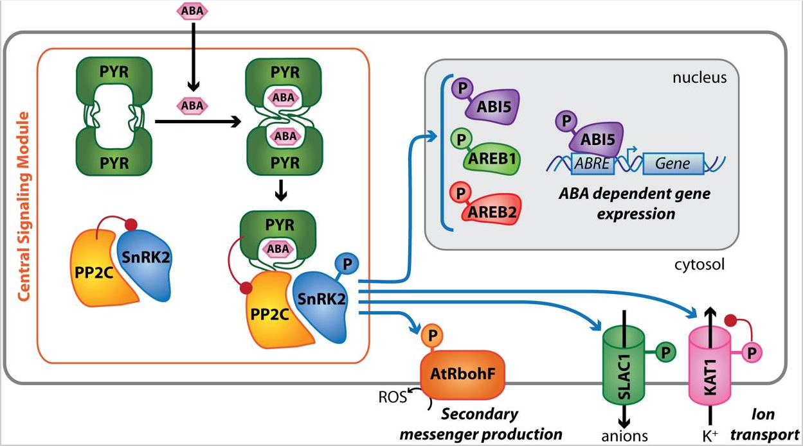

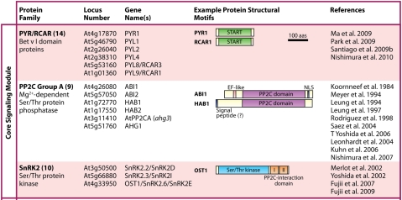

http://www.sciencedirect.com/science/article/pii/S1360138504002985
